Preliminary results of U.S.–Russian collaborative modeling to improve the assessment of Pacific cod stocks in the Bering Sea

Authors: Steven J. Barbeaux1, Aleksei Baitaliuk2, Vladimir Kulik2, Peter Hulson1, Andrey Savin2, Ingrid Spies1, and James Thorson1

1 U.S.A., National Oceanic and Atmospheric Administration, Alaska Fisheries Science Center (AFSC)

2Russian Federation, Federal Agency for Fishery, Pacific Scientific Research Fisheries Center (TINRO)

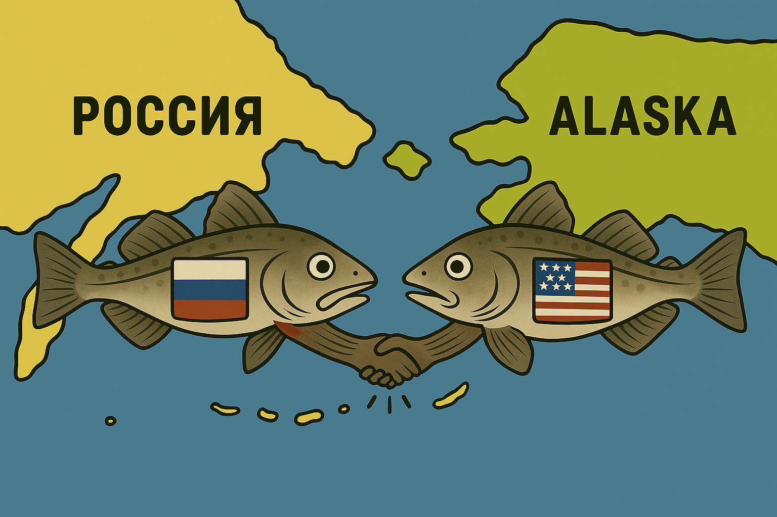

# Abstract

# Pacific cod (*Gadus macrocephalus*) support valuable fisheries across both U.S. and Russian waters of the Bering Sea, yet stock assessments have traditionally been conducted independently on either side of the international boundary. Increasing evidence from genetics and tagging demonstrates that cod exhibit both regional differentiation and substantial seasonal exchange across the North Pacific, underscoring the importance of spatially explicit, transboundary assessments.

# Here we present the first integrated two-area assessment, combining U.S. (Eastern and Northern Bering Sea, Western Gulf of Alaska) and Russian (Western Bering Sea) data within a unified modeling framework. Standardized biomass indices were developed using spatiotemporal models in the R package sdmTMB, applied to U.S. and Russian bottom trawl survey data. Environmental covariates including depth and cold pool extent were incorporated, and two sets of indices were generated: a U.S.-only model and an all-data model including Russian surveys. The latter was used as the primary input to Stock Synthesis.

# Stock Synthesis models were fit under two configurations: a two-area model allowing movement between U.S. and WBS regions, and a single-area sensitivity run. The two-area model produced good fits to survey biomass indices and length compositions, and highlighted strong regional contrasts. U.S. cod were characterized by larger asymptotic lengths and well-constrained growth, whereas WBS cod exhibited smaller asymptotic sizes and wide uncertainty due to the absence of Russian age–length data. This uncertainty propagated into recruitment and movement estimates, limiting the ability to distinguish local WBS production from immigration. Biomass and spawning stock biomass trajectories were positively associated with cold pool extent, with recent declines coinciding with warming conditions. Exploitation was stable in U.S. regions but more variable in the WBS, where catches were sustained in part by inflows from U.S. stocks.

# These results emphasize the transboundary nature of Pacific cod in the Bering Sea and the need for continued U.S.–Russian collaboration. Expanded biological sampling in the WBS, particularly age–length data, is essential for reducing uncertainty, refining recruitment and movement estimates, and improving future assessments.

# 1. Introduction

Pacific cod (*Gadus macrocephalus*) is a widely distributed, transboundary species in the Bering Sea whose management could potentially benefit from coordinated assessments between the United States and Russia. Historically, stock assessments have relied primarily on survey and fishery data from the respective nation for the portion of the population in their respective zones (Figure 1), but recent collaborative efforts have sought to integrate U.S. and Russian observations from the entire distribution of Pacific cod in the Bering Sea to capture the full dynamics of the population. This integration is particularly important because the Western Bering Sea (WBS) often functions as a receiving area for migrants originating from the eastern Bering Sea (EBS) and northern Bering Sea (NBS), meaning that transboundary connectivity shapes biomass availability and exploitation opportunities across jurisdictions (Nielsen et al. 2025, Zuenko et al. 2025)

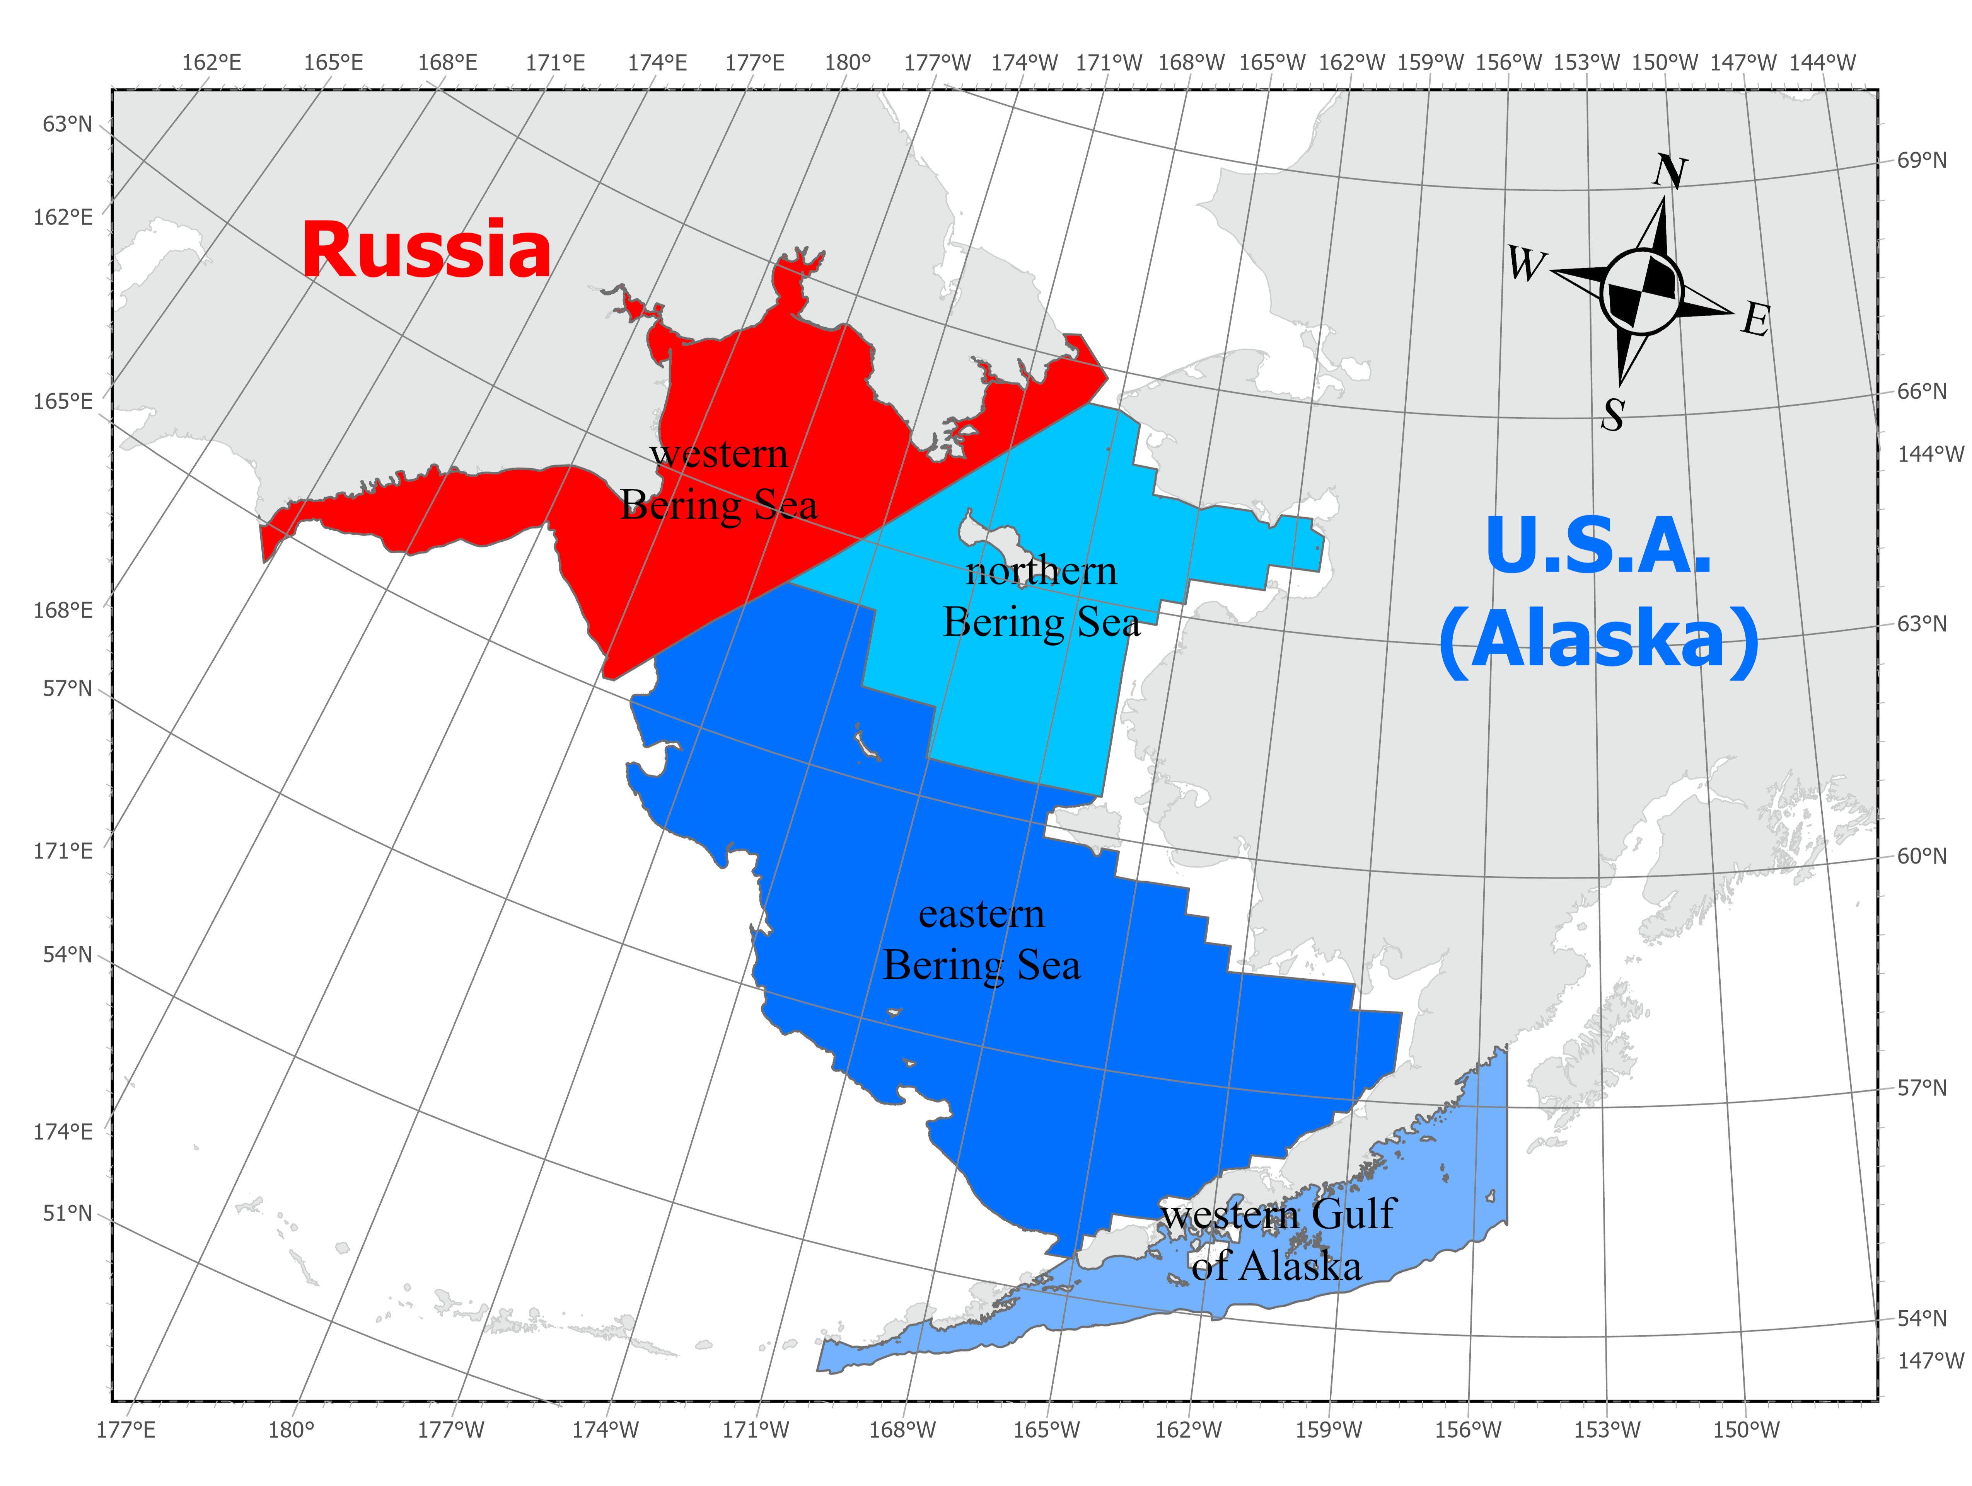

Figure . Map of Bering Sea shelf regions to 300m in depth with the Russian western Bering Sea in red and the U.S.A. northern and eastern Bering Sea and western Gulf of Alaska regions in blue.

Environmental variability strongly influences cod distribution and productivity in the Bering Sea. Episodes of extreme warming—such as the 2016–2019 marine heatwave—disrupted the cold pool, accelerated northward expansions of cod, and intensified exchanges between eastern and western regions (Zuenko et al. 2025). Russian studies highlight that during such events, large fractions of the cod biomass in the WBS were comprised of migrants from the southeastern Bering Sea, reshaping both spatial dynamics and stock composition. These findings underscore the necessity of a joint analytical framework capable of reconciling local production with large-scale migratory influxes.

Complementary U.S. research has provided additional insight into connectivity. Recent genetic analyses have revealed subtle but meaningful differentiation between eastern and western Bering Sea populations (Spies et al. 2022, Barbeaux et al. 2024), while tagging studies demonstrate seasonal migrations linking the Gulf of Alaska, eastern Bering Sea, and Russian shelf (Nielsen et al. 2025). These findings highlight that Pacific cod exhibit both partial residency and long-distance exchange, further justifying the development of spatially explicit assessment models.

Recent modeling work using spatiotemporal indices and biomass reconstructions has demonstrated the potential of modern statistical approaches such as sdmTMB and Bayesian production models (e.g., JABBA) to incorporate both survey and environmental covariates (Kulik et al. 2025) For the WBS, model-based indices that explicitly account for bottom temperature have revealed substantial declines in biomass in recent years, falling from over 1.2 million t in 2017 to near or below 200 thousand t in 2024 (Kulik et al. 2025). These abrupt changes highlight both the volatility of the stock and the challenge of separating environmental effects from demographic and fishery drivers.

Together, these lines of evidence emphasize that Bering Sea Pacific cod cannot be fully understood or sustainably managed without joint U.S.–Russian assessments. The present study builds on this foundation by evaluating a two-area Stock Synthesis model that incorporates both U.S. and Russian data, with the combined one-area model retained as a sensitivity case. This approach allows for a clearer understanding of growth, recruitment, movement, and exploitation dynamics across the transboundary system, while also quantifying the uncertainties that arise from data limitations—notably the lack of age information in Russian surveys and fisheries.

# 2. Methods

## 2.1 Data Inputs

The assessment incorporated data from U.S. and Russian fisheries, trawl surveys, and environmental monitoring, with coverage summarized inFigure 2**.** Catch data were available for both U.S. and Russian fisheries throughout the 1977–2024 period (Figure 3). U.S. catches included the Eastern and Northern Bering Sea and Western Gulf of Alaska fisheries, while Russian catch data represented the Western Bering Sea. For the Russian fishery, only total catch was available; no length or age composition data were provided.

Abundance indices were developed using spatiotemporal sdmTMB models applied to U.S. and Russian bottom trawl survey data (see section 2.1.a below for full description of methods). The indices were used as the inputs to Stock Synthesis, ensuring that the assessment incorporated the full transboundary distribution of Pacific cod. U.S. survey data (EBS, NBS, and WGOA) and Russian survey data (WBS) were combined in the spatiotemporal framework, which accounted for depth, temperature, and survey-specific effects.

## Length composition data were available from multiple sources. U.S. fisheries provided annual length data from observer sampling across trawl, longline, and pot sectors. U.S. and Russian surveys supplied length data throughout most of the time series. Russian fishery length data were not available. Age composition data were only available from the U.S. surveys, derived from otolith samples. These age data played a critical role in informing growth and recruitment but remain absent from the Russian data stream.

## Environmental information was also included in the analysis. Mean bottom temperature anomalies were compiled from U.S. survey observations across the Bering Sea beginning in 1982. These anomalies were used both as covariates in exploratory analyses and for post hoc comparisons with recruitment, biomass variability, and movement. Collectively, this diverse set of data sources provided the empirical foundation for the two-area stock assessment model.

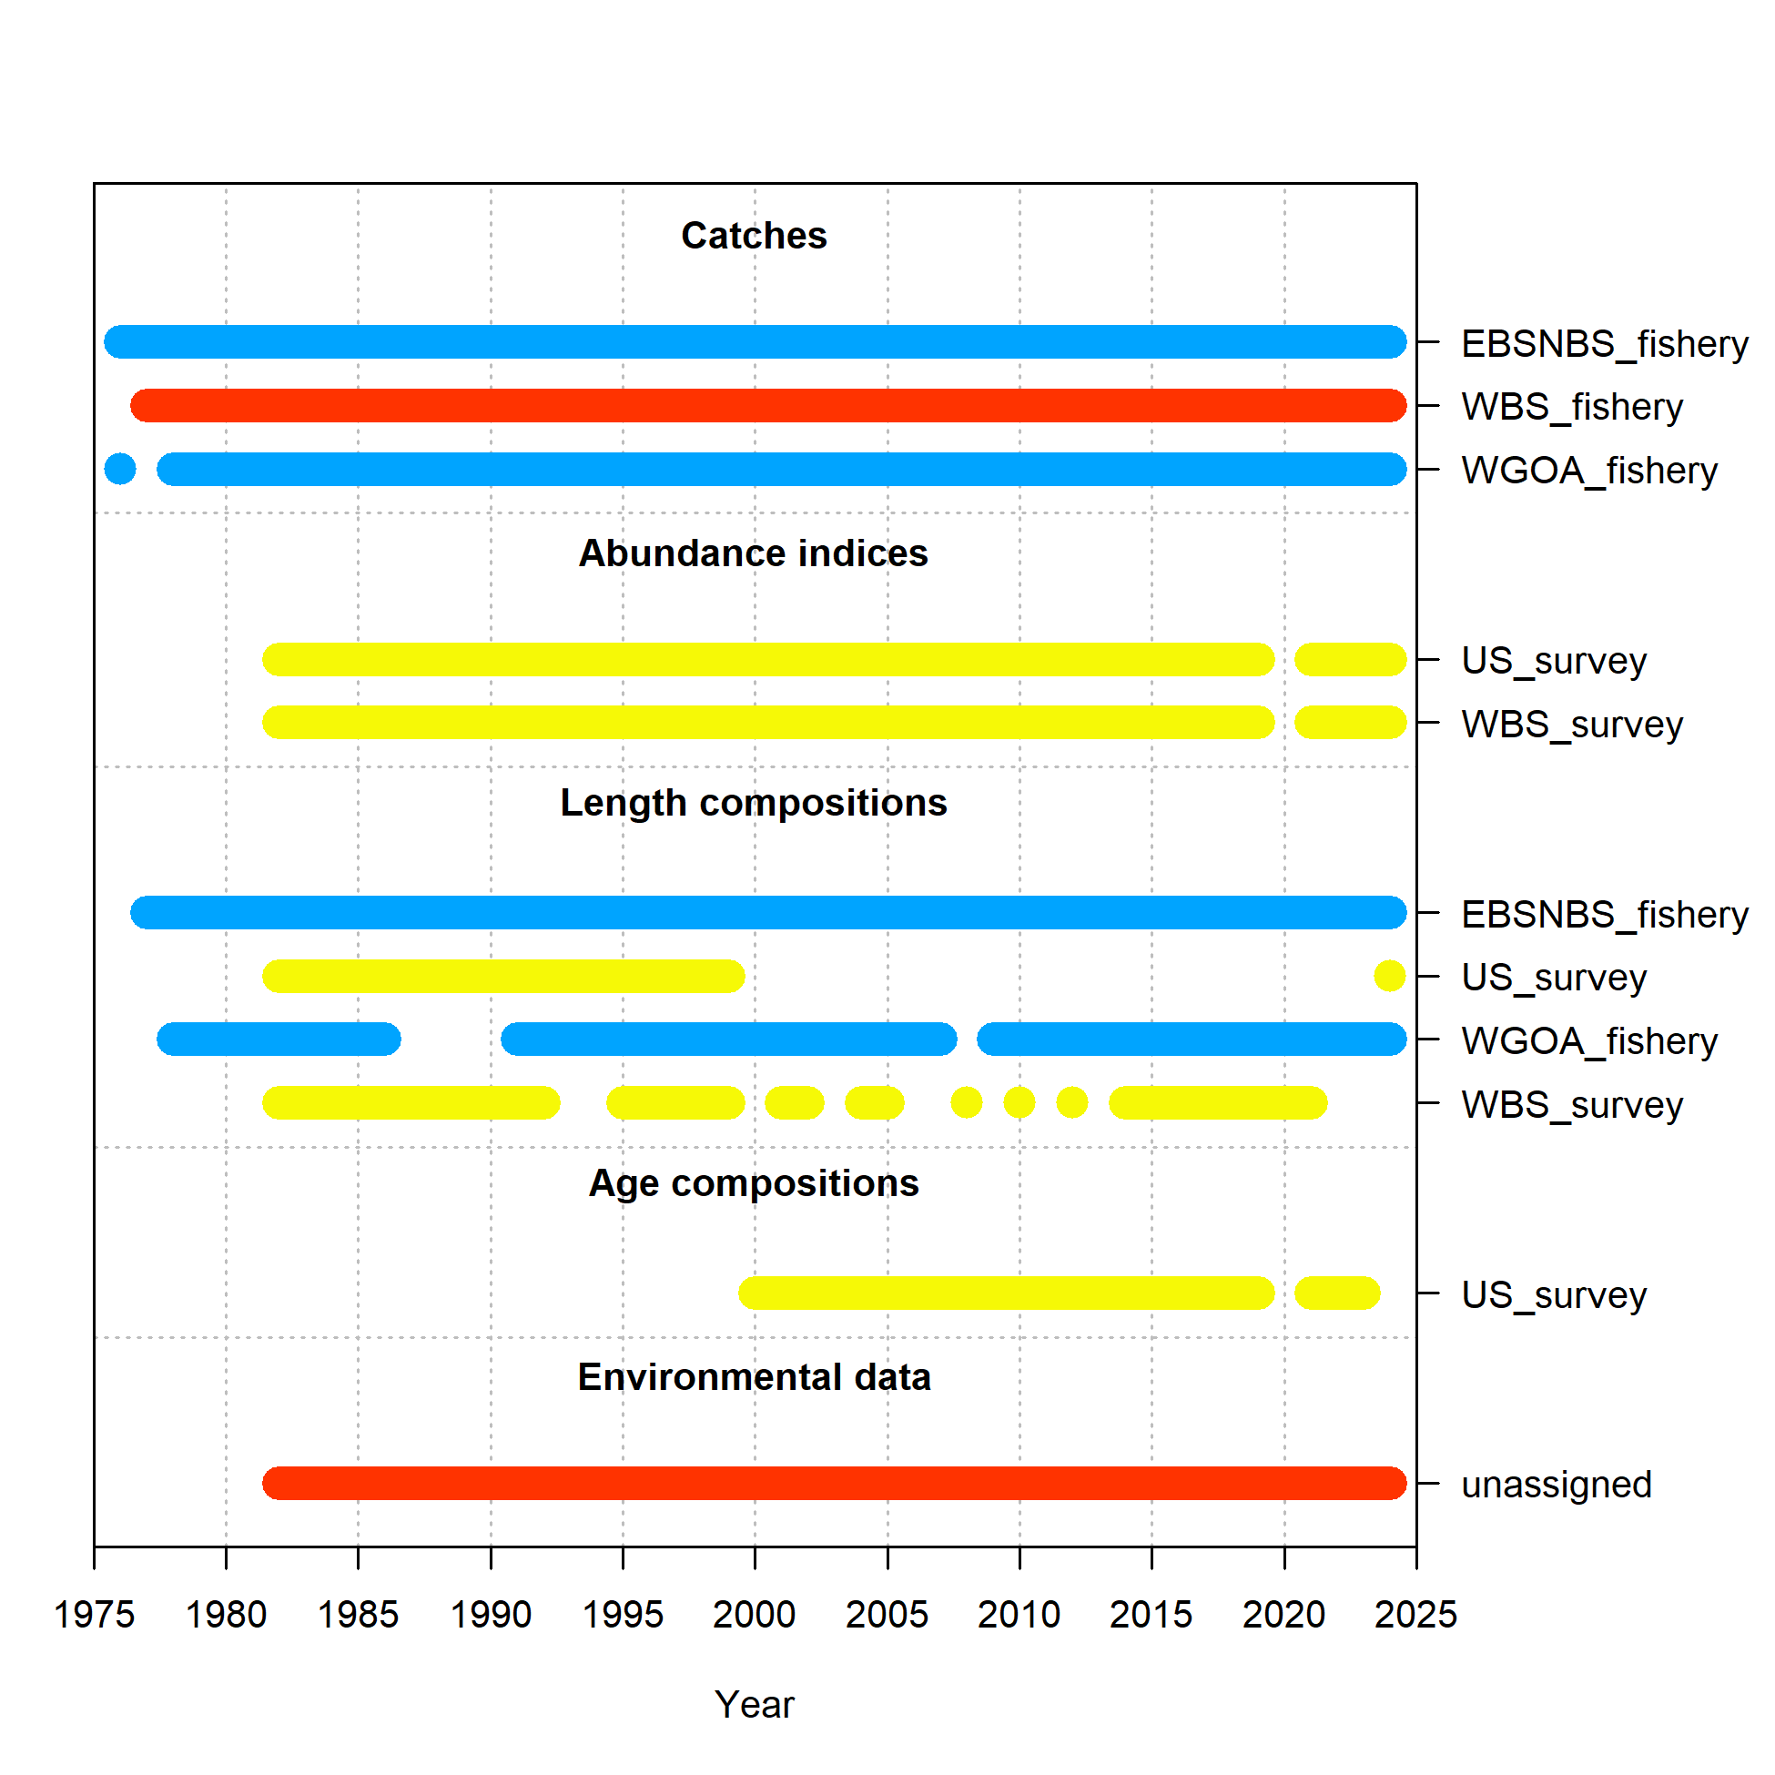

Figure Data sources used in the two-area Stock Synthesis model for Pacific cod (1977–2024). Time coverage is shown for catches (blue = U.S. EBS/NBS and WGOA fisheries; red = Russian WBS fishery), abundance indices (yellow = U.S. and Russian surveys), length compositions (blue = fisheries; yellow = surveys), and age compositions (yellow = U.S. survey). Environmental data (red, “unassigned”) represent annual cold pool extent and bottom temperature anomalies used as covariates.

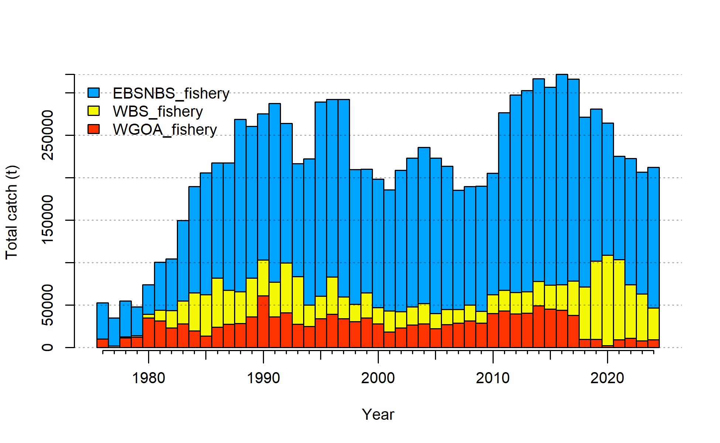

Figure Total catch (t) of Pacific cod by region and fishery, 1977–2024, as used in the two-area Stock Synthesis model. Blue bars represent combined U.S. fisheries in the Eastern and Northern Bering Sea (EBS/NBS), yellow bars represent the Russian Western Bering Sea (WBS) fishery, and red bars represent the U.S. Western Gulf of Alaska (WGOA) fishery. The EBS/NBS fishery consistently accounted for the majority of removals, with smaller but persistent contributions from the WBS and WGOA.

#### 2.1a Spatiotemporal Biomass Indices (sdmTMB)

## To generate standardized biomass indices of Pacific cod, we fitted spatiotemporal models using the R package sdmTMB (Anderson et al. 2022). The model was specified with a Tweedie distribution to accommodate the continuous, non-negative nature of biomass-per-unit-area data and to handle the large number of zero catches present in trawl survey datasets.

## The response variable was biomass catch-per-unit-effort standardized by tow area, and the fixed-effects structure included a factor for nation (U.S. vs. Russia), a continuous year effect to capture long-term temporal trends, and a smooth effect of depth that was allowed to vary by survey. This structure enabled the model to capture survey-specific depth–biomass relationships, which differ between the U.S. and Russian survey designs.

## Spatially varying effects were included allowing for the influence of cold-pool extent and survey-specific effects to vary spatially, following the approach of Thorson (2019). The cold-pool covariate provided a biologically meaningful driver of cod distribution, as reduced cold-pool extent is associated with northward expansion of Pacific cod into the northern and western Bering Sea, while expanded cold pools restrict cod distribution to the south.

## The spatial domain was represented using a barrier mesh, which incorporated coastlines and political boundaries. A mesh of ~300 knots was constructed using a polygon shapefile of the Bering Sea and Western Gulf of Alaska including waters from 20m to 300 m in depth (figure x). This mesh size was chosen as a computationally efficient resolution, after exploratory tests confirmed that estimates were stable compared to denser meshes (e.g., 750 knots). The barrier mesh prevented unrealistic correlations across land or unsampled regions, while allowing continuous spatial processes within marine habitats. A range fraction of 0.2 and projection scaling of 1000 were used to tune the barrier field.

## Both spatial and spatiotemporal random fields were included in the model, with the spatiotemporal component structured as an AR(1) process in time to account for temporal autocorrelation. The model was fit assuming isotropic spatial correlation.

## We fitted two versions of this model:

## U.S.-only model, using EBS, NBS, and WGOA survey data.

## All-data model, using both U.S. (EBS, NBS, WGOA) and Russian (WBS) survey data.

## The all-data model was used as the primary input to Stock Synthesis, ensuring that indices reflected the full transboundary distribution of Pacific cod, while the U.S.-only model was used as a sensitivity comparison to evaluate the influence of Russian data.

## Model adequacy was assessed by confirming convergence, verifying positive definiteness of the Hessian matrix, and inspecting residual diagnostics. Dunn–Smyth randomized quantile residuals were computed and examined in both quantile–quantile plots and spatial maps for each year to detect systematic deviations. These diagnostics confirmed that model fits were robust, with no evidence of major residual structure.

## For prediction, the fitted model was projected onto a 40 km resolution grid covering the Bering Sea and Western Gulf of Alaska from 20 m to 300 m depth, encompassing the full extent of Pacific cod habitat. Predictions incorporated both annual cold pool extent and depth covariates, ensuring that spatiotemporal patterns were driven by ecologically meaningful processes.

## 2.2 Stock Synthesis Model Structure

The primary assessment was conducted in Stock Synthesis 3 (SS3 V 3.30.24) using a two-area spatial structure that separated U.S. waters (EBS, NBS, and WGOA; Area 1) from the Russian WBS (Area 2). Population dynamics were modeled using an age-structured framework with annual recruitment, a fixed natural mortality rate of 0.3866, and growth estimated separately for each area. Growth was represented using a Richards growth curve, which provides flexibility relative to the traditional von Bertalanffy model. For the U.S. region, all growth parameters were estimated directly, while in the WBS the LAmin parameter was fixed in order to stabilize model estimation given limited data availability. Recruitment was estimated annually for each area as deviations around a Beverton–Holt stock–recruitment relationship with steepness fixed at 1.0, allowing region-specific productivity to be characterized. Three fisheries were modeled which included the WBS, EBS+NBS, and WGOA fisheries. Selectivity patterns were estimated for each fishery and survey fleet using double-normal selectivity functions. Since length composition data were not available for the WBS fishery, the selectivity for this fishery mirrored the EBS+NBS selectivity. Movement of age-3 and older cod between regions was explicitly modeled, with movement rates assumed to be age-invariant and interannual variability fit as a random walk on each of the four movement trajectories (U.S. source from U.S. to WBS, U.S. source from WBS to U.S., WBS source from WBS to U.S. and WBS source from U.S. to WBS) but estimated directly from the data. This two-area structure allowed the model to account for area-specific differences in growth, recruitment, and exploitation, while also quantifying connectivity between U.S. and Russian waters.

## 2.3 Sensitivity Test: Combined Model

To evaluate the influence of spatial structuring on model outputs, a sensitivity analysis was conducted using a single-area version of the Stock Synthesis model. In this framework, the survey indices from both U.S. and Russian sources were aggregated into a single population unit, and parameters such as growth and recruitment were estimated without regional separation. Fisheries remained separate in this model run. This combined model provided a direct comparison against the two-area framework, highlighting whether differences in biomass, spawning stock biomass (SSB), and fishing mortality (F) arose primarily from data inputs or from structural assumptions about regional separation. Although the combined model was expected to smooth over spatial contrasts, it offered a useful benchmark for testing the robustness of results and for demonstrating the added value of explicitly modeling U.S. and WBS regions as distinct components of a transboundary stock.

## 2.4 Exploitation Metrics

Fishing mortality and exploitation rates were estimated directly from model outputs and ancillary analyses to evaluate harvest dynamics across regions and fleets. Within Stock Synthesis, annual fishing mortality (F) was calculated using the Z–M method, where total mortality (Z) is partitioned into natural mortality (M) and fishing mortality. This standardized annual F statistic (F = Z–M) provided a consistent measure of exploitation over time and across areas. Exploitation rates were further disaggregated to compare trends between the U.S. and Russian regions, as well as among major fisheries. To place these results in context, catch versus biomass plots were produced, illustrating density-dependent harvest patterns and the relative scaling of removals to underlying stock abundance. In addition, exploratory Schaefer surplus production models were fit to the catch–biomass data for each region. These surplus production fits yielded semi-independent estimates of maximum sustainable yield (MSY) and biomass at MSY (BMSY), providing a simple comparative benchmark for exploitation dynamics. However, they were considered diagnostic and exploratory only, and not used to guide management advice, as the primary assessment relied on the age-structured Stock Synthesis framework.

## 2.5 Environmental Data

Environmental conditions were incorporated into the analysis through bottom temperature observations collected during U.S. trawl surveys of the Bering Sea. All environmental data used as covariates were computed within the *coldpool* R package (<https://github.com/afsc-gap-products/coldpool>; Rohan et al., 2023). These data were standardized into anomalies relative to the long-term mean and summarized as annual values spanning the 1982–2024 period. To reduce interannual noise, anomalies were smoothed using three-year running means, allowing broader regime shifts to be distinguished from short-term fluctuations. Although environmental variables were not formally included as covariates in the Stock Synthesis models, they were used in exploratory analyses to evaluate correlations with recruitment deviations and to provide ecological context for biomass and spawning biomass trends. Specifically, recruitment patterns were compared against cold and warm periods defined by bottom temperature anomalies, while biomass and spawning biomass trajectories were interpreted alongside these environmental signals. This integration of environmental information allowed the assessment to evaluate potential climate influences on Pacific cod productivity and to highlight the role of thermal variability in shaping transboundary dynamics.

# 3. Results

## 3.1 Model-based Biomass Indices (sdmTMB)

Model-based indices from the sdmTMB analysis highlight both consistencies and differences across regions depending on whether Russian survey data were included. Results for the Eastern Bering Sea (EBS), Northern Bering Sea (NBS), Western Gulf of Alaska (WGOA), and Western Bering Sea (WBS) are shown in Figure 4 A–D, while the combined U.S. index and the all-region index (including the WBS) are summarized in Figure 5 A–B.

In the Eastern Bering Sea (EBS) (Figure 4-A), the inclusion of Russian survey data made almost no difference to biomass trajectories. Both models captured the same long-term declines in the late 1980s and early 2000s, as well as the rebuilding and peak observed in the mid-2010s.

For the Northern Bering Sea (NBS) (Figure 4-B), the addition of Russian survey information produced lower and smoother biomass estimates, particularly during the 1980s and 1990s, while maintaining the overall pattern of expansion during the mid-2010s and subsequent decline. This suggests that Russian data help constrain uncertainty in this transboundary region.

In the Western Gulf of Alaska (WGOA) (Figure 4-C), biomass estimates were consistently low and stable relative to the Bering Sea, and the two models produced nearly identical results across the full time series.

The Western Bering Sea (WBS) (Figure 4-D) could only be represented when Russian data were included, since no U.S. surveys cover this area. The WBS index revealed distinct dynamics, with relatively high biomass in the early 1980s, declines through the 1990s and 2000s, and a pronounced peak in the late 2010s followed by a steep decline to recent lows.

At the aggregate scale, the U.S.-only index (EBS, NBS, WGOA combined; Figure 5-A) was nearly unaffected by the inclusion of Russian data, with both versions showing high biomass in the early 1980s, a decline through the early 2000s, and a rebuilding peak in the mid-2010s. By contrast, when the full transboundary stock was represented by including the WBS (Figure 5-B), biomass dynamics appeared more volatile, with stronger fluctuations in the 1980s and 2010s and sharper recent declines. These differences underscore the importance of incorporating Russian survey information to capture the full transboundary dynamics of Pacific cod, particularly in the western Bering Sea.

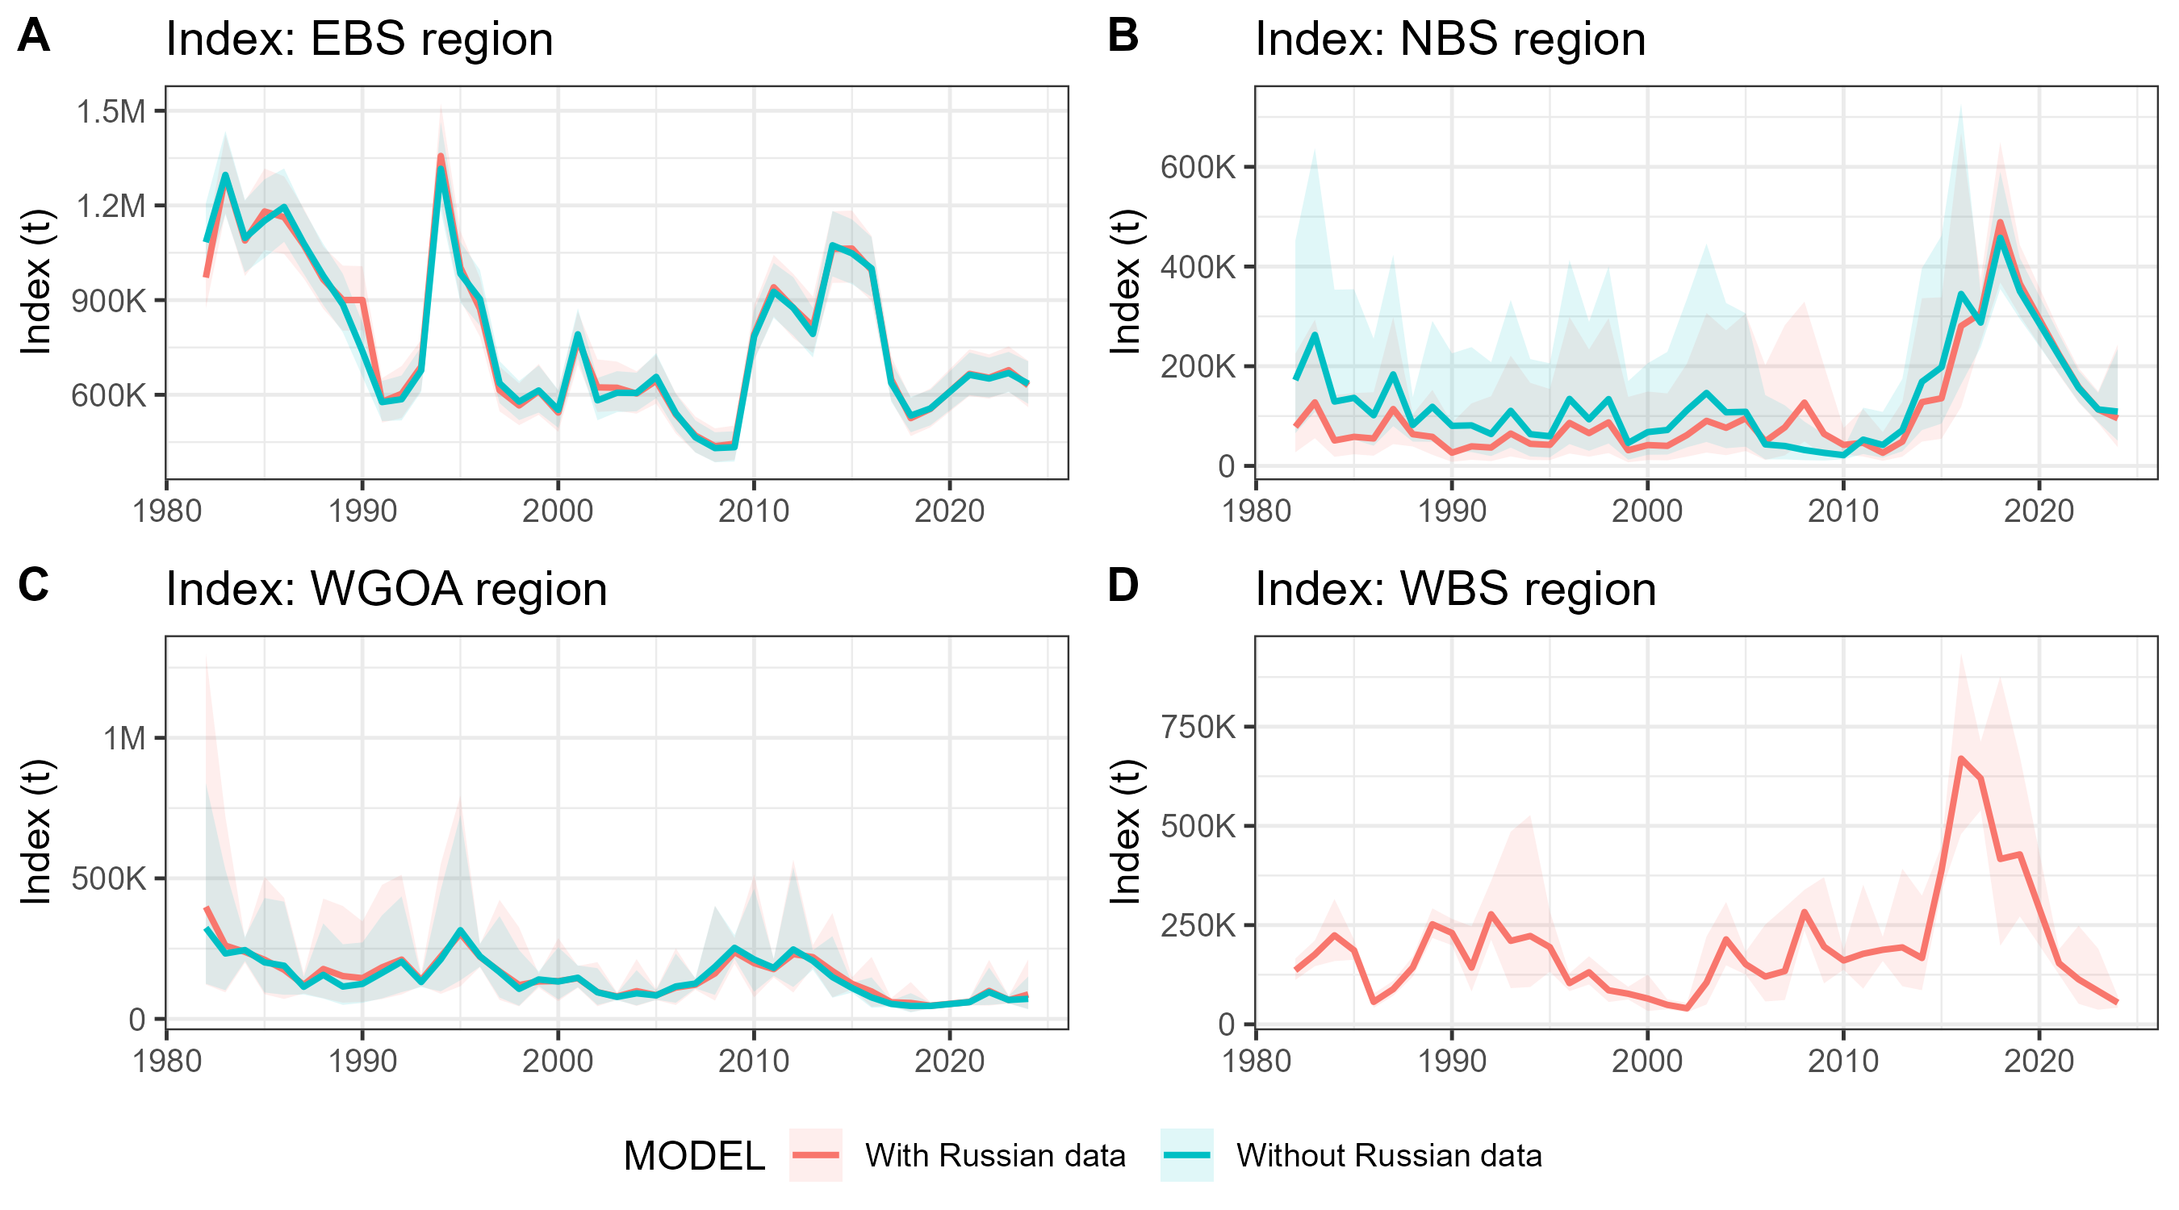

Figure Model-based biomass indices of Pacific cod from spatiotemporal sdmTMB models, shown by region: (A) Eastern Bering Sea (EBS), (B) Northern Bering Sea (NBS), (C) Western Gulf of Alaska (WGOA), and (D) Western Bering Sea (WBS). Red lines and shaded areas indicate indices estimated with Russian survey data included, while blue lines and shaded areas indicate indices estimated using U.S. survey data only. Shaded regions show approximate 95% confidence intervals.

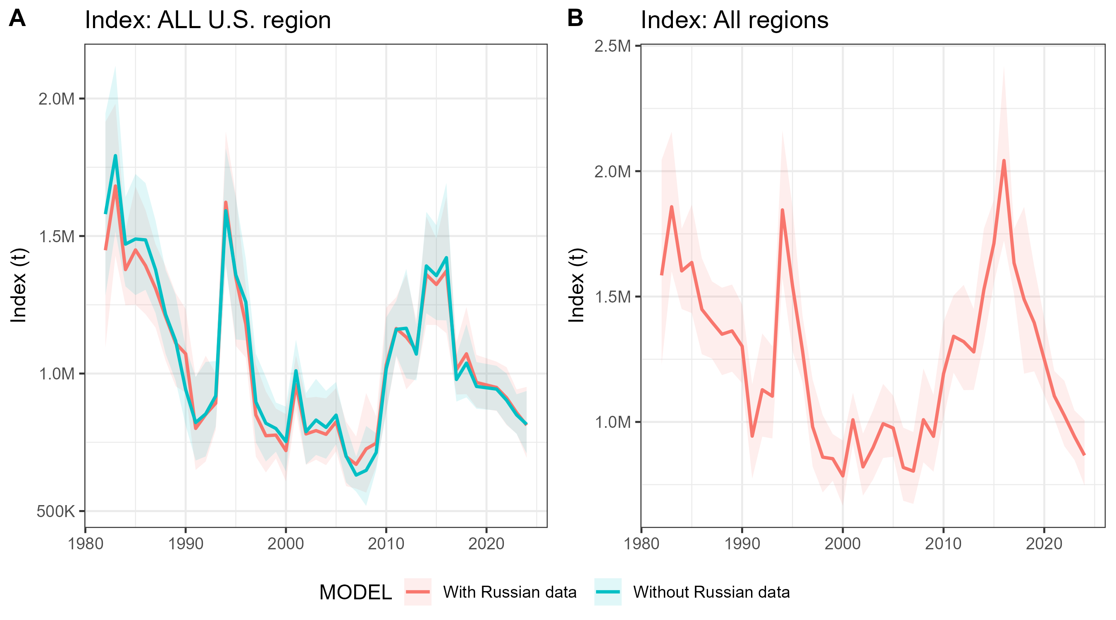

Figure Aggregate biomass indices of Pacific cod from spatiotemporal sdmTMB models. Panel A shows the combined U.S. index (EBS, NBS, and WGOA), with red lines including Russian survey data and blue lines using U.S. survey data only. Panel B shows the all-region index (EBS, NBS, WGOA, and WBS), which is only available when Russian survey data are included. Shaded regions represent approximate 95% confidence intervals.

## 3.2 Stock Synthesis Model Fits

The two-area Stock Synthesis model produced generally good fits to both survey biomass indices and length composition data. The inclusion of Russian data did not substantially change the overall trends but did affect the degree of uncertainty in the fits.

Survey indices: For the U.S. (EBS, NBS, and WGOA) survey, the model captured long-term fluctuations in biomass, including peaks in the early 1980s, late 2000s, and mid-2010s (Figure 6). Confidence intervals around the observations were relatively narrow, reflecting consistent survey coverage, and residuals were small, indicating a close fit. For the Russian WBS survey, the model reproduced the general pattern of biomass variation, but with wider uncertainty intervals and greater scatter in residuals. This reflects the noisier nature of the Russian time series rather than a systematic bias.

Length compositions: Fits to length composition data were broadly consistent across both survey and fishery fleets (). The U.S. fishery and survey distributions were well captured by the model, with observed and predicted length frequencies closely overlapping. By contrast, the Russian survey length compositions showed some localized deviations, particularly at intermediate lengths, and residual plots indicated greater variability.

Further diagnostics can be found in the github repository ().

B

A

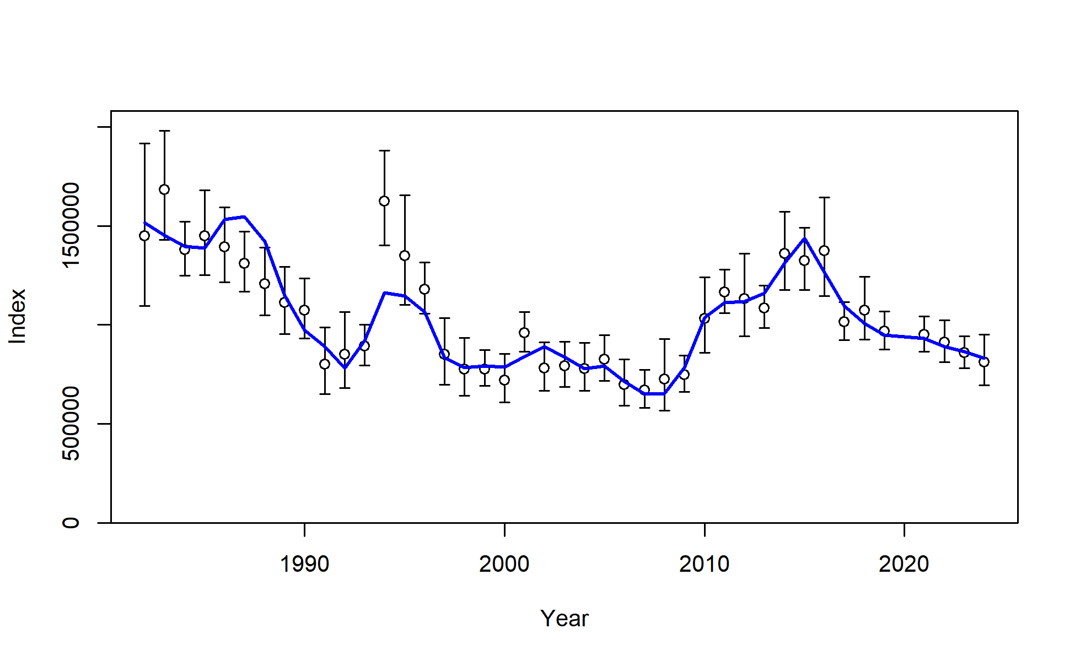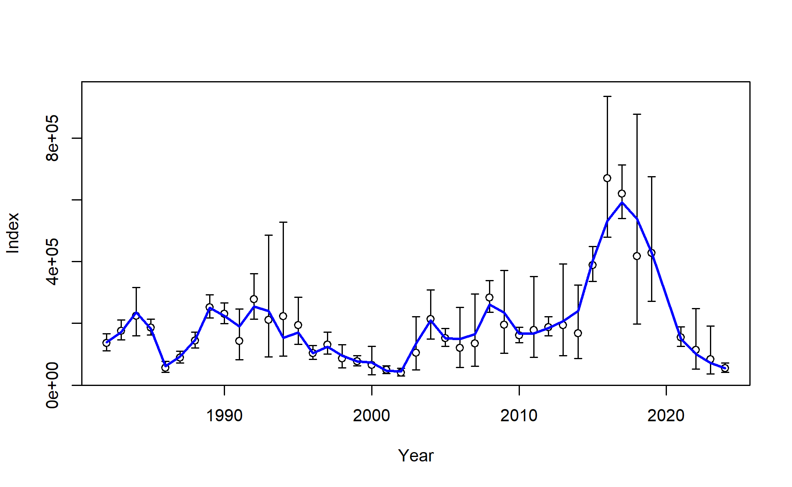

Figure Stock Synthesis fits to the A) U.S. survey biomass index (EBS, NBS, and WGOA) and B) Russian (WBS) survey biomass index.

B

A

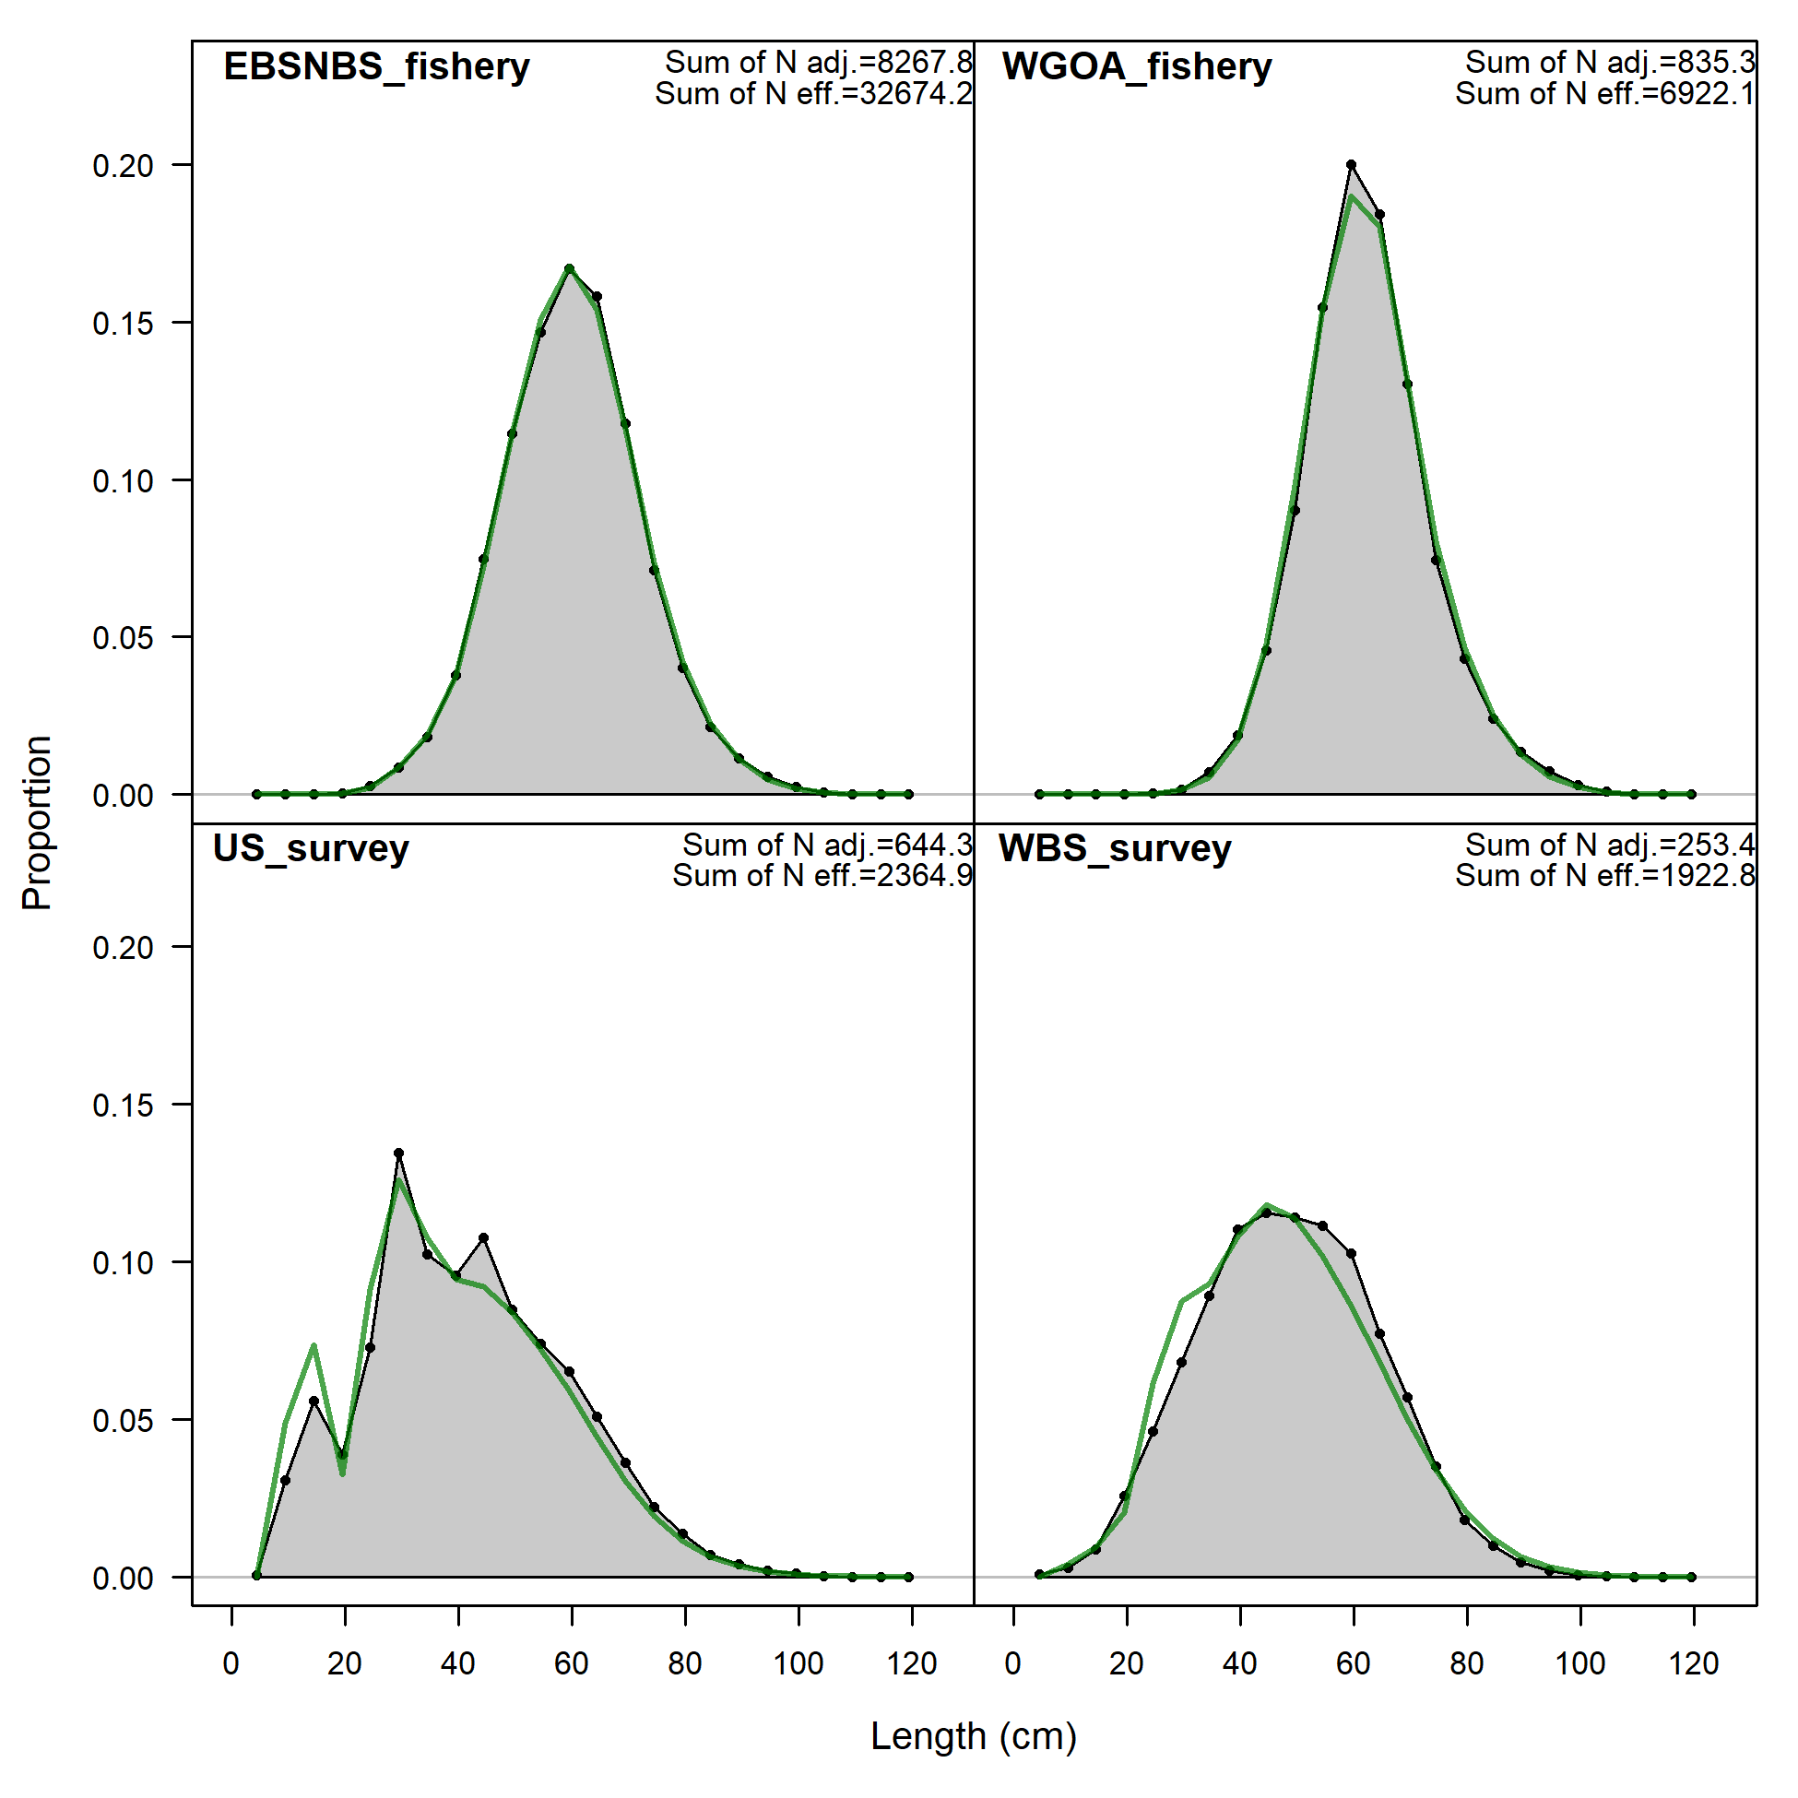 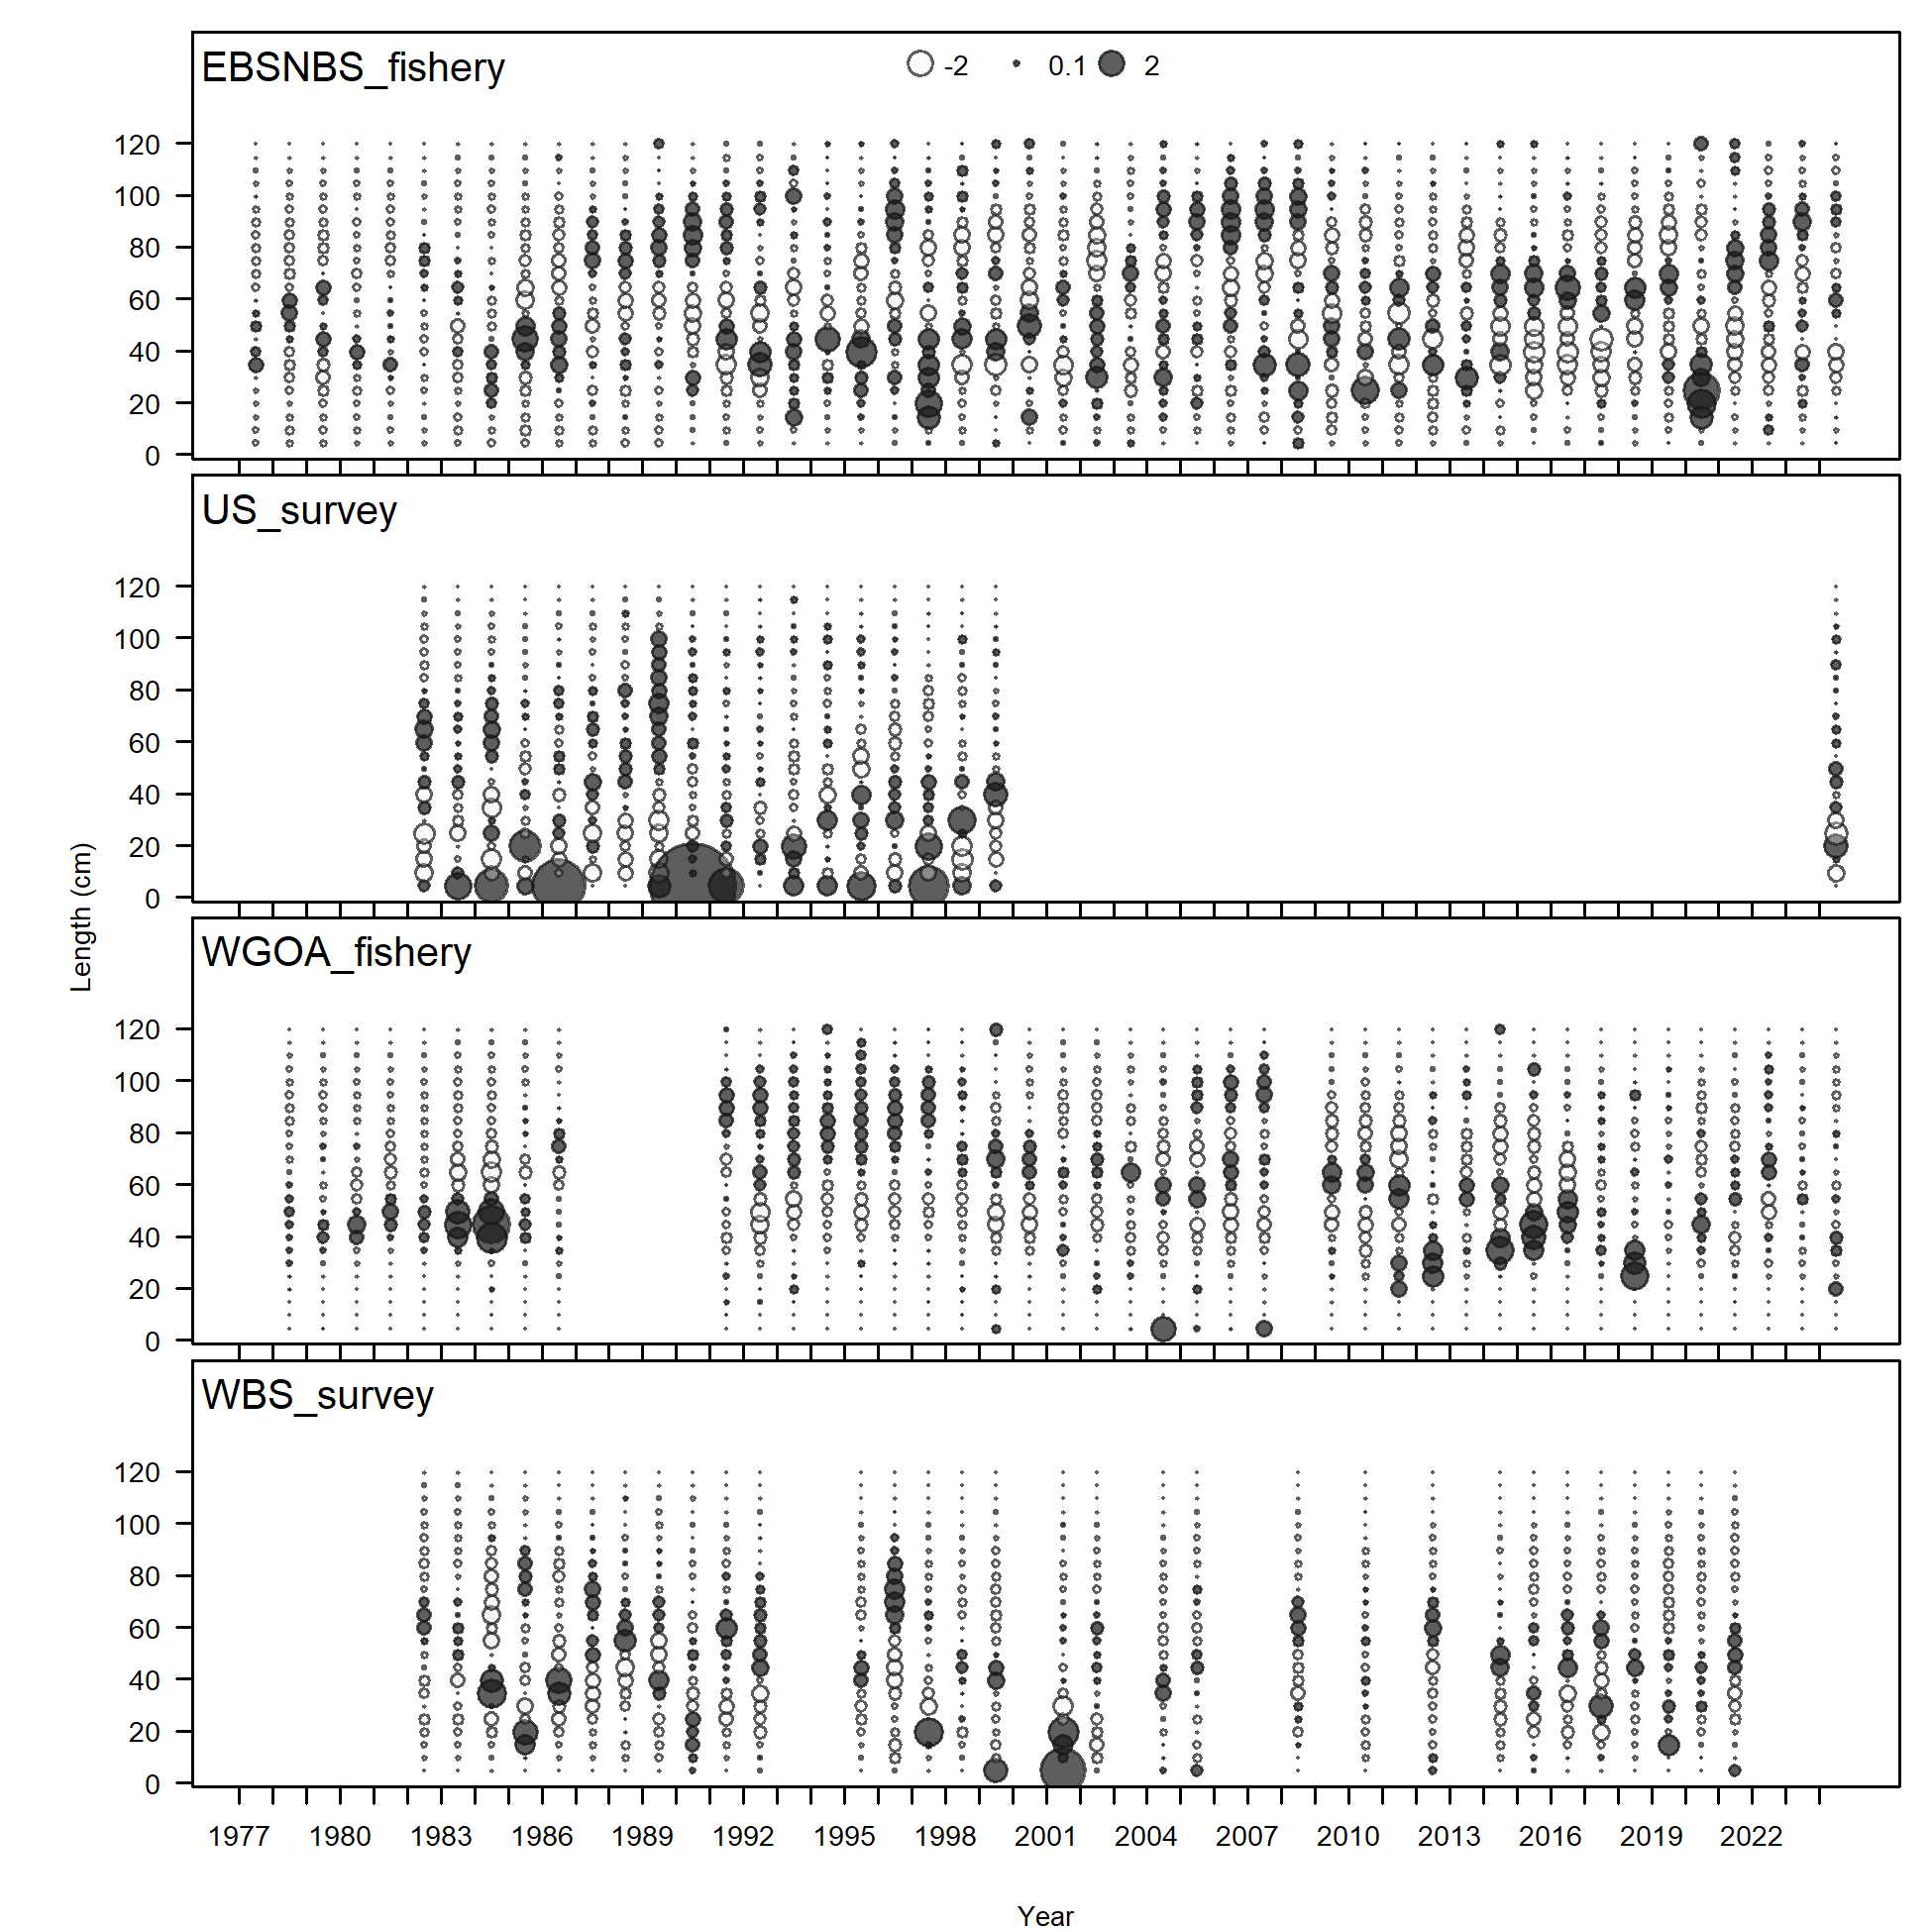

Figure Fits to survey and fishery length composition data: A) aggregated fits by fleet, and B) Pearson residuals by fleet.

## 3.3 Sensitivity Test: Combined Model

For comparison, a combined single-area model was run with all U.S. and Russian data aggregated. Biomass and spawning stock biomass (SSB) from the combined model were generally lower than those from the two-area model, particularly in recent years. Fishing mortality (F) estimates were correspondingly higher, as the combined framework smoothed over regional differences.  
  
Although the combined model produced acceptable fits, it masked important contrasts between the U.S. and WBS data series.

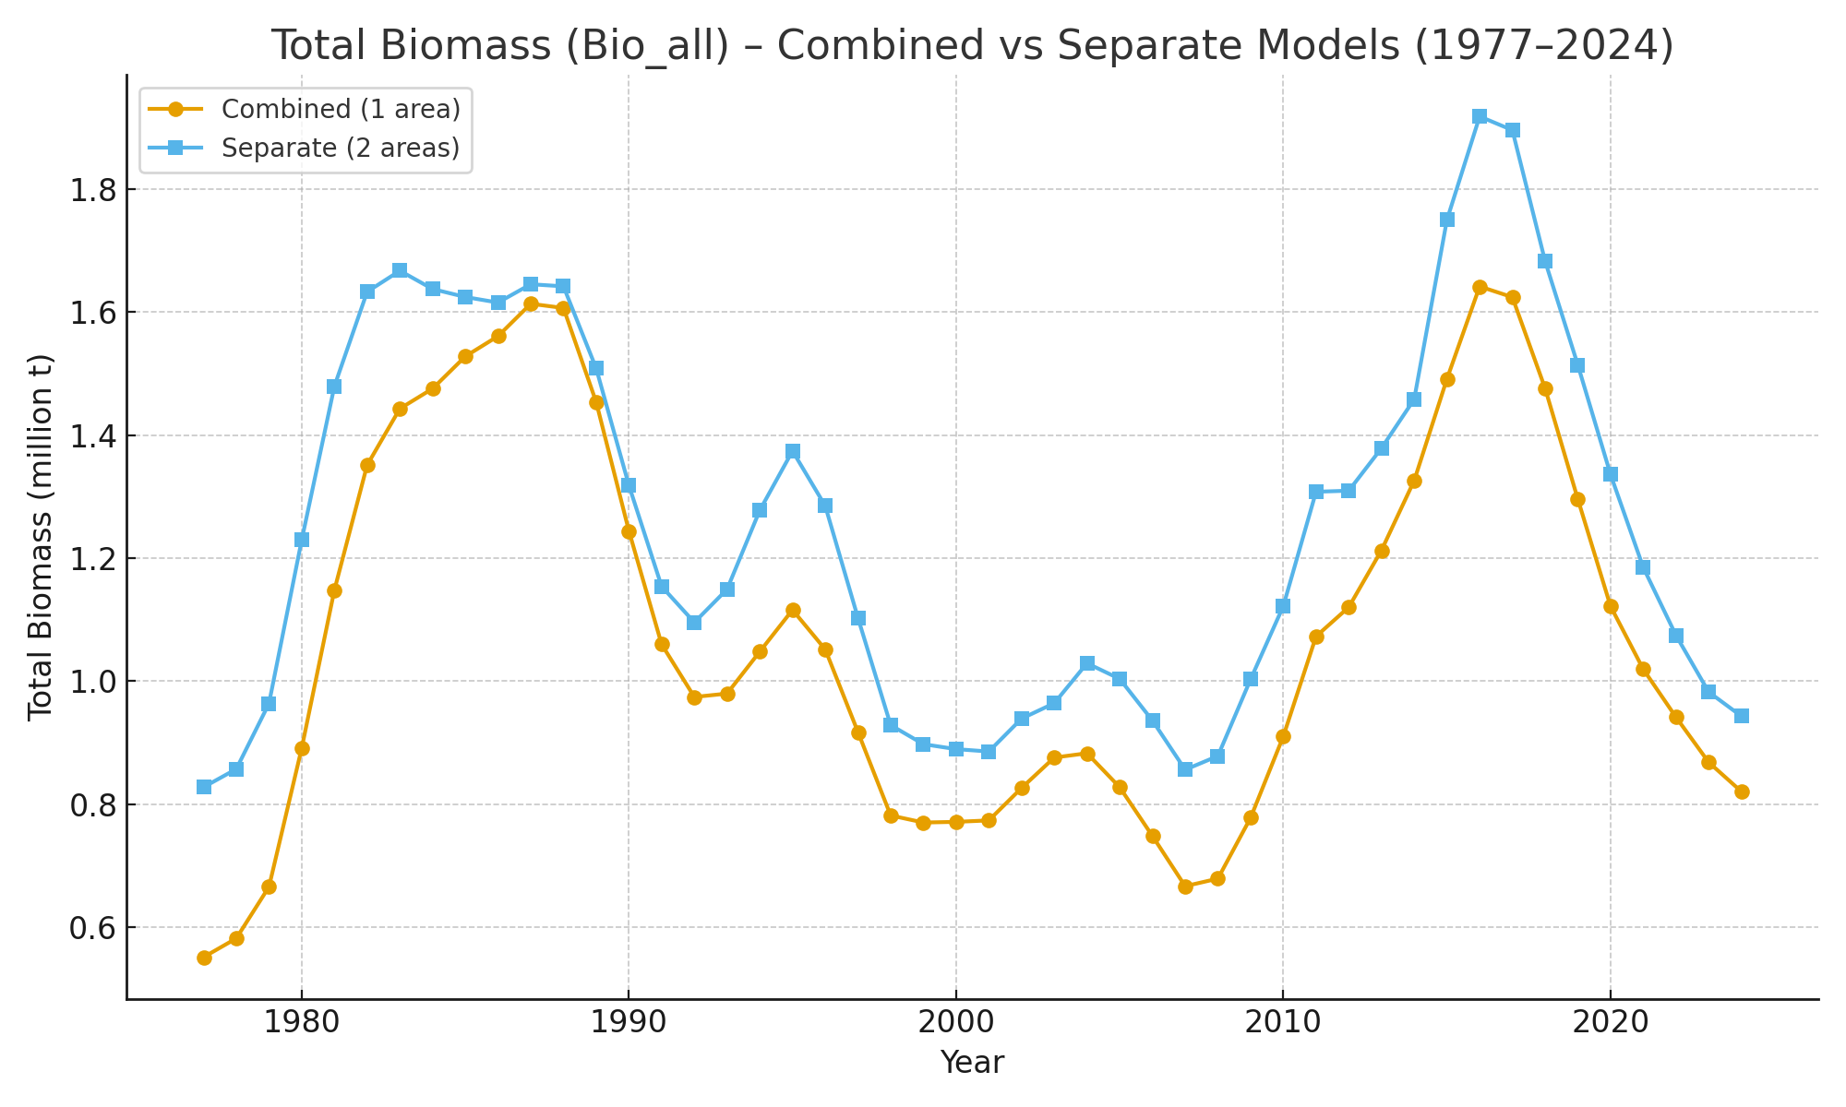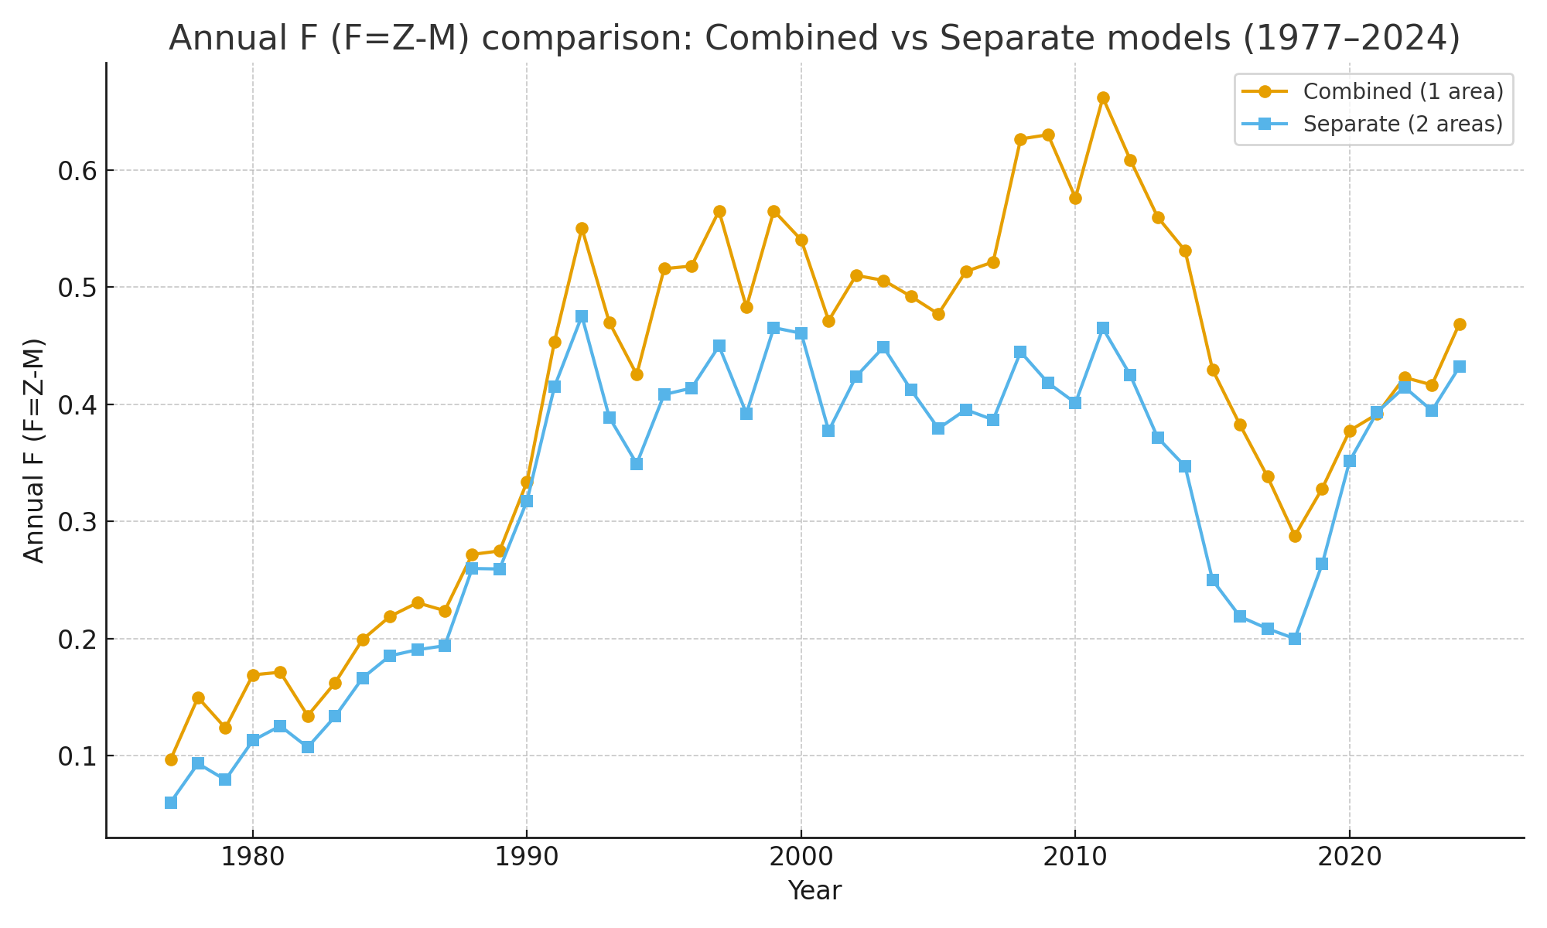

A

B

Figure Comparison of A) total biomass and B fishing mortality trajectories between the combined single-area model and the two-area model.

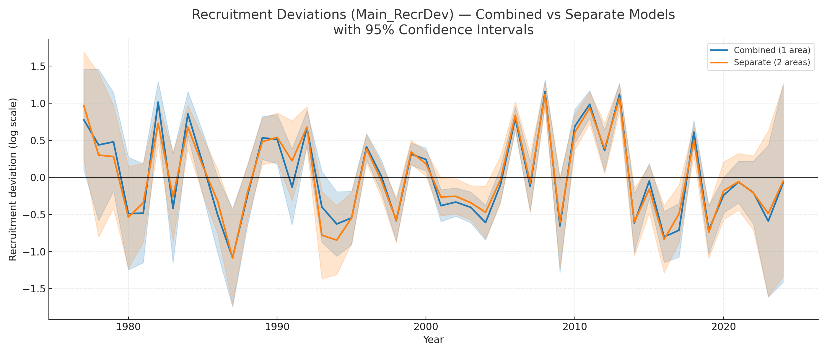

Figure Comparison of age-0 recruitment deviation trajectories between the combined single-area model and the two-area model.

## 3.4 Growth

Growth parameter estimates showed clear differences between areas, highlighting contrasting life-history dynamics between U.S. (EBS/NBS+WGOA) and Russian (WBS) Pacific cod. For the U.S. component, asymptotic lengths (LAmax) were larger (≈110–120 cm) and estimated with relatively narrow confidence intervals, reflecting both the higher quantity and quality of length-at-age data available. In contrast, WBS cod were characterized by substantially smaller asymptotic lengths (≈80 cm), with confidence intervals that were much wider. This greater uncertainty reflects the lack of age data from the Russian survey, as well as fewer fishery composition samples compared to U.S. data sources.

The LAmin parameter, which anchors expected size at the youngest modeled age, was fixed for the WBS to stabilize estimation given the limited Russian data. In the U.S. areas, this parameter was freely estimated, but results showed little variation across models, indicating consistent information from survey and fishery length-at-age data.

Von Bertalanffy growth coefficients (K) were relatively similar between models, but again displayed much wider uncertainty for the WBS, underscoring the difficulty of identifying growth rates without supporting age data. The Richards growth parameter showed only modest differences between areas, with estimates overlapping broadly across models.

Bar chart comparisons (Fig. 10) clearly illustrate these contrasts: U.S. growth parameters are well defined, with tight confidence bounds, while WBS parameters—especially L_at_Amax and K—show markedly greater uncertainty. These results emphasize the need for incorporating length-at-age information from Russian surveys and fisheries in order to better constrain growth processes for the WBS stock component.

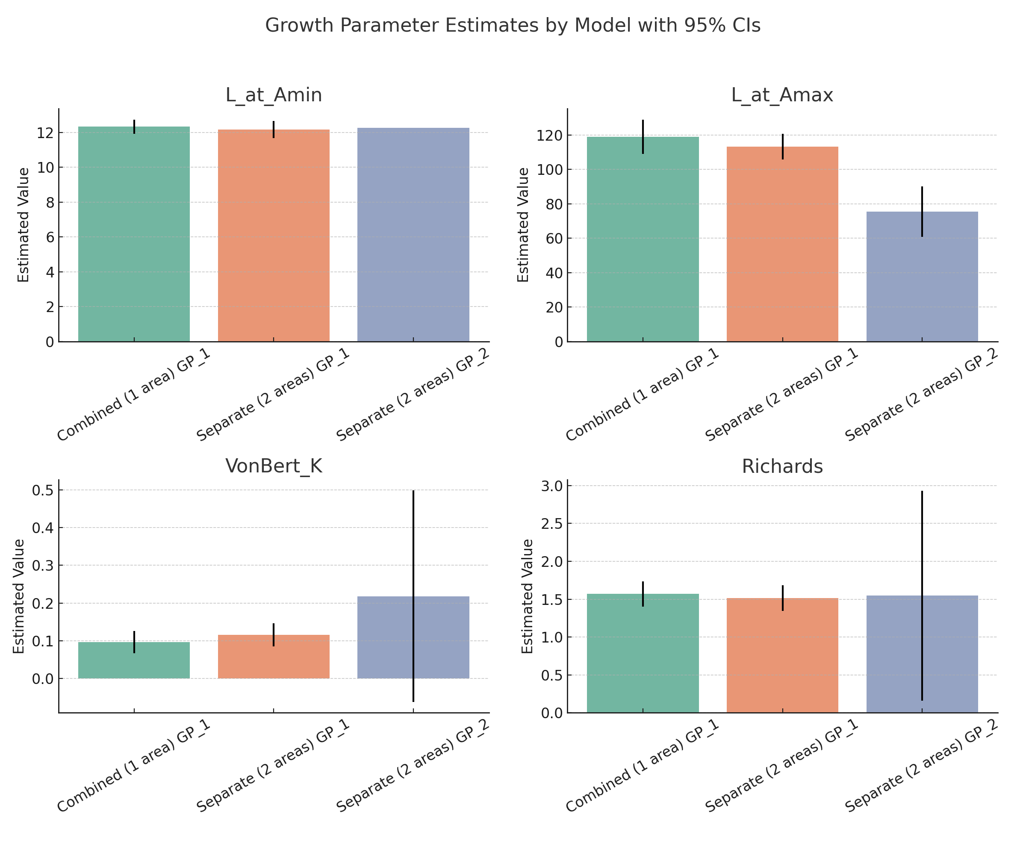

Figure Growth parameter estimates (L_at_Amin, L_at_Amax, K, Richards) for the combined U.S. and WBS one area model and separate for both U.S. (GP_1) and WBS (GP_2) cod, with 95% confidence intervals.

## 3.5 Recruitment

Recruitment dynamics in the two-area Stock Synthesis model showed clear contrasts between the U.S. regions (EBS, NBS, WGOA; Area 1) and the Western Bering Sea (WBS; Area 2).

Absolute recruitment estimates (Fig. 11A) indicate that the majority of recruits were consistently produced in Area 1, with interannual variation ranging from fewer than 200,000 to more than 1.5 million in strong year classes. In contrast, Area 2 (WBS) recruitment was an order of magnitude smaller, with peaks rarely exceeding 300,000 recruits. Despite these differences in magnitude, the WBS exhibited distinct pulses of stronger recruitment in the 1980s and late 2010s.

When examined as a fraction of total recruitment (Fig. 11B), Area 1 accounted for 70–90% of recruits in most years, but the relative contribution from Area 2 varied considerably. In certain periods, such as the late 1980s and early 2000s, WBS recruitment comprised up to 30–40% of the total, illustrating the potential for episodic contributions from this region.

Recruitment was also compared with environmental drivers (Fig. 12). Correlation analyses indicated that recruitment is positively associated with cold pool extent (r ≈ 0.37–0.41) and negatively associated with bottom temperature anomalies (r ≈ –0.38 to –0.40). These associations were strongest without lags and weakened slightly at 1–2 year lags, suggesting that recruitment is most closely tied to contemporaneous or near-term environmental conditions. Scatterplots confirm this pattern: larger recruitment events in Area 1 tended to occur during cold years with expanded cold pools, while recruitment was depressed during warm years with reduced cold pools.

Together, these results highlight two key points: (1) recruitment is consistently dominated by U.S. regions but with episodic and sometimes substantial contributions from the WBS, and (2) recruitment strength appears linked to environmental variability, particularly cold pool dynamics, underscoring the role of climate forcing in shaping transboundary cod productivity.

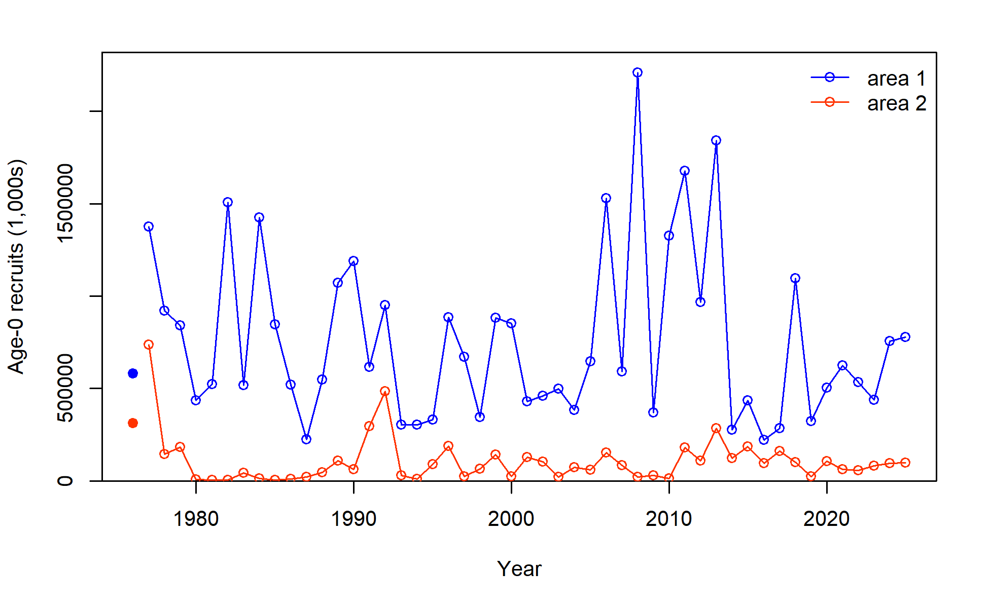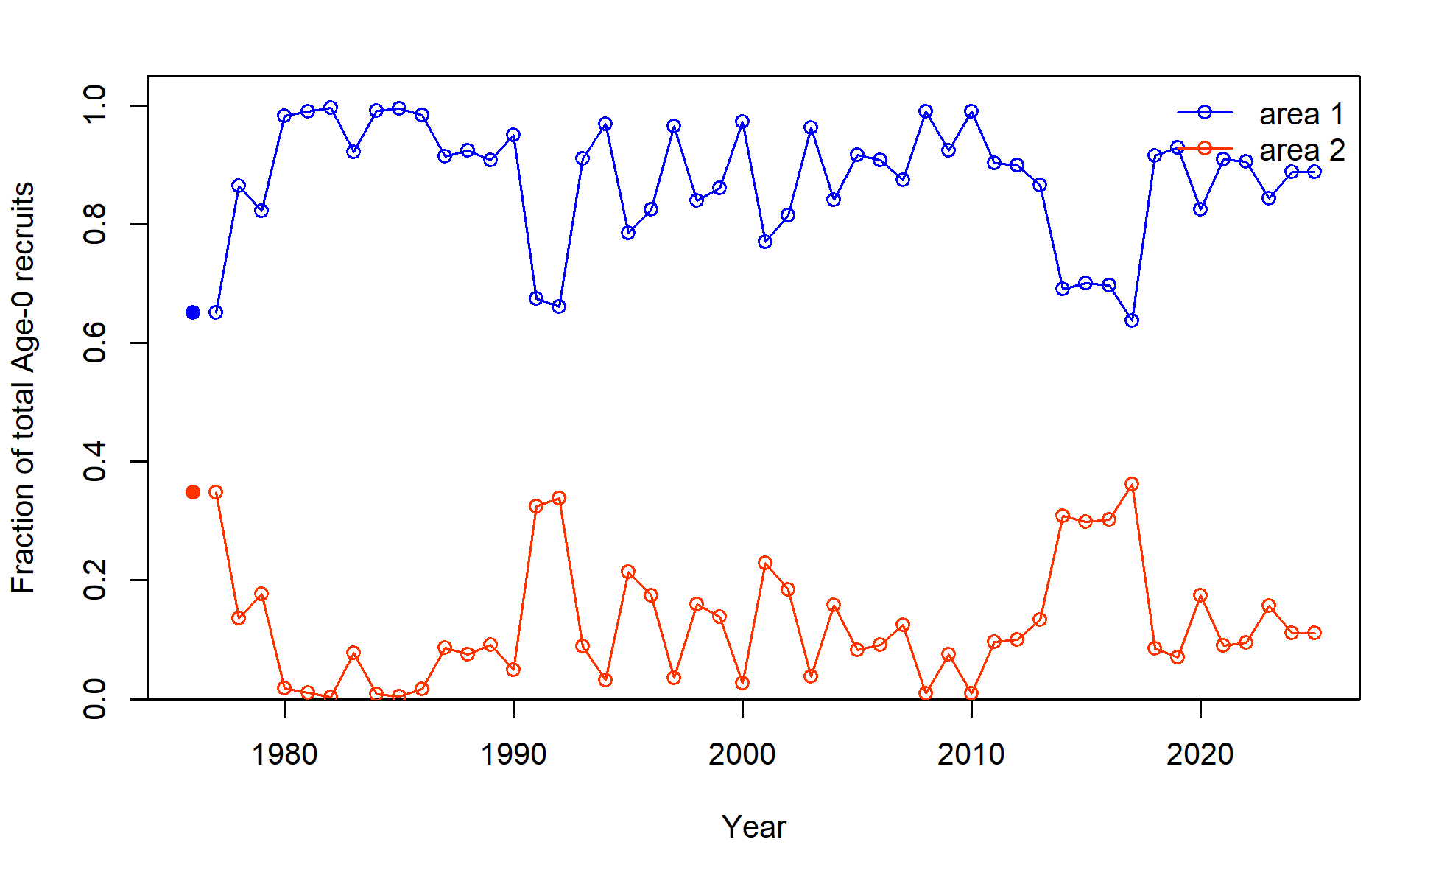

B

A

Figure Age-0 A) recruitment numbers (1000’s) and B) annual proportion of recruitment for Area 1 (EBS,NBS,WGOA) and Area 2 (WBS).

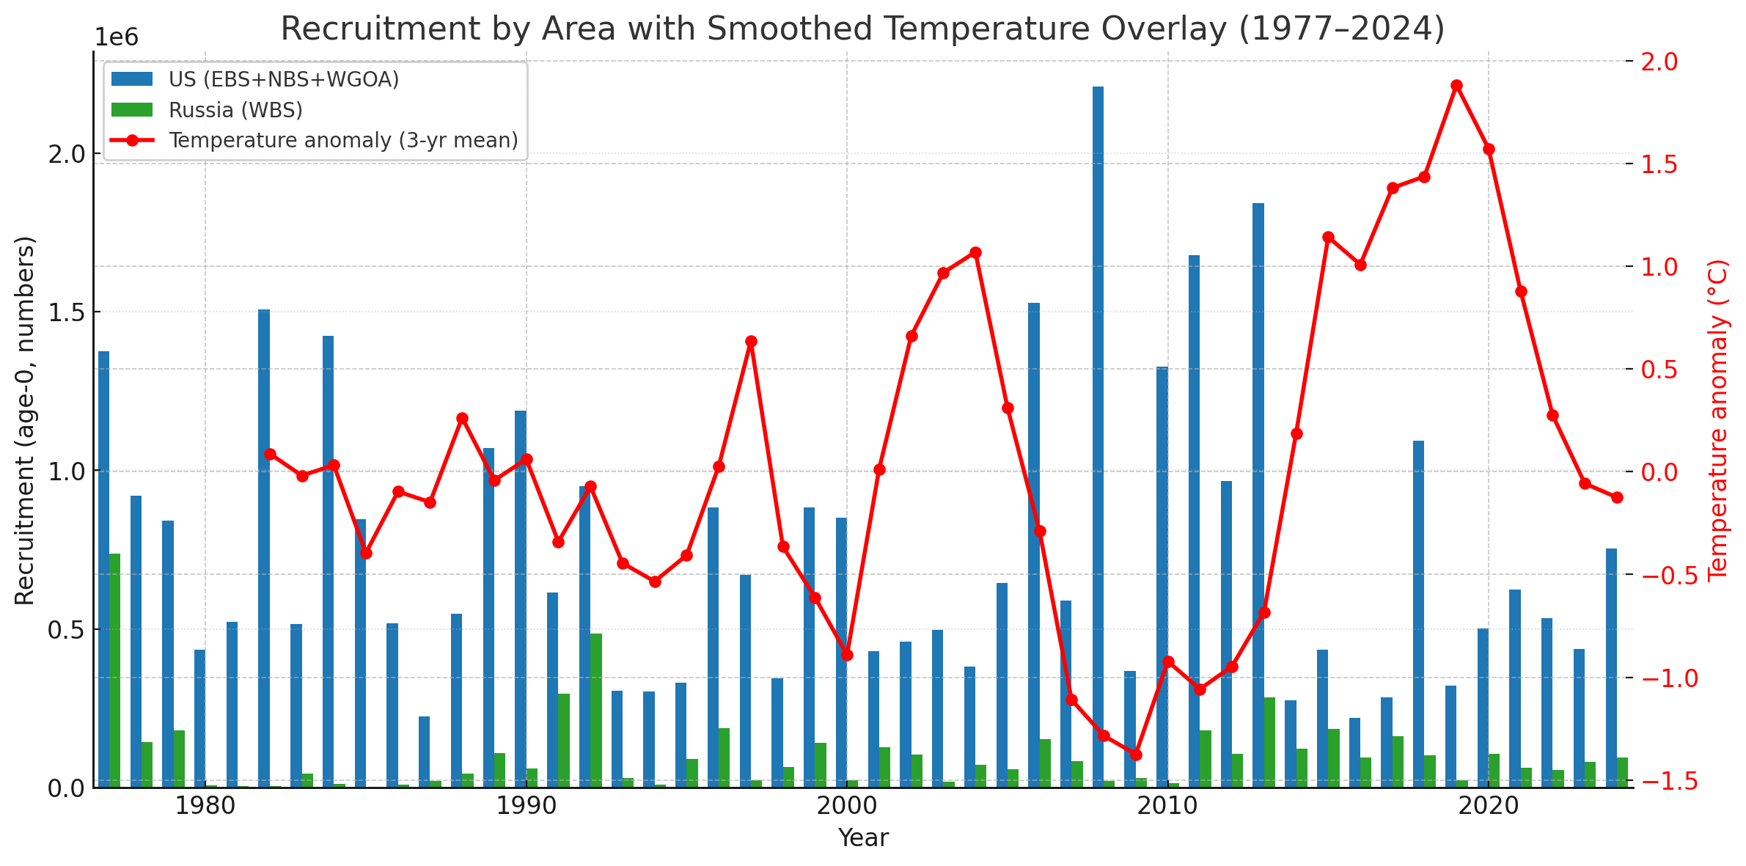

Figure Recruitment for Pacific cod at age-0 for area 1 (EBS,NBS, and WGOA) and Area 2 (WBS), overlaid with 3-year mean eastern Bering Sea bottom temperature anomalies.

## 3.6 Total Biomass and Spawning Biomass

Estimates from the two-area Stock Synthesis model show coherent but distinct biomass dynamics between the U.S. portion of the stock (Area 1: EBS+NBS+WGOA) and the Western Bering Sea (Area 2: WBS) (Fig. 13 and Fig. 14).

In Area 1 (U.S. regions), total biomass carried most of the stock’s abundance throughout the time series, reflecting its role as the stable core of the population. Biomass was high in the early–mid 1980s, declined through the 1990s–early 2000s, and rebounded strongly in the mid-2010s. At its peak, total biomass reached ~1.54 million t with spawning biomass near 0.88 million t. By 2024, these values had dropped to ~0.86 million t and ~0.49 million t, respectively, indicating a moderate decline from the mid-2010s plateau but still within the historical range (Fig. 13A–B, blue).

In contrast, Area 2 (WBS) contributed less biomass on average but showed sharp episodic booms and busts. Total biomass peaked near ~0.71 million t with spawning biomass ~0.44 million t in the late 2010s, rivaling levels in the U.S. regions during that same period. However, this high was short-lived: by 2024 biomass had collapsed to ~0.08 million t (spawning biomass ~0.04 million t). This pattern underscores the volatility of the WBS, which can contribute substantially in some years but is prone to steep declines that quickly reduce its influence on the transboundary stock.

When compared with environmental indicators, biomass and SSB trajectories appear to lag recruitment drivers. The biomass highs of the mid-to-late 2010s occurred during warm bottom temperature anomalies, yet recruitment analyses (Section 3.5; Fig. 14) showed that strong year classes were associated with cooler conditions and expanded cold pools. This apparent paradox is explained by cohort dynamics: strong year classes formed during cool periods earlier in the decade subsequently elevated biomass several years later, even as ocean temperatures shifted warmer. In other words, recruitment is most directly tied to cold pool dynamics, while biomass integrates those signals with a delay.

Uncertainty in growth parameters (Section 3.4) further complicates interpretation, especially in the WBS. Smaller asymptotic length estimates and wide confidence intervals reduce the ability of the model to resolve year-class strength in the WBS, which inflates uncertainty in recruitment and, by extension, in biomass trajectories. Thus, while Area 1 provides the stable backbone of the population, Area 2’s contribution is both episodic and less precisely estimated, amplifying the challenge of capturing true transboundary dynamics.

Together, these results demonstrate that biomass dynamics of Pacific cod in the Bering Sea are shaped by three interacting processes: the stable but variable core contribution from U.S. regions, the episodic and volatile booms and busts in the WBS, and the lagged propagation of environmentally driven recruitment into biomass trends, with additional uncertainty introduced by poorly constrained growth in the WBS.

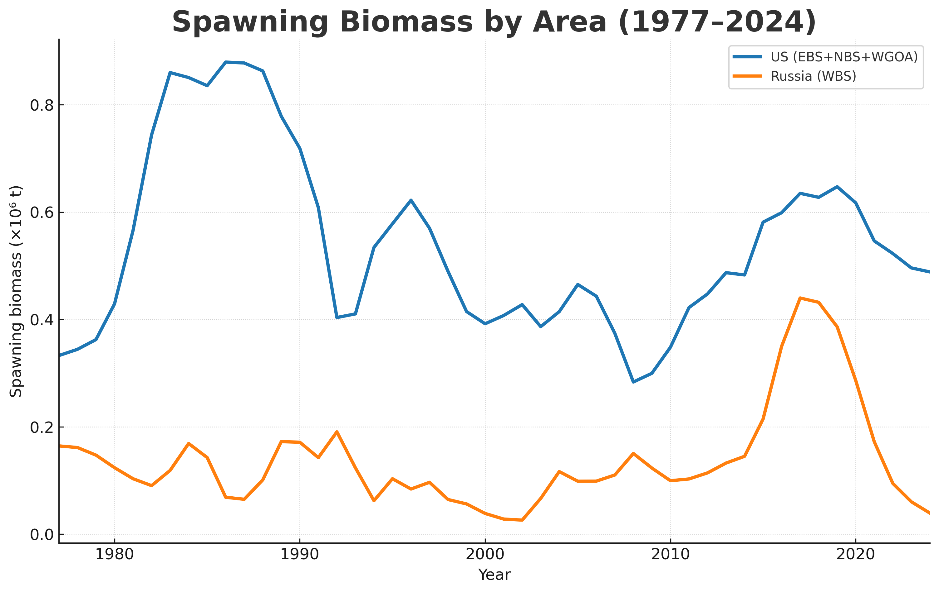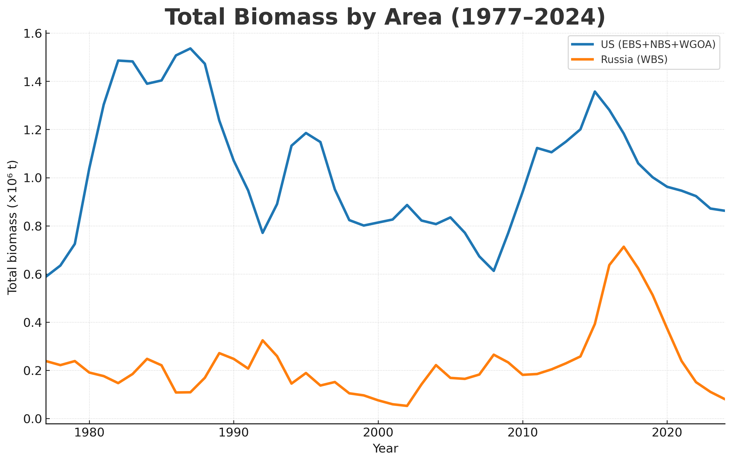

Figure A) Spawning biomass by area (1977–2024) and B) Total biomass by area (1977–2024): Area 1 (blue) and Area 2 (orange).

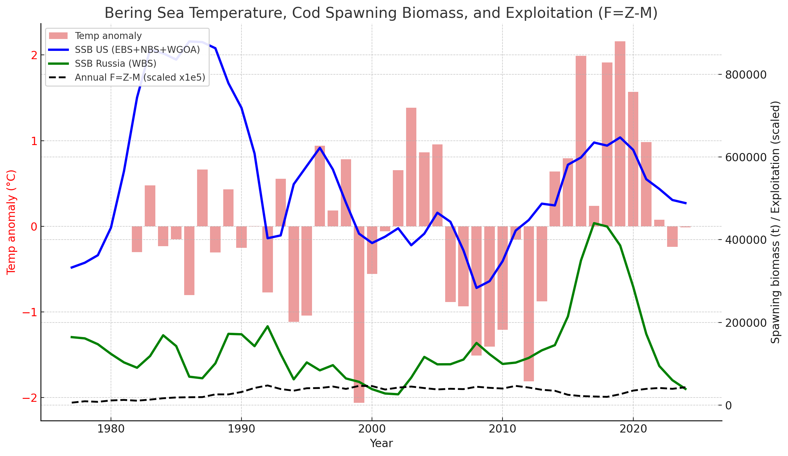

Figure Bering Sea bottom temperature anomalies (bars), SSB by area (lines), and annual exploitation (F = Z–M, dashed; scaled) to illustrate broad coherence and lags between environment, recruitment, and biomass

## 3.7 Exploitation

Annual fishing mortality (F = Z–M) from the two-area model exhibited strong temporal variability, with distinct contrasts between U.S. and Russian fisheries . Exploitation peaked during the 1980s in both regions but subsequently diverged under modern management. U.S. exploitation rates declined and then stabilized at moderate levels, consistent with precautionary harvest strategies, while the WBS (Russia) experienced sharper fluctuations and periods of substantially higher F.

Area-specific exploitation rates underscored these differences. U.S. fisheries (EBS, NBS, WGOA) operated within relatively moderate bounds throughout the time series, with annual F values typically ranging between 0.2 and 0.5, and only occasional excursions above 0.6. In contrast, the Russian fishery showed much greater interannual variability, with sharp spikes in F exceeding 1.0 in some years. This volatility is consistent with less stable management and greater dependence on short-term catch opportunities.

Fishery-specific exploitation rates (Figure 15) highlighted the relative smoothness of U.S. sectors compared to the Russian fleet. The GOA fishery contributed minimally to overall mortality, while EBS/NBS exploitation dominated the U.S. side. By comparison, the Russian fishery not only fluctuated more strongly but also exerted periods of disproportionately high exploitation pressure relative to local biomass.

Catch versus biomass plots revealed expected density-dependent patterns, with catch increasing with biomass up to a threshold and then declining as biomass fell (Figure 16). The U.S. system showed clearer compensation, while Russian catch levels often occurred at lower biomass levels, reflecting more aggressive harvest relative to stock size.

Exploratory Schaefer surplus production fits provided indicative estimates of maximum sustainable yield (MSY) and the corresponding biomass reference points (BMSY) (Figures 17-18). These results suggest that U.S. fisheries operated closer to sustainable reference levels, with BMSY estimated near 1.2 million t and CMSY near 200 kt. In contrast, the WBS showed a much lower BMSY (0.38–0.52 million t) and CMSY (55–60 kt), consistent with a smaller, more variable stock. Importantly, these fits are intended as comparative diagnostics rather than formal reference points, but they highlight the contrast in stock productivity and exploitation dynamics across regions.

Linking these exploitation dynamics back to biomass and recruitment trends (Section 3.6) reveals important interactions. Periods of high fishing mortality in both regions often coincided with unfavorable environmental conditions (e.g., warm anomalies reducing cod distribution and recruitment success), amplifying biomass declines. Conversely, rebuilding periods in the U.S. were supported not only by reduced exploitation but also by favorable recruitment pulses linked to cooler conditions. In the WBS, however, the combination of high exploitation variability and lower, more uncertain recruitment appears to have constrained recovery potential, leading to sharper boom–bust cycles.

Uncertainty in WBS growth parameters (Section 3.4) compounds this problem. Because smaller asymptotic size and wide confidence intervals reduce the model’s ability to clearly distinguish year classes, estimates of recruitment and movement between regions are less precise. This uncertainty cascades into exploitation estimates: when recruitment strength is poorly resolved, the perceived productivity of the WBS stock can shift dramatically, resulting in more volatile estimates of sustainable harvest. Thus, growth uncertainty amplifies the already greater variability in estimates of WBS exploitation, limiting confidence in the stability of management strategies for the western region.

Together, these analyses emphasize that while U.S. exploitation has remained relatively stable and within bounds consistent with sustainable yield, Russian exploitation appears more volatile and has at times potentially exceeded levels inferred to be sustainable. The contrasting exploitation histories provide important context for interpreting differences in recruitment, biomass trajectories, and environmental responses across the two regions, underscoring the need for coordinated transboundary management.

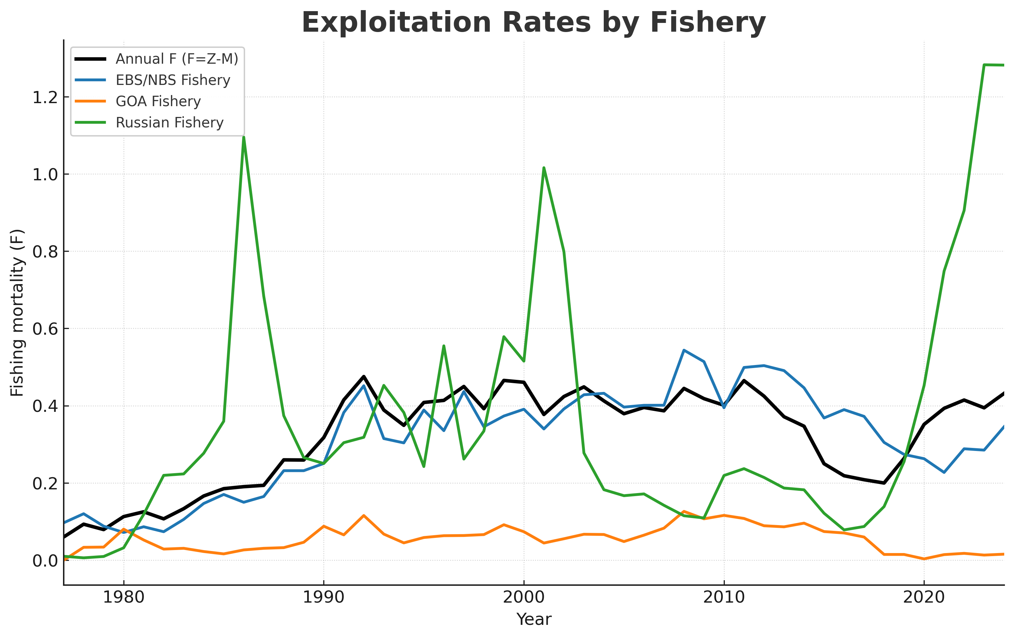

Figure Exploitation rates (F=Z-M) by fishery (EBS/NBS, GOA, Russian)

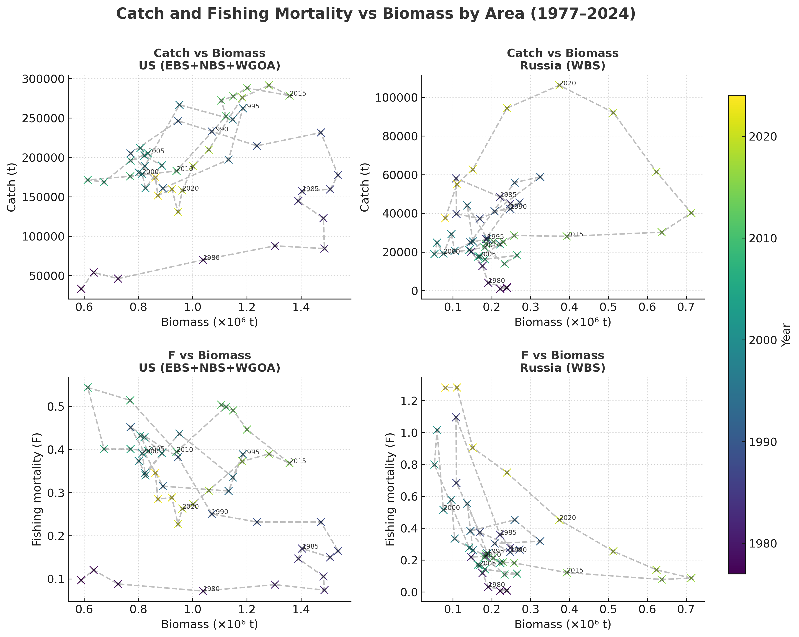

Figure Catch (top) and fishing mortality (bottom) versus total biomass by area (U.S. vs. WBS).

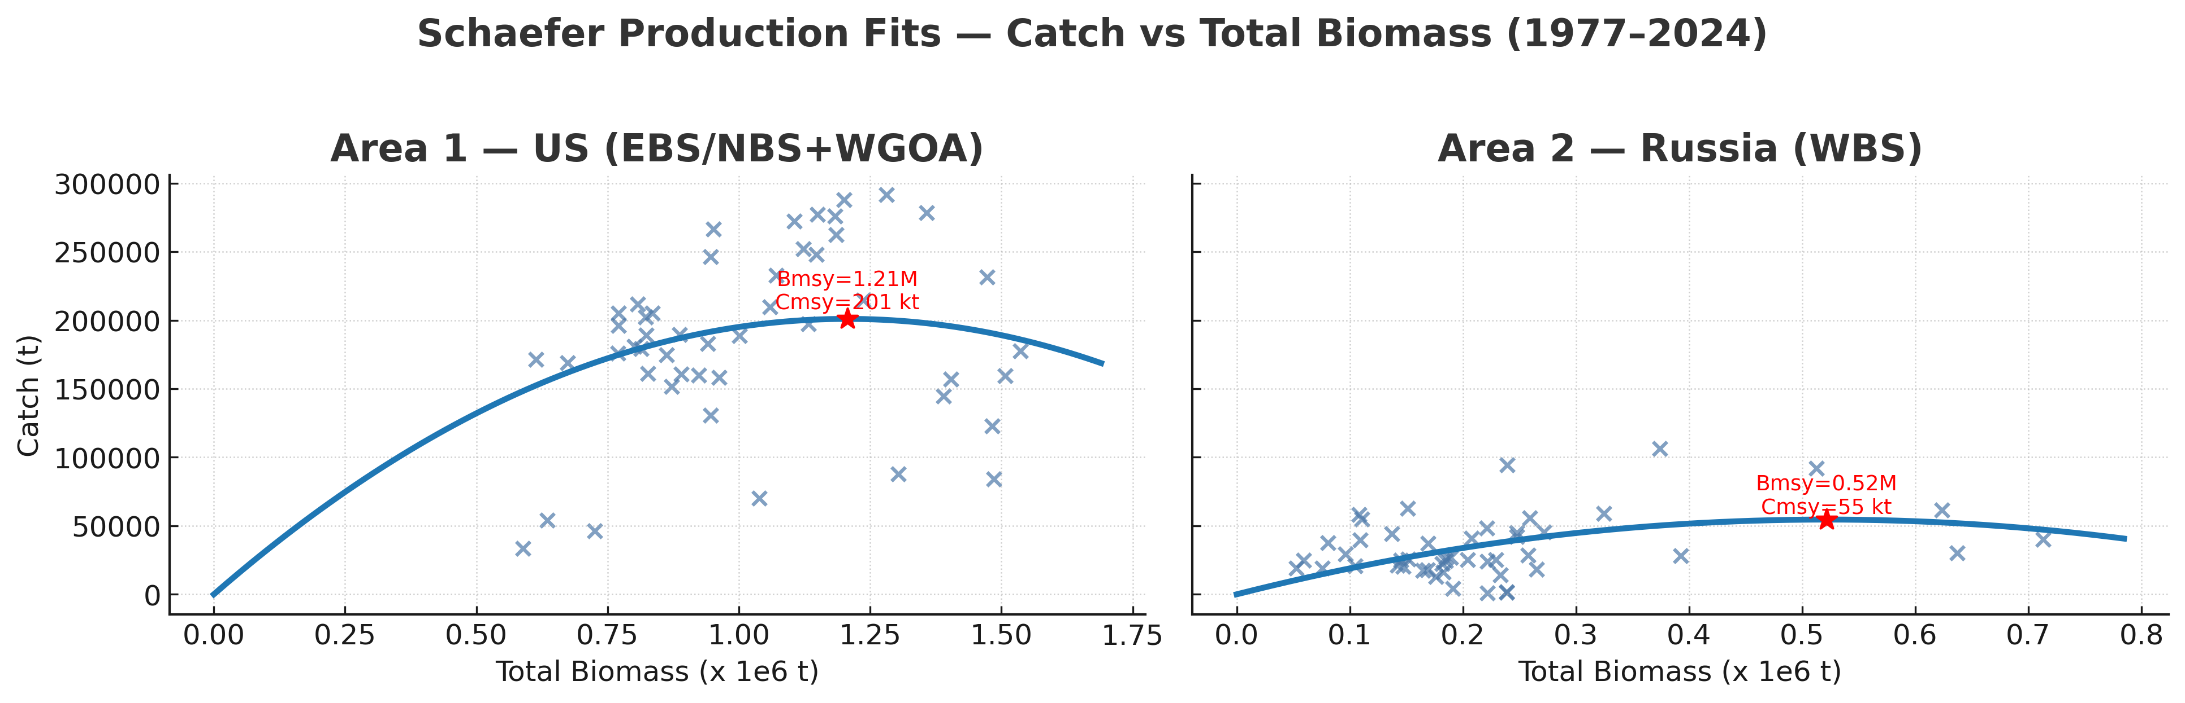

Figure Schaefer production fits for U.S. and WBS regions, showing estimated B_MSY and C_MSY based on total biomass.

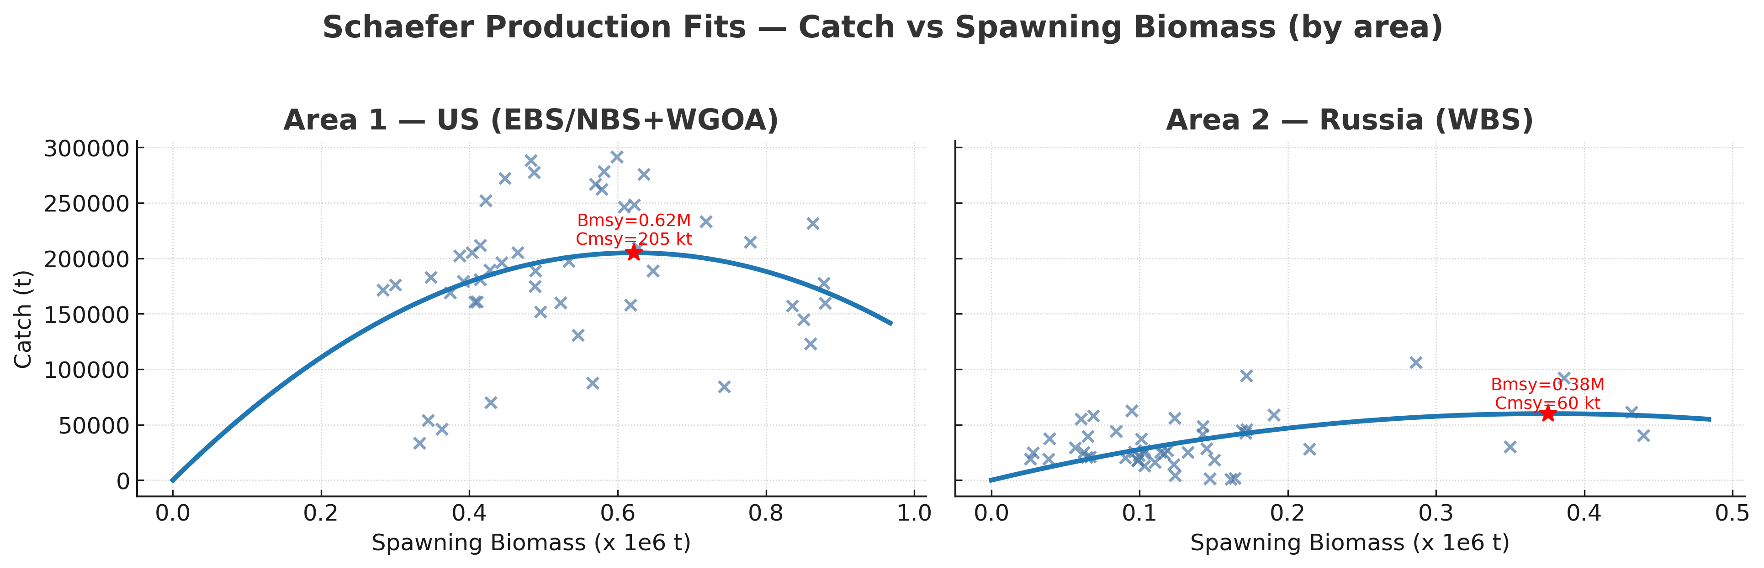

Figure Schaefer production fits for U.S. and WBS regions, showing estimated BMSY and CMSY based on spawning biomass.

## 3.8 Movement

The two-area Stock Synthesis model estimated substantial inter-regional movement of age-3+ Pacific cod between U.S. (EBS/NBS+WGOA) and Russian (WBS) regions. Outbound transfers from the U.S. into the WBS dominated the dynamics, while reverse flows from the WBS into U.S. waters were comparatively minor (Fig. 19).

Time series of estimated flows (Fig. 19, top) highlight peaks in movement from the U.S. to the WBS during the mid-1980s and again in the early 2010s, exceeding 400–500 thousand t in some years. Transfers within U.S. subareas (EBS/NBS+WGOA internal exchanges) were smaller, and flows originating from the WBS were minimal. The net movement series (Fig. 19, bottom) confirms that the WBS consistently functioned as a net recipient, with inflows dominating throughout the modeled period.

Correlation analyses reinforce this asymmetric relationship. U.S. biomass was strongly correlated with movement into the WBS (r ≈ 0.92), indicating that emigration is primarily driven by the availability of biomass in U.S. regions (Fig. 20). By contrast, WBS biomass showed almost no correlation with inflows (r ≈ 0.06), underscoring its role as a sink rather than a driver of immigration. Conversely, the smaller return flows from the WBS back into the U.S. were positively associated with WBS biomass (r ≈ 0.71), suggesting that export from the WBS only occurs when local biomass is relatively abundant (Fig. 20). Net flow was therefore almost entirely determined by U.S. biomass levels (r ≈ 0.92), with WBS biomass playing little role.

The relationship between biomass and movement is further illustrated in Fig. X, which shows total biomass trends in both regions alongside movement responses. Inflows to the WBS increased sharply when U.S. biomass was high, while return flows from the WBS were only observed when WBS biomass reached elevated levels. Net flow tracked U.S. biomass closely, confirming the WBS’s role as a consistent sink sustained by immigration. These results highlight that biomass levels are the primary determinant of connectivity between regions, with U.S. stock size driving the majority of exchange.

When environmental variables were evaluated separately, results suggested that biomass remains the dominant driver of movement, with limited additional signal from climate indicators. For U.S. outflows into the WBS, neither cold pool extent nor bottom temperature were significant predictors when tested individually, confirming that movement in this direction is almost entirely explained by U.S. biomass availability. For return flows from the WBS into the U.S., both cold pool extent and temperature were marginally significant (p ≈ 0.04–0.05), hinting that environmental variability may weakly influence export when WBS biomass is relatively high. For net flow, neither environmental variable added explanatory power beyond biomass, reinforcing that inter-area connectivity is primarily biomass-driven (Fig. 20).

Despite these patterns, it is important to emphasize that movement estimates are highly uncertain. As detailed in Section 3.4, WBS growth parameters were estimated with wide confidence intervals, reducing the ability of the model to clearly resolve size-at-age and year-class structure. This uncertainty propagates directly into recruitment attribution and, in turn, into estimates of inter-area movement. The apparent dominance of U.S. outflow into the WBS is a robust qualitative result, but the precise magnitude of transfers is less certain, and could shift as additional age–length data from the WBS are incorporated.

Finally, movement dynamics have important implications for exploitation (Section 3.7). Inflows of biomass into the WBS increase local availability to Russian fisheries, meaning that high exploitation in the WBS may in part reflect immigration from U.S. regions rather than local production. This underscores the transboundary nature of Pacific cod management and the need for caution: exploitation strategies in one region directly affect the availability of fish in the other, and movement estimates remain sensitive to underlying growth and recruitment assumptions.

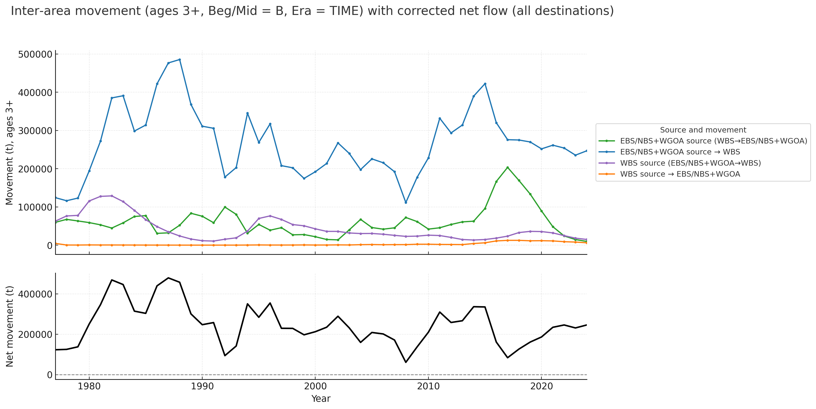

Figure Movement of age-3+ Pacific cod between U.S. and WBS regions estimated by the two-area model.

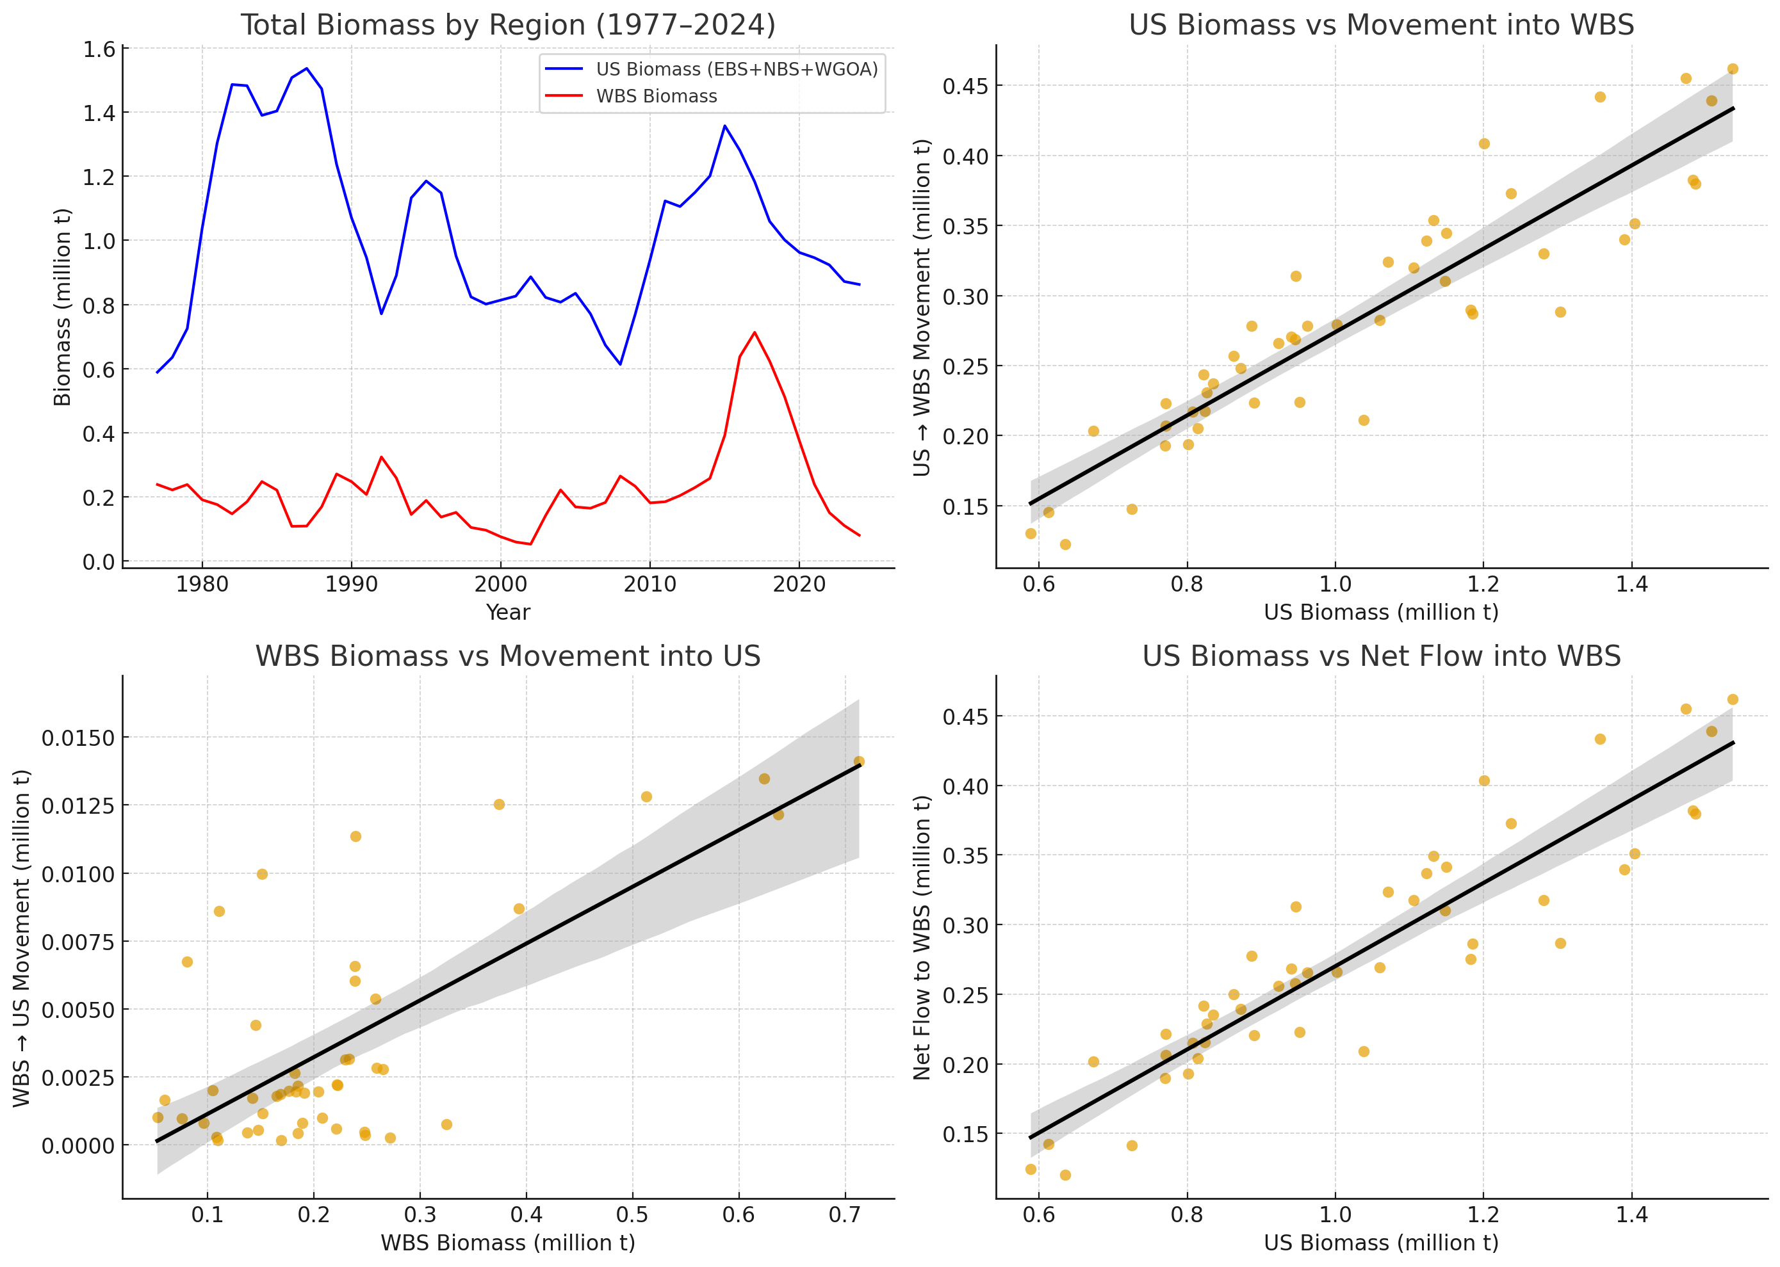

Figure Relationships between biomass and inter-area movement of Pacific cod in the two-area Stock Synthesis model (1977–2024). Top-left: time series of total biomass for the U.S. (EBS+NBS+WGOA) and WBS regions. Top-right: positive relationship between U.S. biomass and movement into the WBS, indicating that outflow is primarily driven by U.S. stock size. Bottom-left: relationship between WBS biomass and return movement into U.S. regions, which occurs only when WBS biomass is relatively high. Bottom-right: net flow into the WBS as a function of U.S. biomass, confirming that the WBS acts as a net recipient area throughout the time series.

# 4. Discussion

## 4.1 Growth, Recruitment, and Uncertainty

Our two-area assessment revealed clear biological contrasts between U.S. (EBS/NBS+WGOA) and Russian (WBS) regions, but also highlighted substantial uncertainty in parameter estimation. Growth parameters for U.S. Pacific cod were estimated with relatively narrow confidence intervals, indicating well-constrained asymptotic lengths and growth rates. By contrast, WBS cod showed smaller asymptotic sizes but with wide uncertainty ranges, and the LAmin parameter had to be fixed to achieve model stability. This disparity reflects the limited availability of WBS age–length data, which constrains the model’s ability to resolve size-at-age patterns. The resulting uncertainty propagates through multiple components of the assessment: weakly defined growth reduces the capacity to distinguish year classes, which in turn limits recruitment estimation and complicates inference on movement between regions. Improving WBS growth characterization through new survey and fishery sampling of age–length data should therefore be a top priority for future transboundary assessments.

Recruitment dynamics further underscored these challenges. While broad patterns were captured, year-class strength in the WBS was estimated with wide uncertainty bands compared to U.S. regions. Moreover, the sensitivity of recruitment estimates to growth assumptions means that regional contrasts in productivity remain difficult to quantify with precision. This finding reinforces the importance of improving data inputs from the WBS and highlights the cascading effect of growth uncertainty on recruitment, movement, and ultimately management advice.

## 4.2 Environmental Forcing and Biomass Dynamics

Environmental forcing emerged as a key driver of recruitment and biomass trends. Recruitment in both areas was positively correlated with cold pool extent and negatively associated with bottom temperature anomalies, suggesting that cooler conditions favor cod productivity. These relationships persisted when smoothed over three-year windows, consistent with cod life history and the timing of age-0 to age-2 survival bottlenecks. Biomass and spawning stock biomass (SSB) trajectories reflected these recruitment–environment linkages: major biomass peaks in the early 1980s, mid-2000s, and early 2010s coincided with periods of expanded cold pool extent. Conversely, recent declines in biomass across both U.S. and WBS regions occurred alongside successive warm years with contracted cold pools.

These results highlight that environmental variability does not act uniformly across the stock complex. In the NBS, recruitment pulses were strongly tied to cold years, while in the WBS, responses were more muted and uncertain. Nonetheless, at the aggregate scale, both regions displayed synchronous declines following recent warming events. Incorporating environmental covariates directly into future stock assessment models may therefore improve predictive skill, particularly given the likelihood of continued climate variability in the Bering Sea.

## 4.3 Exploitation, Movement, and Transboundary Management

Exploitation dynamics differed markedly between regions. U.S. fisheries exhibited relatively stable exploitation rates under modern management, with F values declining from high levels in the 1980s to sustainable levels in recent decades. By contrast, the Russian WBS fishery displayed sharper fluctuations and higher interannual variability, reflecting both local biomass changes and greater sensitivity to immigration from U.S. regions. Schaefer surplus production analyses supported these differences, with exploitation in the WBS more variable relative to estimated biomass trajectories.

Movement dynamics provided critical context for these exploitation patterns. The two-area model estimated substantial transfers of biomass from U.S. regions into the WBS, particularly during the mid-1980s and early 2010s, with the WBS functioning consistently as a net recipient. Regression analyses demonstrated that U.S. biomass was the primary driver of these inflows, while return flows from the WBS into U.S. regions occurred only when WBS biomass was relatively high. Environmental conditions, when considered separately, provided limited additional explanatory power, though marginal effects of cold pool and temperature were detected for return flows. These findings imply that immigration into the WBS largely reflects U.S. stock size rather than local WBS productivity, and that high exploitation in the WBS may partially reflect harvest of immigrants from U.S. waters.

Uncertainty must temper these conclusions. As discussed above, WBS growth and recruitment are weakly constrained, meaning that movement estimates—particularly their magnitude—carry substantial uncertainty. Nevertheless, the qualitative conclusion that the WBS is sustained by connectivity from U.S. regions is robust across model variants.

From a management perspective, these results underscore the transboundary nature of Pacific cod in the Bering Sea. Effective stewardship cannot be achieved in isolation: exploitation in one region directly affects availability in the other. The inclusion of Russian data in this analysis was critical for revealing these dynamics, and expanded collaboration will be necessary to refine movement, growth, and recruitment estimates. Joint survey design, shared biological sampling, and harmonized assessment methods represent clear pathways to improve the quality of future transboundary stock assessments.

# 5. Conclusion

# This study represents the first integrated two-area assessment of Pacific cod across U.S. (EBS/NBS+WGOA) and Russian (WBS) regions, combining model-based indices from U.S. and Russian surveys with a two-area Stock Synthesis framework. Several conclusions emerge:

# Utility of transboundary indices. Incorporating Russian survey data into spatiotemporal sdmTMB models provided a more complete representation of Pacific cod biomass, particularly in the WBS where no U.S. surveys are available. While inclusion of Russian data had little effect on U.S. indices, it was essential for capturing WBS dynamics and constraining overall stock trends.

# Growth and recruitment uncertainty. A central limitation of this assessment is the absence of age–length data from Russian surveys and fisheries. While U.S. survey data provided strong constraints on growth and recruitment processes, WBS estimates were far more uncertain. Growth parameters for WBS cod were estimated with wide confidence intervals, and the LAmin parameter had to be fixed for stability. This uncertainty propagated directly into recruitment estimates, reducing the model’s ability to resolve year-class strength and obscuring whether observed WBS biomass peaks were due to local production or immigration. It also limited the reliability of movement estimates between regions, since recruitment attribution is a critical determinant of inferred connectivity. Expanding biological samples from the WBS—particularly length-at-age data—remains a top priority for reducing uncertainty in transboundary stock assessments.

# Environmental forcing. Recruitment was positively related to cold pool extent and negatively to bottom temperature anomalies, indicating that cooler conditions favor cod productivity. Biomass peaks corresponded with cold periods, while recent warming has coincided with stock declines. Environmental covariates should be considered in future model development to improve forecasting skill.

# Exploitation contrasts. Exploitation rates were stable in U.S. regions under modern management but more variable in the WBS, where catches appear strongly influenced by immigration from U.S. regions. This asymmetry highlights the need for cautious interpretation of WBS fishery yields, as local harvests may rely on imported biomass.

# Movement and transboundary connectivity. The two-area model indicated that the WBS functions primarily as a net recipient of Pacific cod, with inflows strongly driven by U.S. biomass. Although this qualitative conclusion appears robust, the quantitative magnitude of flows is highly uncertain because of weak growth and recruitment information in the WBS. Improved biological sampling would greatly enhance the ability to distinguish local production from immigration, reducing uncertainty in both exploitation and movement dynamics.

# Together, these results emphasize the transboundary nature of Pacific cod in the Bering Sea. Effective management will require continued U.S.–Russian collaboration to improve data collection, refine growth and recruitment estimates, and develop harmonized assessment approaches that explicitly account for inter-area connectivity and the uncertainty that stems from current data limitations.

# 6.0 References

Anderson, S.C., Ward, E.J., English, P.A., Barnett, L.A.K., and Tinker, M.T. 2022. sdmTMB: An R package for fast, flexible, and user-friendly generalized linear mixed effects models with spatial and spatiotemporal random fields. Methods in Ecology and Evolution, 13(1), pp.215–220. <https://doi.org/10.1111/2041-210X.13701>

Barbeaux, S.J., Barnett, L. Hulson, P., Nielsen, J., Shotwell, S.K., Siddon, E., Spies, I. Assessment of the Pacific Cod Stock in the Eastern Bering Sea. *In* Plan Team for the Groundfish Fisheries of the Bering Sea/Aleutian Islands (compiler), Stock assessment and fishery evaluation report for the groundfish resources of the Bering Sea/Aleutian Islands regions, p. 1-149. North Pacific Fishery Management Council, 605 W. 4th Avenue Suite 306, Anchorage, AK 99501 Available: <https://www.npfmc.org/wp-content/PDFdocuments/SAFE/2024/EBSpcod.pdf>

Dunn, P.K. and Smyth, G.K. 1996. Randomized quantile residuals. Journal of Computational and Graphical Statistics, 5(3), pp.236–244.

Hartig, F. 2021. DHARMa: Residual diagnostics for hierarchical (multi-level/mixed) regression models. R package version 0.4.5. Available at: https://cran.r-project.org/package=DHARMa

Kulik, A.B., Savin, A.B., Maltsev I.V., Bezrukov, R.G., Korneichuk, I.A. 2025. Индекс биомассы трески в Западно-Беринговоморской зоне с учётом придонной температуры с 1977 по 2024 гг. [Index of Pacific cod biomass in the Western Bering Sea zone accounting for bottom temperature, 1977–2024]. TINRO, Vladivostok.

Nielsen, J.K., McDermott, S.S., Rand, K.M., Dawson, E., Bryan, D.R., Britt, L.L., Kotwicki, S. and Nichol, D., 2025. Insights into the northward shift of Pacific cod in warming Bering Sea waters from pop-up satellite archival tags. Canadian Journal of Fisheries and Aquatic Sciences. Just-IN <https://doi.org/10.1139/cjfas-2024-0342>

O’Leary, C.A., Thorson, J.T., Ianelli, J.N., and Kotwicki, S. 2020. Model-based indices from delta-GLMMs improve the precision of eastern Bering Sea pollock stock assessment estimates. ICES Journal of Marine Science, 77(3), pp.939–952.

Rohan, S., Kotwicki, S., and Rooper, C. 2023. coldpool: Tools for cold pool extent calculation and visualization. R package. Available at: https://github.com/afsc-gap-products/coldpool

Spies, I., Tarpey, C., Kristiansen, T., Fisher, M., Rohan, S. and Hauser, L., 2022. Genomic differentiation in Pacific cod using P ool‐S eq. Evolutionary Applications, 15(11), pp.1907-1924.

Thorson, J.T. 2018. Three problems with the conventional delta-model for biomass sampling data, and a computationally efficient alternative. Canadian Journal of Fisheries and Aquatic Sciences, 75(9), pp.1369–1382.

Thorson, J.T. 2019. Guidance for decisions using the Vector Autoregressive Spatio-Temporal (VAST) package in stock assessment. Fisheries Research, 210, pp.143–161.

Thorson, J.T. and Kristensen, K. 2016. Implementing a generic method for bias correction in statistical models using random effects, with spatial and population dynamics examples. Fisheries Research, 175, pp.66–74.

Zuenko, Y.I., Savin, A.B., Basyuk, E.O. 2025. Influence of climatic variability on Pacific cod distribution in the western Bering Sea. Journal of Ichthyology, 65(1), pp.1–16.

# Appendix 1: sdmTMB model description

sdmTMB formulation:

mesh_all <- make_mesh(d3, xy_cols=c("X","Y"), type="cutoff_search", n_knots=300)

bm_all <- add_barrier_mesh(spde_obj=mesh_all,

barrier_sf=sf::st_transform(sf::st_read("shapes/Russian_US_MESH.shp"), 32603),

range_fraction=0.2, proj_scaling=1000, plot=FALSE)

ctrl <- sdmTMBcontrol()

fit_all <- sdmTMB(

cpuew ~ 0 + nation + year_scaled + s(depth_scaled, by=survey_name2),

spatial_varying = ~ cold_scaled + survey_name2,

data = d3, mesh = bm_all, family = tweedie(),

time = "year", spatial = "on", spatiotemporal = "ar1",

extra_time = 2020L, anisotropy = FALSE, silent = TRUE, control = ctrl)

## Data, response, and distribution

The response variable was biomass catch-per-unit-effort standardized by tow area (cpuew). A Tweedie distribution with a log link was specified to accommodate the continuous, non-negative nature of the data and to handle the large proportion of zero catches typical of trawl survey observations.

Let *y*s,t​ denote biomass catch-per-unit-effort standardized by tow area (“cpuew”) observed at spatial location sss and year ttt.

* **Likelihood:** Tweedie compound Poisson–Gamma with log link:

$y_{s,t}\sim Tweedie\left(μ_{s,t},p,ɸ\right), { ɳ}_{s,t}=log\left(μ_{s,t}\right)$.

Here *p* ∈(1,2) is the Tweedie index parameter and ϕ >0 is the dispersion. This choice accommodates continuous, non-negative data with many zeros typical of trawl CPUE.

* **Indexing & time:** time = "year"; annual time steps indexed by integer *t*. An additional “dummy” step is specified via extra_time = 2020L for stable AR(1) initialization as Eastern Bering Sea survey data were unavailable for 2020.

## Linear predictor (fixed effects & smooths)

The fixed effects included a factor for nation (U.S. vs. Russia), a linear time trend on a standardized year covariate, and smooth survey-specific effects of depth. This structure accounted for broad temporal trends and allowed depth–biomass relationships to differ by survey program.

The fixed-effects portion of the linear predictor matches the formula:

cpuew ~ 0 + nation + year_scaled + s(depth_scaled, by = survey_name2)

so that

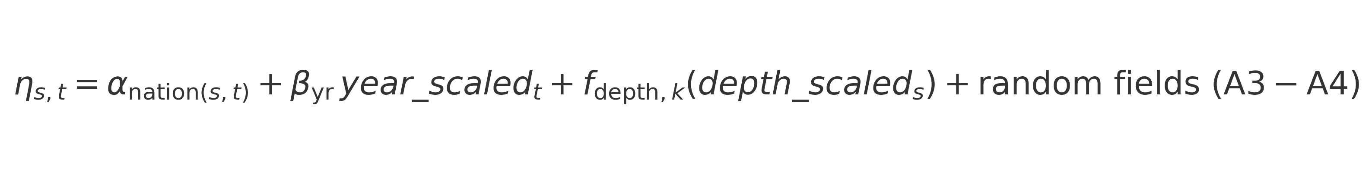

* nation is a **no-intercept** factor (the 0 + removes the global intercept), estimating separate intercepts for U.S. vs. Russia.
* year_scaled is a centered/scaled continuous covariate giving a linear temporal trend.
* s(depth_scaled, by = survey_name2) is a thin-plate spline–type smooth of (centered/scaled) depth with **survey-specific** coefficients, allowing different depth–biomass relationships by survey program (e.g., EBS/NBS/WGOA vs. WBS).

## Spatially varying coefficients

Spatially varying coefficients (SVC) were specified for cold pool extent and survey program. These fields allow the effect of cold pool variability and survey-specific differences to vary geographically, improving fit across heterogeneous designs.

The call

spatial_varying = ~ cold_scaled + survey_name2

adds spatially varying coefficients for the listed covariates, implemented as independent spatial Gaussian random fields that modulate their effects over space:

$$ɳ_{s,t}←ɳ_{s,t}+b_{cold}\left(s\right){cold_scale}_{t}+b_{suvey=k}\left(s\right)$$

* cold_scaled (annual, centered/scaled) enters with a spatially varying slope bcold(s), allowing the cold-pool effect to differ geographically (e.g., stronger in shelf areas influenced by the cold pool).
* survey_name2 as an SVC produces survey-specific spatial offsets bsurvey=k(s), capturing spatial differences in effective catchability/design between survey programs beyond constant intercept shifts. Together with the survey-specific depth smooths, this helps reconcile heterogeneous designs while pooling strength.

Each SVC field follows a Matérn SPDE on the same mesh, independent of ωs and ϵs,t ​.

## Barrier SPDE mesh and spatial domain

A two-stage mesh is built and then converted to a **barrier** mesh to prevent spurious correlation across land and political boundaries:

mesh_all <- make_mesh(d3, xy_cols = c("X","Y"),

type = "cutoff_search", n_knots = 300)

bm_all <- add_barrier_mesh2(

spde_obj = mesh_all,

barrier_sf = sf::st_transform(

sf::st_read("shapes/Russian_US_MESH.shp"), 32603),

range_fraction = 0.2,

proj_scaling = 1000,

plot = FALSE)

* **Base mesh:** ~300 knots placed by k-means over sampled locations and prediction extent, balancing resolution and computational efficiency.
* **Barrier polygon:** read from Russian_US_MESH.shp, transformed to **EPSG:32603 (UTM Zone 3N)**; acts as an permiable boundary to correlation (ocean/land segmentation and jurisdictional cuts as encoded in the shapefile).
* **Tuning:** range_fraction = 0.2 and proj_scaling = 1000 set the relative thickness and numerical scaling of the barrier; these stabilize optimization while allowing realistic correlation decay around coasts and narrow passages.

**Note:** All spatial random fields (A3–A4) share this barrier geometry; this is crucial for transboundary applications so that correlation does not “leak” across the Alaska Peninsula, islands, or land barriers.

## Spatial & spatiotemporal random fields

The random‐effects structure is enabled via spatial = "on" and spatiotemporal = "ar1":

* **Spatial (time-invariant) Matérn field** ωs​ on the barrier mesh (A5).
* **Spatiotemporal AR(1) field**

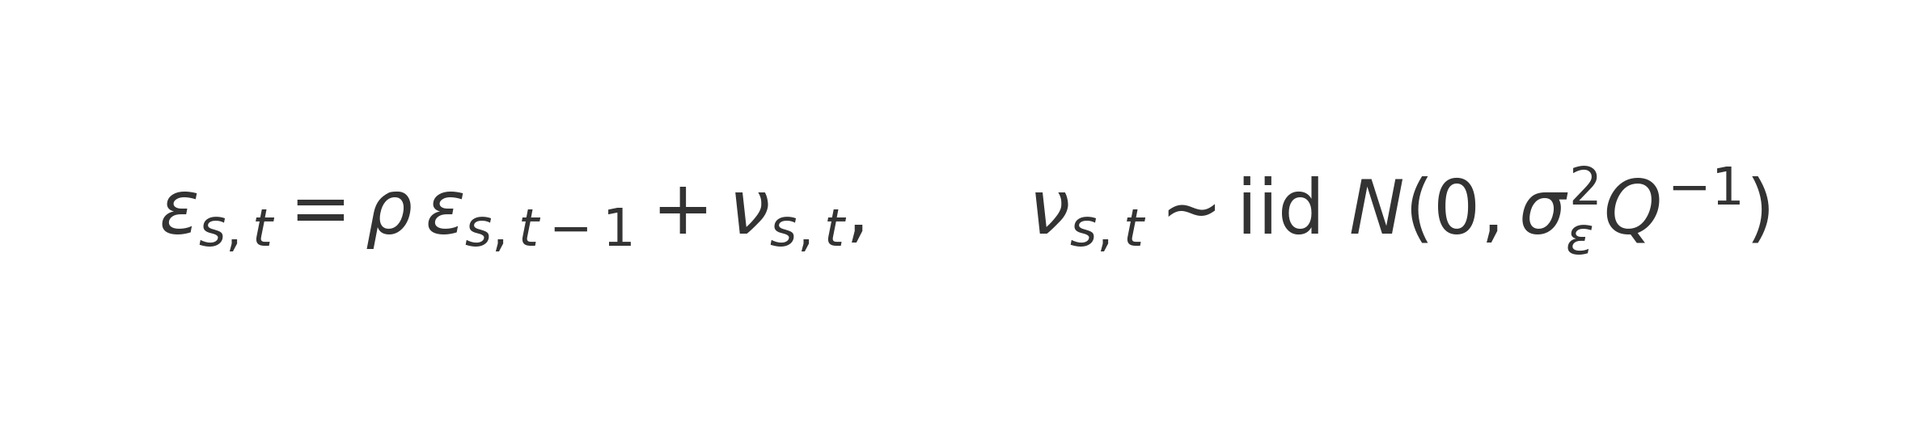

where *ρ* ∈ (−1,1) is estimated and Q is the SPDE precision induced by the mesh.

* **Isotropy:** anisotropy = FALSE implies an **isotropic** Matérn covariance (single range parameter per field; no directional stretching).

Thus, without spatially varying coefficients (below), the random-effect contribution is ωs+ϵs,t​.

## Prediction and biomass index construction

The fitted model was projected onto a 40 km grid covering the Bering Sea and Western Gulf of Alaska (20–300 m depth). Predictions incorporated cold pool and depth covariates. Biomass indices were computed as area-weighted sums of predicted densities, with uncertainty derived from the joint covariance of model parameters.

## Table A1. Model terms, interpretation, and rationale

|  |  |  |  |
| --- | --- | --- | --- |
| **Term / Setting** | **Description** | **Units / Scale** | **Rationale for inclusion** |
| Response (cpuew) | Biomass catch-per-unit-effort standardized by tow area | kg per hectare (or standardized unit) | Index of relative abundance from bottom trawl surveys |
| Distribution: Tweedie | Compound Poisson–Gamma, log link | – | Handles continuous, non-negative data with many zeros; efficient vs. delta-GLMM |
| Fixed effect: nation | Intercepts for U.S. vs. Russia | Factor (categorical) | Controls for systematic catchability / sampling program differences |
| Fixed effect: year_scaled | Linear trend in time | Continuous, scaled | Captures broad secular changes not explained by random fields |
| Smooth: s(depth_scaled, by=survey_name2) | Survey-specific smooth of depth | Scaled depth | Models differing depth–biomass relationships across surveys |
| SVC: cold_scaled | Spatially varying effect of cold pool extent | Annual, standardized anomaly | Allows cold-pool influence to vary geographically |
| SVC: survey_name2 | Survey-specific spatially varying offsets | Factor with spatial fields | Adjusts for spatial structure unique to each survey program |
| Spatial random field | Time-invariant spatial variation (Matérn) | – | Captures unmeasured habitat & persistent spatial patterns |
| Spatiotemporal AR(1) field | Year-to-year autocorrelated anomalies | – | Accounts for dynamic spatial shifts in cod distribution |
| Mesh | 300 knots, cutoff search, barrier mesh | UTM Zone 3N | Balanced resolution/computation; prevents cross-land correlation |
| Barrier mesh settings | Polygon barrier mesh with range_fraction=0.2, proj_scaling=1000 | – | Ensures biologically realistic correlation respecting coastlines |
| Anisotropy = FALSE | Isotropic Matérn covariance | – | Simplifies correlation structure; stable without directional patterns |
| Extra_time = 2020 | Additional time step beyond observed series | Year index | Stabilizes AR(1) estimation near time-series boundaries |
| Estimation framework | Laplace approximation via TMB | – | Efficient estimation of high-dimensional latent fields |

# Appendix 2: Stock Synthesis Data File

#V3.30.24.00-prerel;_safe;_compile_date:_Jul 8 2025;_Stock_Synthesis_by_Richard_Methot_(NOAA)_using_ADMB_13.2

#_Stock_Synthesis_is_a_work_of_the_U.S._Government_and_is_not_subject_to_copyright_protection_in_the_United_States.

#_Foreign_copyrights_may_apply._See_copyright.txt_for_more_information.

#_User_support_available_at:_https://groups.google.com/g/ss3-forum_and_NMFS.Stock.Synthesis@noaa.gov

#_User_info_available_at:_https://nmfs-ost.github.io/ss3-website/

#_Source_code_at:_https://github.com/nmfs-ost/ss3-source-code

#_Start_time: Fri Aug 29 11:35:00 2025

#_echo_input_data

#C data file created using the SS_writedat function in the R package r4ss

#C file write time: 2022-03-07 17:04:05

#V3.30.24.00-prerel;_safe;_compile_date:_Jul 8 2025;_Stock_Synthesis_by_Richard_Methot_(NOAA)_using_ADMB_13.2

1977 #_StartYr

2024 #_EndYr

1 #_Nseas

12 #_months/season

2 #_Nsubseasons (even number, minimum is 2)

1 #_spawn_month

1 #_Nsexes: 1, 2, -1 (use -1 for 1 sex setup with SSB multiplied by female_frac parameter)

20 #_Nages=accumulator age, first age is always age 0

2 #_Nareas

5 #_Nfleets (including surveys)

#_fleet_type: 1=catch fleet; 2=bycatch only fleet; 3=survey; 4=predator(M2)

#_sample_timing: -1 for fishing fleet to use season-long catch-at-age for observations, or 1 to use observation month; (always 1 for surveys)

#_fleet_area: area the fleet/survey operates in

#_units of catch: 1=bio; 2=num (ignored for surveys; their units read later)

#_catch_mult: 0=no; 1=yes

#_rows are fleets

#_fleet_type fishery_timing area catch_units need_catch_mult fleetname

1 -1 1 1 0 fishery # 1

3 1 1 1 0 survey # 2

1 -1 2 1 0 russia # 3

1 -1 1 1 0 goa # 4

3 1 2 1 0 rus_surv # 5

#Bycatch_fleet_input_goes_next

#a: fleet index

#b: 1=include dead bycatch in total dead catch for F0.1 and MSY optimizations and forecast ABC; 2=omit from total catch for these purposes (but still include the mortality)

#c: 1=Fmult scales with other fleets; 2=bycatch F constant at input value; 3=bycatch F from range of years

#d: F or first year of range

#e: last year of range

#f: not used

# a b c d e f

#_Catch data: year, seas, fleet, catch, catch_se

#_catch_se: standard error of log(catch)

#_NOTE: catch data is ignored for survey fleets

-999 1 1 42500 0.01

1977 1 1 33335 0.01

1978 1 1 42543 0.01

1979 1 1 33761 0.01

1980 1 1 35058 0.01

1981 1 1 56507 0.01

1982 1 1 61104 0.01

1983 1 1 94801 0.01

1984 1 1 125103 0.01

1985 1 1 143447 0.01

1986 1 1 135605 0.01

1987 1 1 149903 0.01

1988 1 1 203071 0.01

1989 1 1 178323 0.01

1990 1 1 172067 0.01

1991 1 1 210241 0.01

1992 1 1 164210 0.01

1993 1 1 133186 0.01

1994 1 1 172263 0.01

1995 1 1 228498 0.01

1996 1 1 209067 0.01

1997 1 1 232601 0.01

1998 1 1 158529 0.01

1999 1 1 145867 0.01

2000 1 1 151376 0.01

2001 1 1 142542 0.01

2002 1 1 166555 0.01

2003 1 1 175443 0.01

2004 1 1 183748 0.01

2005 1 1 182940 0.01

2006 1 1 168818 0.01

2007 1 1 140129 0.01

2008 1 1 139802 0.01

2009 1 1 147174 0.01

2010 1 1 142844 0.01

2011 1 1 209201 0.01

2012 1 1 232623 0.01

2013 1 1 236691 0.01

2014 1 1 238718 0.01

2015 1 1 232829 0.01

2016 1 1 247620 0.01

2017 1 1 237851 0.01

2018 1 1 199867 0.01

2019 1 1 178904 0.01

2020 1 1 155665 0.01

2021 1 1 121749 0.01

2022 1 1 148810 0.01

2023 1 1 143541 0.01

2024 1 1 165659 0.01

-999 1 3 0 0.1

1977 1 3 1685 0.1

1978 1 3 994 0.1

1979 1 3 1464 0.1

1980 1 3 4090 0.1

1981 1 3 12797 0.1

1982 1 3 20233 0.1

1983 1 3 26729 0.1

1984 1 3 45058 0.1

1985 1 3 48513 0.1

1986 1 3 58049 0.1

1987 1 3 39745 0.1

1988 1 3 37250 0.1

1989 1 3 45590 0.1

1990 1 3 42308 0.1

1991 1 3 41064 0.1

1992 1 3 58860 0.1

1993 1 3 55920 0.1

1994 1 3 24998 0.1

1995 1 3 26795 0.1

1996 1 3 44100 0.1

1997 1 3 25476 0.1

1998 1 3 20639 0.1

1999 1 3 29230 0.1

2000 1 3 19179 0.1

2001 1 3 24846 0.1

2002 1 3 18919 0.1

2003 1 3 20992 0.1

2004 1 3 23988 0.1

2005 1 3 17769 0.1

2006 1 3 17631 0.1

2007 1 3 16239 0.1

2008 1 3 18312 0.1

2009 1 3 13993 0.1

2010 1 3 22423 0.1

2011 1 3 24358 0.1

2012 1 3 25360 0.1

2013 1 3 25250 0.1

2014 1 3 28530 0.1

2015 1 3 28130 0.1

2016 1 3 30240 0.1

2017 1 3 40220 0.1

2018 1 3 61450 0.1

2019 1 3 92090 0.1

2020 1 3 106200 0.1

2021 1 3 94400 0.1

2022 1 3 62700 0.1

2023 1 3 55011 0.1

2024 1 3 37499 0.1

-999 1 4 10000 0.1

1977 1 4 0 0.01

1978 1 4 11512.6 0.01

1979 1 4 12464.4 0.01

1980 1 4 34914 0.01

1981 1 4 31299.1 0.01

1982 1 4 23227.6 0.01

1983 1 4 28085.8 0.01

1984 1 4 19575 0.01

1985 1 4 13744.7 0.01

1986 1 4 23879.9 0.01

1987 1 4 27661.3 0.01

1988 1 4 28386 0.01

1989 1 4 36356.3 0.01

1990 1 4 60897.9 0.01

1991 1 4 36060.4 0.01

1992 1 4 40855.2 0.01

1993 1 4 27515.3 0.01

1994 1 4 24904.2 0.01

1995 1 4 33796.3 0.01

1996 1 4 39096.9 0.01

1997 1 4 34048.5 0.01

1998 1 4 30396.2 0.01

1999 1 4 35030 0.01

2000 1 4 27724.7 0.01

2001 1 4 18408.8 0.01

2002 1 4 23184.2 0.01

2003 1 4 26762.6 0.01

2004 1 4 27989.4 0.01

2005 1 4 22227.8 0.01

2006 1 4 27110.5 0.01

2007 1 4 28710.3 0.01

2008 1 4 31582 0.01

2009 1 4 28836.8 0.01

2010 1 4 39971.5 0.01

2011 1 4 42911.3 0.01

2012 1 4 39596.9 0.01

2013 1 4 40670.6 0.01

2014 1 4 49274.9 0.01

2015 1 4 45505.7 0.01

2016 1 4 43824.2 0.01

2017 1 4 38029.2 0.01

2018 1 4 9822.22 0.01

2019 1 4 9789.46 0.01

2020 1 4 2380.44 0.01

2021 1 4 9108.31 0.01

2022 1 4 11156 0.01

2023 1 4 8099.83 0.01

2024 1 4 9000 0.01

-9999 0 0 0 0

#

#_CPUE_and_surveyabundance_and_index_observations

#_units: 0=numbers; 1=biomass; 2=F; 30=spawnbio; 31=exp(recdev); 36=recdev; 32=spawnbio*recdev; 33=recruitment; 34=depletion(&see Qsetup); 35=parm_dev(&see Qsetup)

#_errtype: -1=normal; 0=lognormal; 1=lognormal with bias correction; >1=df for T-dist

#_SD_report: 0=not; 1=include survey expected value with se

#_note that link functions are specified in Q_setup section of control file

#_dataunits = 36 and 35 should use Q_type 5 to provide offset parameter

#_fleet units errtype SD_report

1 1 0 0 # fishery

2 1 0 1 # survey

3 1 0 0 # russia

4 1 0 0 # goa

5 1 0 1 # rus_surv

#_year month fleet obs stderr

1982 7 2 1.44826e+06 0.14249 #_ survey

1983 7 2 1.68198e+06 0.0834092 #_ survey

1984 7 2 1.37789e+06 0.0504494 #_ survey

1985 7 2 1.44957e+06 0.0753678 #_ survey

1986 7 2 1.39233e+06 0.069212 #_ survey

1987 7 2 1.30968e+06 0.0588699 #_ survey

1988 7 2 1.20642e+06 0.0725051 #_ survey

1989 7 2 1.1108e+06 0.077726 #_ survey

1990 7 2 1.07172e+06 0.0722821 #_ survey

1991 7 2 800477 0.106677 #_ survey

1992 7 2 851060 0.114325 #_ survey

1993 7 2 892322 0.0586131 #_ survey

1994 7 2 1.62297e+06 0.0750459 #_ survey

1995 7 2 1.34906e+06 0.103905 #_ survey

1996 7 2 1.17893e+06 0.0555024 #_ survey

1997 7 2 849330 0.100301 #_ survey

1998 7 2 773873 0.0965541 #_ survey

1999 7 2 776392 0.0595966 #_ survey

2000 7 2 719797 0.0862589 #_ survey

2001 7 2 959727 0.0534098 #_ survey

2002 7 2 780290 0.079311 #_ survey

2003 7 2 792588 0.073256 #_ survey

2004 7 2 778962 0.079258 #_ survey

2005 7 2 824243 0.0709274 #_ survey

2006 7 2 698134 0.085196 #_ survey

2007 7 2 669722 0.0719853 #_ survey

2008 7 2 725928 0.125887 #_ survey

2009 7 2 746915 0.0623688 #_ survey

2010 7 2 1.0316e+06 0.0937239 #_ survey

2011 7 2 1.16388e+06 0.0476218 #_ survey

2012 7 2 1.13226e+06 0.0935744 #_ survey

2013 7 2 1.08522e+06 0.0499968 #_ survey

2014 7 2 1.35987e+06 0.0736439 #_ survey

2015 7 2 1.32386e+06 0.0602177 #_ survey

2016 7 2 1.37289e+06 0.0918821 #_ survey

2017 7 2 1.01421e+06 0.047664 #_ survey

2018 7 2 1.0718e+06 0.0751395 #_ survey

2019 7 2 967540 0.0502711 #_ survey

2021 7 2 949424 0.0481395 #_ survey

2022 7 2 911852 0.0587706 #_ survey

2023 7 2 858233 0.0476774 #_ survey

2024 7 2 812235 0.0807115 #_ survey

1982 7 5 136132 0.100565 #_ rus_surv

1983 7 5 176100 0.093755 #_ rus_surv

1984 2 5 224299 0.174412 #_ rus_surv

1985 9 5 186373 0.0694118 #_ rus_surv

1986 10 5 56579.9 0.158856 #_ rus_surv

1987 7 5 88769.3 0.107874 #_ rus_surv

1988 8 5 143424 0.0910306 #_ rus_surv

1989 7 5 252175 0.0751824 #_ rus_surv

1990 7 5 230162 0.0735132 #_ rus_surv

1991 7 5 142906 0.279372 #_ rus_surv

1992 6 5 277405 0.134519 #_ rus_surv

1993 9 5 210351 0.426707 #_ rus_surv

1994 9 5 222614 0.439862 #_ rus_surv

1995 9 5 194410 0.19461 #_ rus_surv

1996 9 5 103850 0.109829 #_ rus_surv

1997 10 5 131288 0.136506 #_ rus_surv

1998 9 5 85695.7 0.214465 #_ rus_surv

1999 9 5 77024.7 0.106221 #_ rus_surv

2000 7 5 64972.2 0.335525 #_ rus_surv

2001 10 5 48979.9 0.129279 #_ rus_surv

2002 8 5 40383.1 0.148098 #_ rus_surv

2003 10 5 105175 0.379761 #_ rus_surv

2004 9 5 214084 0.186201 #_ rus_surv

2005 9 5 151398 0.0972409 #_ rus_surv

2006 9 5 120379 0.37575 #_ rus_surv

2007 9 5 134172 0.40112 #_ rus_surv

2008 8 5 283045 0.0921263 #_ rus_surv

2009 7 5 195686 0.326033 #_ rus_surv

2010 8 5 160892 0.0792308 #_ rus_surv

2011 8 5 177771 0.348349 #_ rus_surv

2012 8 5 187783 0.082751 #_ rus_surv

2013 9 5 193876 0.359205 #_ rus_surv

2014 9 5 167031 0.338793 #_ rus_surv

2015 7 5 388177 0.0745298 #_ rus_surv

2016 6 5 669599 0.17044 #_ rus_surv

2017 6 5 619639 0.0711268 #_ rus_surv

2018 9 5 416616 0.379479 #_ rus_surv

2019 8 5 428248 0.232076 #_ rus_surv

2021 9 5 153919 0.105015 #_ rus_surv

2022 9 5 113224 0.400864 #_ rus_surv

2023 9 5 83772 0.420358 #_ rus_surv

2024 9 5 54561.3 0.13546 #_ rus_surv

-9999 1 1 1 1 # terminator for survey observations

#

0 #_N_fleets_with_discard

#_discard_units (1=same_as_catchunits(bio/num); 2=fraction; 3=numbers)

#_discard_errtype: >0 for DF of T-dist(read CV below); 0 for normal with CV; -1 for normal with se; -2 for lognormal; -3 for trunc normal with CV

# note: only enter units and errtype for fleets with discard

# note: discard data is the total for an entire season, so input of month here must be to a month in that season

#_fleet units errtype

# -9999 0 0 0.0 0.0 # terminator for discard data

#

0 #_use meanbodysize_data (0/1)

#_COND_0 #_DF_for_meanbodysize_T-distribution_like

# note: type=1 for mean length; type=2 for mean body weight

#_year month fleet part type obs stderr

# -9999 0 0 0 0 0 0 # terminator for mean body size data

#

# set up population length bin structure (note - irrelevant if not using size data and using empirical wtatage

3 # length bin method: 1=use databins; 2=generate from binwidth,min,max below; 3=read vector

121 # number of population size bins

0.001 0.5 1.5 2.5 3.5 4.5 5.5 6.5 7.5 8.5 9.5 10.5 11.5 12.5 13.5 14.5 15.5 16.5 17.5 18.5 19.5 20.5 21.5 22.5 23.5 24.5 25.5 26.5 27.5 28.5 29.5 30.5 31.5 32.5 33.5 34.5 35.5 36.5 37.5 38.5 39.5 40.5 41.5 42.5 43.5 44.5 45.5 46.5 47.5 48.5 49.5 50.5 51.5 52.5 53.5 54.5 55.5 56.5 57.5 58.5 59.5 60.5 61.5 62.5 63.5 64.5 65.5 66.5 67.5 68.5 69.5 70.5 71.5 72.5 73.5 74.5 75.5 76.5 77.5 78.5 79.5 80.5 81.5 82.5 83.5 84.5 85.5 86.5 87.5 88.5 89.5 90.5 91.5 92.5 93.5 94.5 95.5 96.5 97.5 98.5 99.5 100.5 101.5 102.5 103.5 104.5 105.5 106.5 107.5 108.5 109.5 110.5 111.5 112.5 113.5 114.5 115.5 116.5 117.5 118.5 119.5

1 # use length composition data (0/1/2) where 2 invokes new comp_control format

#_mintailcomp: upper and lower distribution for females and males separately are accumulated until exceeding this level.

#_addtocomp: after accumulation of tails; this value added to all bins

#_combM+F: males and females treated as combined sex below this bin number

#_compressbins: accumulate upper tail by this number of bins; acts simultaneous with mintailcomp; set=0 for no forced accumulation

#_Comp_Error: 0=multinomial, 1=dirichlet using Theta*n, 2=dirichlet using beta, 3=MV_Tweedie

#_ParmSelect: consecutive index for dirichlet or MV_Tweedie

#_minsamplesize: minimum sample size; set to 1 to match 3.24, minimum value is 0.001

#

#_Using old format for composition controls

#_mintailcomp addtocomp combM+F CompressBins CompError ParmSelect minsamplesize

-1 1e-06 0 0 0 0 1 #_fleet:1_fishery

-1 1e-06 0 0 0 0 1 #_fleet:2_survey

-1 1e-06 0 0 0 0 1 #_fleet:3_russia

-1 1e-06 0 0 0 0 1 #_fleet:4_goa

-1 1e-06 0 0 0 0 1 #_fleet:5_rus_surv

# sex codes: 0=combined; 1=use female only; 2=use male only; 3=use both as joint sex*length distribution

# partition codes: (0=combined; 1=discard; 2=retained

24 #_N_LengthBins; then enter lower edge of each length bin

4.5 9.5 14.5 19.5 24.5 29.5 34.5 39.5 44.5 49.5 54.5 59.5 64.5 69.5 74.5 79.5 84.5 89.5 94.5 99.5 104.5 109.5 114.5 119.5

#_year month fleet sex part Nsamp datavector(female-male)

1977 1 1 0 0 6 0 0 0 0 0.00362252 0.0181539 0.101316 0.0865233 0.0839393 0.187675 0.173473 0.146357 0.0879133 0.0527983 0.0307615 0.011796 0.00767459 0 0.00118147 0.00681511 0 0 0 0

1978 1 1 0 0 10 0 0 0.000177906 0.000177906 0.000119319 0.000802694 0.00648208 0.0288083 0.108268 0.172168 0.26059 0.240946 0.0911354 0.0433593 0.0275661 0.0126828 0.00425771 0.00148852 0.000968133 1.898e-06 0 0 0 0

1979 1 1 0 0 12 0 0 0 0 0.000164069 0.00508808 0.0196141 0.103959 0.154082 0.121896 0.116743 0.165922 0.195242 0.0825783 0.0270551 0.00594664 0.000797923 0.000306898 0.000137823 0.000448718 1.80499e-05 0 0 0

1980 1 1 0 0 12 0 0 0 0 0.000907222 0.024553 0.0987834 0.218437 0.187287 0.135292 0.0922057 0.087306 0.0606648 0.029477 0.032151 0.015135 0.0104509 0.00132681 0.00584916 0.000132067 2.08443e-05 2.08443e-05 0 0

1981 1 1 0 0 14 0 0 0.000234417 0.000401764 0.00179389 0.0290771 0.0838984 0.0654652 0.147408 0.180125 0.185488 0.138862 0.0936622 0.0456146 0.0158286 0.00712021 0.00314408 0.00157678 0.000246355 2.54411e-05 0 2.66508e-05 0 0

1982 1 1 0 0 7 0 0 0 0.00023744 1.00567e-05 0.00288428 0.0272793 0.0265732 0.0597653 0.106756 0.150687 0.17341 0.161202 0.116195 0.0914248 0.0557932 0.0161739 0.00620942 0.00398769 0.000875986 0.000276115 0.000260473 0 0

1983 1 1 0 0 25 0 0 0 0.000348974 0.00262978 0.00269266 0.00631118 0.0455854 0.0378368 0.0514876 0.154413 0.206837 0.209861 0.133634 0.0826597 0.0388206 0.0177856 0.00672229 0.00196545 0.000372478 3.01461e-05 6.7071e-06 0 0

1984 1 1 0 0 30 0 0.000175751 0.000473473 0.00777358 0.0355708 0.0561848 0.0579261 0.0658194 0.043256 0.0531203 0.0911589 0.126985 0.163513 0.130111 0.0806369 0.0526406 0.0229077 0.00894053 0.00216074 0.000528594 0.000116919 0 0 0

1985 1 1 0 0 46 0 0 1.21965e-05 2.11757e-05 4.81112e-06 0.00337628 0.0455992 0.114423 0.216874 0.164489 0.0893476 0.0526477 0.0639336 0.100176 0.0647025 0.0481862 0.0192132 0.0102247 0.00454898 0.0013274 0.000853228 2.93318e-05 9.83533e-06 0

1986 1 1 0 0 47 0 1.42401e-05 0.00022055 0.000569669 0.015481 0.0441181 0.0785297 0.0663656 0.110712 0.148292 0.163185 0.115515 0.0731475 0.0631836 0.0449825 0.0401185 0.0192096 0.00928612 0.00421586 0.00133682 0.0011197 3.34184e-05 0.000360468 4.36096e-06

1987 1 1 0 0 86 0 1.48465e-05 0.000663823 0.00223451 0.0041447 0.0230876 0.0431371 0.0444096 0.0859445 0.0777287 0.0974567 0.121104 0.125954 0.117667 0.10414 0.0696701 0.0396158 0.0275227 0.0113011 0.0030995 0.00083179 0.000221829 4.94385e-05 0

1988 1 1 0 0 88 5.60128e-05 0.000122257 0.000601773 0.000330831 0.00116063 0.0166425 0.0353882 0.0516626 0.0963714 0.104338 0.0974535 0.103812 0.109522 0.133193 0.107335 0.0676994 0.0402373 0.0199651 0.00914916 0.0036053 0.00115237 0.000195326 5.31455e-06 0

1989 1 1 0 0 40 0 0 6.62605e-05 0.000135818 0.000932783 0.00778737 0.0216026 0.0238356 0.0625557 0.0877252 0.0916491 0.104795 0.118812 0.139367 0.127152 0.0983259 0.0592398 0.0320416 0.0154034 0.00612355 0.00151435 0.000482867 0.000109788 0.000341892

1990 1 1 0 0 42 0 0 7.704e-06 1.83334e-05 0.00445997 0.014699 0.00683266 0.00355221 0.00740968 0.0179746 0.0452774 0.10086 0.156171 0.173183 0.163859 0.127169 0.0887773 0.0536413 0.0248184 0.00848528 0.00252547 0.000217281 6.15292e-05 0

1991 1 1 0 0 341 0 1.38269e-05 3.92842e-05 0.000102097 0.00155405 0.0067676 0.00749995 0.0177302 0.0648927 0.0748592 0.0771013 0.101818 0.143578 0.158111 0.132468 0.0954149 0.0566964 0.0342307 0.0172904 0.00679496 0.00248465 0.000527345 2.0263e-05 4.98642e-06

1992 1 1 0 0 336 0 2.00953e-05 5.24858e-05 0.00019487 0.00136718 0.00709771 0.0572548 0.0775525 0.0870788 0.0982812 0.0902388 0.102284 0.122975 0.10975 0.0883242 0.0657296 0.042576 0.0251254 0.0148128 0.00682865 0.00208135 0.000346945 2.59388e-05 2.13341e-06

1993 1 1 0 0 199 9.93461e-07 0 0.00102823 0.000680644 0.00272942 0.00954902 0.0248718 0.0635108 0.118689 0.156472 0.162123 0.137539 0.0907117 0.070298 0.0573441 0.0388875 0.0306904 0.0157642 0.00914278 0.00826627 0.00063836 0.00102289 3.46012e-05 4.35346e-06

1994 1 1 0 0 313 0 3.55532e-07 6.81999e-06 7.57173e-05 0.0025058 0.0104924 0.0133898 0.0371103 0.112076 0.11803 0.150096 0.171362 0.155226 0.0984861 0.0541923 0.0333566 0.0198721 0.0130892 0.00607693 0.00314201 0.00102563 0.000278358 7.5e-05 3.55364e-05

1995 1 1 0 0 340 0 0 7.26756e-05 0.000197541 0.00191123 0.00612382 0.0166062 0.0889072 0.105109 0.10129 0.138843 0.161436 0.153736 0.105356 0.0570878 0.0296517 0.0161597 0.00975734 0.00481126 0.00211673 0.00060677 0.000147771 4.02508e-05 3.07006e-05

1996 1 1 0 0 440 1.27142e-06 1.07333e-05 4.7073e-05 6.00916e-05 0.000928828 0.00447863 0.0056286 0.0182433 0.0659455 0.131728 0.156227 0.153721 0.146825 0.121366 0.0843719 0.0501324 0.0292321 0.0161713 0.00916601 0.00405552 0.00121392 0.000329125 6.05229e-05 5.68477e-05

1997 1 1 0 0 467 3.20639e-05 1.24963e-05 0.00116911 0.00153342 0.00199183 0.00857111 0.0141823 0.0184327 0.0527923 0.0826105 0.133582 0.188853 0.185596 0.136278 0.0843704 0.0423505 0.0249569 0.012985 0.00578401 0.00270042 0.000884323 0.000259 6.50355e-05 7.0293e-06

1998 1 1 0 0 446 2.64418e-07 1.94492e-06 2.68038e-05 5.20509e-05 0.00212654 0.0058443 0.00748602 0.024666 0.058125 0.0863248 0.123226 0.162978 0.183041 0.153447 0.0932508 0.0494353 0.0244586 0.0132058 0.00714706 0.00364231 0.000843135 0.000625874 3.0819e-05 1.48903e-05

1999 1 1 0 0 593 6.87285e-05 5.4053e-05 6.18671e-05 0.0001666 0.00142497 0.00879064 0.0107246 0.0631454 0.11105 0.108715 0.11496 0.133429 0.139703 0.125034 0.084818 0.0509447 0.0251033 0.0125872 0.00531726 0.00252012 0.00098094 0.000295283 4.61344e-05 5.99854e-05

2000 1 1 0 0 645 2.9144e-05 3.46042e-05 0.000599685 3.20631e-05 0.00121889 0.00466432 0.00916955 0.0386682 0.0933174 0.176819 0.193439 0.146079 0.120045 0.0859005 0.0569487 0.0344648 0.0192183 0.0115026 0.00473884 0.00207373 0.000640568 0.0003089 2.54752e-05 6.22975e-05

2001 1 1 0 0 684 1.94132e-05 0 0.000197184 0.000576131 0.00169449 0.00441719 0.00878113 0.0229803 0.058562 0.112912 0.169348 0.205291 0.179739 0.114344 0.0571219 0.0312255 0.0159713 0.00917732 0.00452053 0.00237228 0.00058349 0.000132828 3.31317e-05 0

2002 1 1 0 0 751 3.66597e-05 6.46191e-06 9.99788e-05 0.000536913 0.00245316 0.0173785 0.0281191 0.0497803 0.0851809 0.116681 0.146957 0.174253 0.163175 0.112206 0.055853 0.0257763 0.0113794 0.00562664 0.00276062 0.00117094 0.000388725 0.000125858 4.54566e-05 9.15525e-06

2003 1 1 0 0 936 4.04133e-05 1.21906e-05 5.06592e-05 8.5383e-05 0.000227999 0.00382377 0.0122847 0.0369146 0.0850551 0.13506 0.156572 0.157105 0.149019 0.120292 0.0732521 0.0397571 0.0179492 0.0076851 0.00324094 0.00114562 0.000372254 4.23451e-05 1.04982e-05 2.03534e-06

2004 1 1 0 0 785 8.84815e-06 2.27624e-05 0.000149995 0.000199205 0.001451 0.00863252 0.0141735 0.0207064 0.059433 0.11883 0.172711 0.196684 0.162484 0.106043 0.0609465 0.0370442 0.0211711 0.0107473 0.00557219 0.00225132 0.000528365 0.00017557 1.01367e-05 2.48583e-05

2005 1 1 0 0 753 1.93275e-05 0 3.86643e-05 0.000360288 0.000511685 0.00598229 0.0138156 0.0230978 0.0551977 0.0917998 0.131185 0.168976 0.181849 0.143673 0.0834319 0.0492478 0.0268209 0.014728 0.00648284 0.00219785 0.000485986 7.21991e-05 1.75048e-05 9.13069e-06

2006 1 1 0 0 587 2.31159e-05 0 1.74915e-05 9.22221e-05 0.000288262 0.00450067 0.0143519 0.021706 0.0529918 0.105947 0.140753 0.145212 0.144119 0.129076 0.0962827 0.0671529 0.0409939 0.02102 0.01009 0.00374483 0.00126792 0.000288562 7.59412e-05 5.27156e-06

2007 1 1 0 0 460 2.73788e-05 4.47386e-05 0.000321877 0.000477422 0.00289777 0.0105285 0.0306316 0.0326482 0.0546823 0.0903225 0.139784 0.170085 0.145811 0.108076 0.0760405 0.0567619 0.0387019 0.0234769 0.0121664 0.00463433 0.00155202 0.000265426 3.60435e-05 2.63418e-05

2008 1 1 0 0 545 0.000313487 3.42246e-06 0.000723266 0.001152 0.012172 0.0259008 0.069199 0.0563631 0.0565588 0.090632 0.13221 0.145931 0.14654 0.106006 0.0600275 0.0372736 0.0231911 0.0196408 0.00991347 0.00471779 0.00124245 0.000227401 1.56486e-05 4.53351e-05

2009 1 1 0 0 483 0 0 0.000100315 5.49741e-05 0.00105943 0.00866517 0.0193003 0.078402 0.15466 0.18352 0.126692 0.116348 0.117585 0.0925705 0.0492424 0.0246788 0.0123715 0.00743537 0.00435669 0.002134 0.000651494 0.00016839 3.0906e-06 0

2010 1 1 0 0 430 0 0 0 0.000162165 0.0197218 0.0142343 0.0339707 0.0595023 0.0756632 0.141069 0.18639 0.18344 0.131949 0.0771986 0.0407686 0.020557 0.00846556 0.00352495 0.00184065 0.00106547 0.000289259 0.000172973 1.03611e-05 3.82406e-06

2011 1 1 0 0 565 3.56041e-06 0 0 7.13853e-05 0.0031434 0.00531502 0.014278 0.062732 0.15228 0.145768 0.12986 0.174955 0.160192 0.0856993 0.0354692 0.0171797 0.00748282 0.00332018 0.00144006 0.000571135 0.000183717 5.22477e-05 0 3.82938e-06

2012 1 1 0 0 604 0 0 0 3.68047e-05 0.00229804 0.00865815 0.0256242 0.0342197 0.0643236 0.171975 0.201881 0.176276 0.145615 0.0977233 0.0434814 0.0173361 0.0065342 0.00247946 0.000974091 0.0003187 0.000230063 1.45732e-05 0 0

2013 1 1 0 0 718 2.48836e-05 0 5.21961e-05 0.000795094 0.0059198 0.0238883 0.0285944 0.0462992 0.0779403 0.116532 0.153698 0.200395 0.175863 0.101053 0.044273 0.0160083 0.00544661 0.00206571 0.000702163 0.000315112 0.000111759 1.70306e-05 3.14436e-06 2.65815e-06

2014 1 1 0 0 784 0 1.25163e-05 0.000286479 5.43649e-05 0.00171605 0.0110046 0.0160514 0.072318 0.0947216 0.116798 0.140189 0.165496 0.158175 0.12454 0.0625817 0.024036 0.00751301 0.00289882 0.00114465 0.000360908 8.16243e-05 4.84499e-06 3.48942e-06 1.22946e-05

2015 1 1 0 0 724 6.23523e-06 1.34963e-05 0 0.000251232 0.000500287 0.00697233 0.0140245 0.0206021 0.0605779 0.120044 0.194063 0.192576 0.167099 0.114048 0.0613737 0.0294657 0.0127289 0.00394845 0.00119581 0.000434517 5.79114e-05 5.59397e-06 0 1.21174e-05

2016 1 1 0 0 614 0 0 2.40795e-05 5.10923e-05 0.00012412 0.00113966 0.00515191 0.0247855 0.0740492 0.100491 0.14445 0.199911 0.205079 0.131068 0.0656067 0.0293104 0.0115054 0.00481497 0.00155878 0.000732203 0.000134053 5.27003e-06 8.51241e-06 0

2017 1 1 0 0 538 1.19972e-05 4.48542e-06 1.88903e-06 0.000299721 4.07078e-05 0.00011168 0.00243338 0.00670979 0.0295821 0.110528 0.189919 0.199734 0.179272 0.141269 0.0833868 0.0350051 0.0144835 0.00467184 0.00186121 0.000462819 0.000192634 1.86586e-05 0 0

2018 1 1 0 0 413 0 0 0 6.93725e-05 0 0.000449081 0.00400228 0.0203624 0.0290426 0.0589355 0.1226 0.214903 0.231933 0.155243 0.0880372 0.0452982 0.0180992 0.00689104 0.00313752 0.00084038 0.000142044 4.04023e-06 1.11391e-05 0

2019 1 1 0 0 298 1.07385e-05 8.38692e-07 3.38871e-05 1.83515e-05 9.24537e-06 0.00421081 0.0093281 0.0066585 0.0274267 0.0624353 0.103642 0.158147 0.20047 0.199173 0.12654 0.0595155 0.0245943 0.0113263 0.00454432 0.00140021 0.000344834 0.000169922 0 0

2020 1 1 0 0 228 0 0 0.0011919 0.00401576 0.0215201 0.0200583 0.0391301 0.0299821 0.0280581 0.0434212 0.0917556 0.142479 0.15226 0.1406 0.123189 0.0853143 0.0443788 0.0200919 0.0078875 0.00384199 0.000460281 0.000200637 0 0.000163419

2021 1 1 0 0 187 0 0 0 9.95393e-05 0.000148621 0.0015037 0.007027 0.0251256 0.0585441 0.0777025 0.0935511 0.116394 0.144598 0.146109 0.125732 0.0980011 0.0563035 0.0276233 0.0137949 0.00495075 0.00146716 0.000879783 0.000333398 0.000111133

2022 1 1 0 0 252 6.23084e-06 0.000338276 0.000251063 6.30856e-05 0.000170122 0.00240174 0.00521242 0.0154403 0.0476199 0.122472 0.158345 0.154752 0.118829 0.0957433 0.0966148 0.0705058 0.0527314 0.0323376 0.0185088 0.00615504 0.00143614 6.63103e-05 0 0

2023 1 1 0 0 245 0 0 0 0.000524837 0.000214474 0.00740802 0.0207201 0.0164522 0.0502551 0.0986559 0.142251 0.182222 0.163427 0.107692 0.0662957 0.0486926 0.036802 0.0331091 0.0172132 0.00633778 0.00134933 0.000273733 4.0813e-05 6.3602e-05

2024 1 1 0 0 201 1.9709e-05 6.85526e-06 6.82009e-05 0.000173076 0.000550296 0.00233827 0.00500784 0.0154837 0.0610892 0.097187 0.137793 0.177078 0.171612 0.127744 0.0885567 0.0450333 0.0278051 0.0211458 0.0129531 0.00666259 0.00154048 0.000123286 0 2.80783e-05

1982 7 2 0 0 1170 6.05e-05 0.0108473 0.0320224 0.00803591 0.0148965 0.0818223 0.113754 0.0750444 0.143403 0.125952 0.122289 0.111852 0.0828749 0.0448609 0.0198457 0.00852662 0.00270116 0.000853243 0.000359032 0 0 0 0 0

1983 7 2 0 0 322 0.000544653 0.135889 0.136486 0.0209625 0.0120732 0.0541898 0.0498123 0.0411255 0.10396 0.0978667 0.101809 0.0856144 0.0699866 0.0494053 0.0246672 0.0114692 0.00232175 0.00142902 0.000300175 8.81e-05 0 0 0 0

1984 7 2 0 0 972 0.000527491 0.0153887 0.0130478 0.0477815 0.191807 0.200861 0.0723708 0.0335104 0.0443056 0.0479912 0.0716968 0.0800536 0.0734074 0.0490919 0.0316522 0.0145464 0.00790974 0.00318221 0.000751301 0.000117484 0 0 0 0

1985 7 2 0 0 223 0.0002609 0.0415252 0.117268 0.154854 0.0379503 0.0690975 0.0948082 0.138002 0.111181 0.0400678 0.0283537 0.0320249 0.0405684 0.0397274 0.0292425 0.0149703 0.00654966 0.00224839 0.00100155 0.00029759 0 0 0 0

1986 7 2 0 0 706 0.00152031 0.0389536 0.0409728 0.0165366 0.153334 0.198326 0.113954 0.049151 0.0694946 0.0868689 0.0780646 0.0406687 0.0269874 0.029363 0.0239775 0.0171325 0.00769447 0.00478688 0.00137545 0.000838046 0 0 0 0

1987 7 2 0 0 1150 0 0.00810316 0.0459194 0.0434783 0.054413 0.138197 0.0944538 0.131987 0.140435 0.0785351 0.0564926 0.0611218 0.0591305 0.0385982 0.0199963 0.0155398 0.00673557 0.00460888 0.00156405 0.000648661 0 4.27e-05 0 0

1988 7 2 0 0 1117 0 0.00572581 0.014741 0.0196003 0.0444408 0.0753926 0.10312 0.100692 0.141174 0.130451 0.111285 0.08499 0.0571412 0.0421322 0.0295241 0.0249158 0.00771605 0.00341713 0.00246438 0.000670712 2.98e-05 0.000376937 0 0

1989 7 2 0 0 806 0.000261707 0.017372 0.0458606 0.0111628 0.0111436 0.0194783 0.0503105 0.0591387 0.0874525 0.118758 0.129589 0.114619 0.0943215 0.0856647 0.0672167 0.0338747 0.0245603 0.0141636 0.00898205 0.00606892 0 0 0 0

1990 7 2 0 0 547 0.00451652 0.116427 0.169617 0.0467429 0.0584597 0.0943064 0.0725815 0.042471 0.0347823 0.0404002 0.0621358 0.0745614 0.0515353 0.0482638 0.0325464 0.0230805 0.0147393 0.00581431 0.00467504 0.00189532 0.000447733 0 0 0

1991 7 2 0 0 420 0.000886081 0.0709845 0.0922323 0.0613018 0.11461 0.218244 0.140903 0.0544303 0.0414642 0.0430725 0.0343687 0.0297457 0.0283879 0.024647 0.0151467 0.0156603 0.00687521 0.00283646 0.00297481 0.000984302 0.000244238 0 0 0

1992 7 2 0 0 254 0 0.0491883 0.101653 0.0955425 0.122447 0.175321 0.0950392 0.0988217 0.0950248 0.0566291 0.0251349 0.0231658 0.0183194 0.0108601 0.0101968 0.00891798 0.00519716 0.00371342 0.00292094 0.00153033 0.000276699 4.73e-05 5.27e-05 0

1993 7 2 0 0 349 0.000307957 0.0979255 0.167232 0.103431 0.0349031 0.117034 0.101735 0.0932314 0.104604 0.064291 0.038772 0.025723 0.0219373 0.00834355 0.00602283 0.0047537 0.00353287 0.00200743 0.00228535 0.00136816 0.000360632 5.75e-05 0.000139403 0

1994 7 2 0 0 511 0.000236469 0.0114229 0.0387916 0.0406591 0.094524 0.2419 0.140279 0.0552723 0.0868434 0.0685789 0.0755161 0.0653338 0.0401937 0.0205168 0.00663566 0.00329839 0.00240769 0.00431449 0.00112864 0.00154269 0.000550767 5.39e-05 0 0

1995 7 2 0 0 909 0.000382991 0.0108825 0.0298803 0.0198081 0.0647913 0.121291 0.127661 0.21508 0.147189 0.0667923 0.0470468 0.052486 0.0352934 0.0274741 0.0143204 0.00904105 0.0043328 0.00289911 0.00201248 0.00101408 0.000242063 7.95e-05 0 0

1996 7 2 0 0 549 0.000104021 0.00838238 0.0321619 0.021024 0.0468803 0.126454 0.0941074 0.11394 0.156866 0.149943 0.0977997 0.0537437 0.0313164 0.0260837 0.0160007 0.0118364 0.00772083 0.00272938 0.00180088 0.000781156 0.000324754 0 0 0

1997 7 2 0 0 652 0.000922646 0.0606677 0.120734 0.084991 0.0320138 0.10099 0.0837126 0.0715254 0.0993142 0.0883885 0.0918309 0.0645897 0.0486347 0.0241447 0.0118595 0.0066327 0.0044001 0.00281122 0.00111843 0.000429594 0.000195353 9.31e-05 0 0

1998 7 2 0 0 1037 0.00013255 0.029343 0.0415518 0.0115763 0.146651 0.300515 0.119142 0.0634431 0.0697159 0.0480215 0.0397209 0.0407322 0.0347443 0.0257829 0.0137108 0.00671307 0.00340249 0.00304637 0.000882563 0.00101943 0.000100758 5.1e-05 0 0

1999 7 2 0 0 863 6.34e-05 0.0325851 0.0290292 0.024972 0.0887569 0.110504 0.113422 0.222619 0.155947 0.0650981 0.0417379 0.0376024 0.0280323 0.0208628 0.010818 0.00724215 0.0050444 0.00305673 0.00191842 0.000524526 0.000163688 0 0 0

2000 7 -2 0 0 501 0.00298049 0.0848085 0.136997 0.0132001 0.0479616 0.0960296 0.0771949 0.117629 0.137301 0.113269 0.0713725 0.0424716 0.0210612 0.0147873 0.00781021 0.00630939 0.00447977 0.00255512 0.00152491 0.000256824 0 0 0 0

2001 7 -2 0 0 515 0.00055538 0.0370838 0.164802 0.0914479 0.0600986 0.189232 0.137933 0.0451936 0.0602032 0.0647322 0.054775 0.0414905 0.0258324 0.0129042 0.00616111 0.00358759 0.00170339 0.00110095 0.000694153 0.000238023 0.000231307 0 0 0

2002 7 -2 0 0 909 0.00028342 0.0174026 0.0529742 0.0177303 0.0687737 0.206581 0.133231 0.144064 0.128956 0.0716757 0.0496093 0.0448956 0.0299459 0.0170635 0.00832492 0.00396739 0.00151898 0.00134978 0.0012387 0.000209459 0.000155584 4.95e-05 0 0

2003 7 -2 0 0 425 0.000374707 0.0242523 0.0918216 0.0951951 0.0366468 0.0570114 0.107344 0.150351 0.159712 0.100043 0.0634217 0.0422093 0.0278515 0.0211719 0.0115189 0.00691448 0.00275958 0.00113604 0.000165809 9.89e-05 0 0 0 0

2004 7 -2 0 0 801 0.000209718 0.0283491 0.0843116 0.0472436 0.0603038 0.124056 0.141672 0.0951701 0.0738817 0.0849917 0.0782718 0.0665135 0.0445357 0.0269644 0.0199461 0.0103841 0.00769393 0.00313762 0.00149207 0.000526671 0.000269807 7.55e-05 0 0

2005 7 -2 0 0 335 0 0.0138568 0.103177 0.149437 0.100657 0.0696587 0.102854 0.0911393 0.0774038 0.0628124 0.0464138 0.0473586 0.0448323 0.0327327 0.0259558 0.0161565 0.00901343 0.00407313 0.00183354 0.000633792 0 0 0 0

2006 7 -2 0 0 1048 0.00429478 0.140059 0.139306 0.0500179 0.0309992 0.0911388 0.112883 0.0813295 0.0612286 0.072327 0.0530377 0.0409041 0.0326389 0.026599 0.0214497 0.0196309 0.0117249 0.00618755 0.00284662 0.00114269 0.000253658 0 0 0

2007 7 -2 0 0 118 0.00114138 0.35548 0.266851 0.0718194 0.0345444 0.0533086 0.0338603 0.0296008 0.0300574 0.0291979 0.0213453 0.0216927 0.0163337 0.011534 0.00662277 0.00505669 0.00532664 0.00333652 0.00130155 0.00124181 0.00030736 3.97e-05 0 0

2008 7 -2 0 0 583 0.000481372 0.102277 0.0848755 0.0256515 0.213555 0.213003 0.0716594 0.0509647 0.0496191 0.0471985 0.0399556 0.0356047 0.0247769 0.01524 0.00783996 0.00546873 0.00437256 0.00369731 0.00237833 0.00128313 3.62e-05 6.08e-05 0 0

2009 7 -2 0 0 275 0.00896382 0.26365 0.159164 0.0257892 0.0563212 0.116558 0.0703891 0.106048 0.0796475 0.0361508 0.0245771 0.0209435 0.014533 0.00769103 0.00400113 0.00216512 0.00155837 0.000571128 0.000826748 0.00029135 0.00015947 0 0 0

2010 7 -2 0 0 373 0.000108991 0.0171209 0.0264402 0.0174668 0.177266 0.236672 0.0812987 0.0843255 0.0998535 0.0863615 0.08355 0.0510482 0.0200097 0.00831626 0.00463015 0.002062 0.00166703 0.000905466 0.000605065 0.000141437 0.000122066 2.84e-05 0 0

2011 7 -2 0 0 432 0.000361608 0.0386577 0.140855 0.128412 0.0113094 0.0329285 0.0685441 0.178787 0.151927 0.0631171 0.0574974 0.0606902 0.0387886 0.0177468 0.00509807 0.00275789 0.000930518 0.00105062 0.000183795 0.000322841 3.35e-05 0 0 0

2012 7 -2 0 0 263 0.00611991 0.213367 0.133057 0.0187824 0.047171 0.125867 0.0637409 0.0240642 0.0540225 0.124984 0.0924597 0.0435898 0.0252407 0.0160028 0.00638883 0.00261093 0.00106431 0.000845601 0.000383492 0.000176618 4.5e-05 1.66e-05 0 0

2013 7 -2 0 0 236 0.0005342 0.0395166 0.0461473 0.0446645 0.231366 0.156784 0.045995 0.0651853 0.112492 0.0669181 0.0472181 0.0579907 0.045453 0.0224627 0.00956412 0.004607 0.00173983 0.00101606 0.000270919 7.55e-05 0 0 0 0

2014 7 -2 0 0 298 0.000103087 0.0444096 0.153144 0.0918562 0.0322101 0.107718 0.0852804 0.0854462 0.166471 0.0743441 0.0580261 0.0484625 0.0219158 0.0161868 0.00894743 0.00315267 0.00102804 0.000772357 0.000326834 0.000172707 2.62e-05 0 0 0

2015 7 -2 0 0 785 0 0.0133618 0.0142203 0.0197584 0.038149 0.185965 0.226912 0.0841068 0.115909 0.0926868 0.0944995 0.0562514 0.026433 0.0151041 0.00942039 0.00402264 0.00221441 0.000475035 0.000340435 0.000122827 4.78e-05 0 0 0

2016 7 -2 0 0 1235 4.53e-05 0.00947783 0.0162004 0.0661983 0.0229156 0.0329835 0.0709231 0.137884 0.24473 0.136898 0.0794714 0.067597 0.0582895 0.0324577 0.0119568 0.00676708 0.00294528 0.00121519 0.000532161 0.000511191 0 0 0 0

2017 7 -2 0 0 1722 0 0.00769738 0.0249664 0.0525119 0.056218 0.0528732 0.0587269 0.0745233 0.0971828 0.145115 0.160872 0.103751 0.0662187 0.0453189 0.0313258 0.0145768 0.00496119 0.00222801 0.000810543 7.64e-05 4.56e-05 0 0 0

2018 7 -2 0 0 1420 0 0.00150294 0.0187425 0.0491574 0.0356579 0.0413334 0.104023 0.123776 0.0902201 0.0998268 0.101374 0.112375 0.095546 0.0577166 0.0322389 0.0217299 0.00896925 0.00331012 0.00216583 0.000334241 0 0 0 0

2019 7 -2 0 0 635 0 0.0167608 0.176884 0.283956 0.166935 0.0132189 0.0133949 0.0317408 0.0371873 0.0391218 0.0455063 0.0420205 0.0416528 0.039729 0.0268804 0.013296 0.00677366 0.00317505 0.00128452 0.00043311 4.8e-05 0 0 0

2021 7 -2 0 0 1558 0.00504005 0.00853132 0.055834 0.132285 0.055592 0.0298222 0.0928204 0.164665 0.164085 0.0844506 0.0401513 0.0282491 0.0303345 0.0308307 0.026597 0.0221392 0.0155899 0.00718015 0.00360923 0.00184442 0.000287999 5.99e-05 0 0

2022 7 -2 0 0 1062 6.2e-05 0.0261532 0.108199 0.0887218 0.00851361 0.0337687 0.141401 0.112628 0.0825388 0.124134 0.0977597 0.0604286 0.0305316 0.021423 0.018022 0.0160198 0.0146424 0.00907025 0.0043625 0.00127794 0.000282693 6.02e-05 0 0

2023 7 -2 0 0 717 0 0.0342792 0.119282 0.119797 0.0534684 0.071917 0.1614 0.0757004 0.0599565 0.0901122 0.0633313 0.0490784 0.0385917 0.0227444 0.0115918 0.00974049 0.00745797 0.00611644 0.00343944 0.00169489 0.000300479 0 0 0

2024 7 2 0 0 1027 0 0.0202571 0.0728747 0.0860071 0.0372079 0.0966658 0.128762 0.0916705 0.116597 0.103042 0.0629256 0.0587525 0.0467246 0.0320091 0.0185053 0.0113014 0.00646168 0.00567422 0.00203169 0.00189362 0.000562296 7.32e-05 0 0

1978 1 4 0 0 72 0 0 0 4.21e-05 0.00024186 0.002592 0.00621014 0.0197811 0.0602675 0.128378 0.180596 0.209985 0.173361 0.104669 0.0650366 0.0358971 0.0107827 0.00175113 0.000364725 4.38e-05 0 0 0 0

1979 1 4 0 0 51 8.85e-06 0 0 0 3.9e-05 0.00128427 0.0144663 0.0533437 0.0806629 0.0971244 0.118511 0.15637 0.176593 0.146971 0.0953813 0.0388032 0.0160932 0.00386208 0.000485577 0 0 0 0 0

1980 1 4 0 0 58 0 0 0 0 0 1.07e-05 0.00379089 0.0949706 0.242508 0.16546 0.0884746 0.071985 0.0922112 0.0985406 0.0824232 0.0372699 0.0144216 0.00610426 0.00145458 0.000217274 0.000158226 0 0 0

1981 1 4 0 0 58 0 0 0 0 0 0.000409114 0.0017807 0.0256575 0.126133 0.294505 0.28161 0.144832 0.056465 0.0264341 0.0168342 0.0126374 0.00719626 0.00372252 0.00151775 0.00026731 0 0 0 0

1982 1 4 0 0 79 0 0 0 0 0 9.6e-05 0.00538309 0.0264456 0.0759997 0.16476 0.21071 0.199216 0.144586 0.0952169 0.0446923 0.0185141 0.00865617 0.00407938 0.00129038 0.000354575 0 0 0 0

1983 1 4 0 0 377 0 0 0 0 1.03e-05 0.00010641 0.00309025 0.0263424 0.0954016 0.162001 0.17823 0.165185 0.13367 0.108097 0.0683608 0.0355738 0.015569 0.00552087 0.00222496 0.000558869 5.66e-05 0 0 0

1984 1 4 0 0 355 0 6.64e-07 6.64e-07 6.36e-05 0.0001392 0.000260642 0.00482093 0.0648953 0.152252 0.143728 0.147372 0.120955 0.106672 0.100684 0.0743706 0.0457171 0.0242805 0.0101695 0.00281774 0.000707476 7.23e-05 2.17e-05 0 0

1985 1 4 0 0 239 0 0 0 0 0 0.000250619 0.00312796 0.0248148 0.0613327 0.0862449 0.126744 0.154916 0.134893 0.136022 0.113751 0.0802175 0.0454702 0.0224006 0.00821893 0.00142312 0.000172174 0 0 0

1986 1 4 0 0 357 0 0 0 0 0 0.000656839 0.0055051 0.0109536 0.0263333 0.0698167 0.129345 0.151022 0.135421 0.153338 0.139148 0.0917065 0.0467481 0.024715 0.0107316 0.00378046 0.000658528 6.29e-05 5.84e-05 0

1991 1 4 0 0 622 0 3.53e-06 2.21e-05 1.05e-05 0.000524359 0.00191647 0.00289465 0.00516063 0.0200638 0.0418246 0.0846411 0.133944 0.157853 0.152032 0.133427 0.101202 0.0767224 0.0465903 0.0277846 0.0101938 0.0023466 0.000628694 0.000129288 8.35e-05

1992 1 4 0 0 611 0 0 1.58e-05 3.27e-05 0.000188011 0.00131161 0.00362006 0.010233 0.0192416 0.0390952 0.0942332 0.160332 0.174343 0.14287 0.111926 0.0891225 0.0644893 0.0457949 0.0274811 0.0113861 0.00359621 0.000593538 9.41e-05 0

1993 1 4 0 0 260 0 0 4.49e-06 0.000193785 0.000426152 0.00102566 0.00603871 0.0164577 0.0335269 0.0634695 0.094625 0.166857 0.194001 0.142465 0.0972353 0.0731253 0.0496455 0.0306184 0.0164083 0.0092945 0.00336778 0.00104074 0.000154653 1.87e-05

1994 1 4 0 0 111 0 0 0 0 0 0.00110497 0.0018553 0.00521153 0.0257191 0.0657622 0.110421 0.15155 0.170172 0.147745 0.117805 0.0843515 0.0607405 0.0304294 0.0158248 0.00673589 0.00302366 0.000988229 0 0.000560007

1995 1 4 0 0 407 0 0 0 1.02e-05 6.66e-05 0.00127553 0.00351917 0.0123775 0.0267828 0.0553493 0.10707 0.172284 0.206655 0.167944 0.106082 0.0619247 0.0369267 0.0200669 0.0116716 0.0056158 0.00266336 0.00125541 0.000459327 0

1996 1 4 0 0 187 0 0 0 0 0 0.000547394 0.00183632 0.00420613 0.0167574 0.0534051 0.110445 0.155574 0.177916 0.155466 0.123828 0.0869946 0.0557601 0.0331999 0.0156311 0.00577211 0.00223339 0.000319998 0.000108134 0

1997 1 4 0 0 221 0 0 7.35e-06 0 6.08e-06 0.000644458 0.00216677 0.00312836 0.013297 0.040527 0.0981057 0.191468 0.212829 0.153875 0.093516 0.0718447 0.0578059 0.0324794 0.0173312 0.00869783 0.00199961 0.000158076 8.4e-05 2.83e-05

1998 1 4 0 0 184 0 1.17e-06 7.6e-06 9.97e-05 0.000230141 0.000900051 0.00282378 0.00521373 0.0129742 0.03449 0.0728024 0.149633 0.231944 0.200424 0.137715 0.0698328 0.0388231 0.0210563 0.0132934 0.00602881 0.0014864 0.000131689 8.81e-05 0

1999 1 4 0 0 561 4.49e-05 0 0 0.000167641 0.000269733 0.00149474 0.00275156 0.012006 0.0234017 0.0485197 0.102101 0.170096 0.199089 0.195557 0.122313 0.0716121 0.0291357 0.0110027 0.00609673 0.00281302 0.000914141 0.000264887 0 0.000348408

2000 1 4 0 0 425 0 0 0 0 0.000142464 0.000624311 0.000426102 0.00723228 0.0194446 0.0691992 0.139829 0.215004 0.208495 0.146811 0.0937236 0.0516175 0.0263454 0.0149191 0.00478403 0.00128198 0.000104732 1.56e-05 0 0

2001 1 4 0 0 688 0 0 0 0 7.09e-05 0.000633223 0.00931039 0.0125935 0.0357513 0.0826062 0.15652 0.231821 0.222243 0.130996 0.0673787 0.0262686 0.0147156 0.00550508 0.00212938 0.000995595 0.000391226 6.93e-05 0 0

2002 1 4 0 0 695 0 0 0 0.000143148 0.000424901 0.00181997 0.0060297 0.013764 0.0286971 0.0668106 0.121838 0.203928 0.224555 0.175761 0.0921633 0.0447501 0.0123772 0.00485722 0.00129805 0.000671519 9.94e-05 1.17e-05 0 0

2003 1 4 0 0 690 4.67e-06 0 0 0 0.000272413 0.00126924 0.00143443 0.0109448 0.0436581 0.105303 0.158206 0.183024 0.243992 0.125074 0.0612193 0.0417343 0.0144272 0.00489024 0.00340227 0.00110828 3.54e-05 0 0 0

2004 1 4 0 0 595 0.00035184 0 4.89e-07 5.24e-07 0 0 0.000332587 0.00298949 0.0272208 0.0904553 0.205042 0.273239 0.19099 0.100161 0.050591 0.0301497 0.0153668 0.00776748 0.00329236 0.00200855 3.25e-05 5.36e-06 0 3.48e-06

2005 1 4 0 0 518 2.13e-05 0 0 0.000110241 0.000110241 0.000551206 0.000885039 0.00305922 0.00830255 0.0683907 0.183008 0.2518 0.20801 0.11415 0.062763 0.0400986 0.0233536 0.0198168 0.00965095 0.00430927 0.00151995 8.89e-05 0 0

2006 1 4 0 0 702 3.68e-06 0 0 0 0 1.18e-05 0.00110998 0.00389721 0.0129479 0.043378 0.100331 0.195466 0.230477 0.206307 0.0925086 0.0462915 0.0261849 0.0208328 0.0119584 0.00688954 0.00134159 6.29e-05 0 0

2007 1 4 0 0 518 0.000153163 0 0 0 0 0.0014866 0.00226883 0.00372497 0.0123939 0.053645 0.125587 0.197633 0.197837 0.170854 0.0945576 0.0520824 0.0326822 0.0244305 0.0195224 0.00813467 0.00228979 0.000666596 5.02e-05 0

2009 1 4 0 0 562 0 0 0 0 0.000451916 0.00116561 0.00983424 0.0288097 0.0621425 0.103887 0.1574 0.231991 0.209923 0.114608 0.0426165 0.0204005 0.00833126 0.00351006 0.00296651 0.00155862 0.000337577 6.04e-05 5.94e-06 0

2010 1 4 0 0 664 0 0 0 0 2.51e-05 0.000940738 0.00178732 0.0106351 0.0313224 0.104122 0.211479 0.271293 0.21123 0.102201 0.034155 0.0109765 0.0050424 0.00301963 0.00127196 0.000276652 0.000187237 3.43e-05 0 0

2011 1 4 0 0 859 0 0 0 0.000333112 0.00062571 0.00490138 0.00572933 0.0262822 0.0554841 0.11987 0.245625 0.284814 0.161777 0.0616457 0.0223324 0.00511443 0.00229082 0.00166419 0.000507445 0.00100305 0 0 0 0

2012 1 4 0 0 354 0 0 0 0 0.00556173 0.0127303 0.0204552 0.0203913 0.0594928 0.132761 0.178217 0.225507 0.169892 0.0982797 0.042592 0.0140771 0.013015 0.00377439 0.00280172 0.000435363 1.63e-05 0 0 0

2013 1 4 0 0 392 0 0 0 0 0 0.000609791 0.00937143 0.0128129 0.0452804 0.0822192 0.221821 0.293969 0.166684 0.0982525 0.0404466 0.0118372 0.00868452 0.00342915 0.00304994 0.00114859 0.000379889 3.02e-06 0 0

2014 1 4 0 0 547 0 0 0 0 0.000224995 0.00504443 0.0469398 0.0588838 0.0446771 0.0796071 0.187843 0.248487 0.173766 0.101532 0.038966 0.0101769 0.00172493 0.000876989 0.000983624 0.000177653 9.94e-06 0 0 7.89e-05

2015 1 4 0 0 647 0 0 0 0 0 0.00159226 0.020743 0.0490538 0.130767 0.162657 0.143986 0.168418 0.145966 0.105773 0.0426691 0.0164897 0.00467553 0.00288434 0.0029419 0.000411546 0.00097102 0 0 0

2016 1 4 0 0 445 0 0 0 0 0 0.000255876 0.00415639 0.029275 0.0886699 0.179272 0.236748 0.145387 0.125492 0.0831744 0.0511175 0.0330953 0.0159489 0.00418408 0.00295737 0.000266725 0 0 0 0

2017 1 4 0 0 440 0 0 0 0 0 0.000746849 0.00388377 0.00967838 0.0342156 0.10239 0.157157 0.183415 0.184558 0.155708 0.0925467 0.0390171 0.0231959 0.00867259 0.00429998 0.000508019 6.37e-06 0 0 0

2018 1 4 0 0 115 0 0 0 0 0.00508718 0.0103668 0.023189 0.0057367 0.0151822 0.0651257 0.111396 0.174424 0.253154 0.174163 0.0773182 0.0368034 0.0205372 0.0118518 0.0137661 0.00167074 0.000228642 0 0 0

2019 1 4 0 0 72 0 0 0 0 0 0 0.000222907 0.00161409 0.00392956 0.059403 0.102847 0.18035 0.187972 0.209989 0.115976 0.0680165 0.0312859 0.024808 0.00986107 0.00209033 0.00163395 0 0 0

2020 1 4 0 0 125 0 0 0 0 0.000176488 0.000516712 0.0253197 0.0415559 0.124427 0.110639 0.190317 0.152809 0.10822 0.0777992 0.0450427 0.0904997 0.0317282 0.000928975 9.99e-06 9.99e-06 0 0 0 0

2021 1 4 0 0 219 0 0 2.06e-05 2.06e-05 0.000554393 2.06e-05 0.00221139 0.0176985 0.0879596 0.14403 0.198978 0.161374 0.137002 0.10832 0.0509875 0.039083 0.0283965 0.0112406 0.00884362 0.00217431 0.00108544 0 0 0

2022 1 4 0 0 262 0 0 0 0 0 0.000285579 0.00947014 0.031347 0.0564281 0.0748358 0.138655 0.196038 0.188168 0.124946 0.0620066 0.0357137 0.0321361 0.025204 0.0142952 0.00583135 0.00379419 0.000845296 0 0

2023 1 4 0 0 161 0 0 0 0 0 0.00156087 0.00587751 0.0289061 0.055851 0.109337 0.223059 0.166738 0.173952 0.106643 0.0491183 0.0320513 0.0172126 0.0179975 0.00812882 0.00316192 0.000405727 0 0 0

2024 1 4 0 0 279 0 0 0 0.000967644 0 0.001572 0.0194755 0.0524941 0.0611399 0.120673 0.182524 0.154124 0.145499 0.109437 0.0718474 0.0468339 0.0209894 0.00907069 0.00199381 0.00135904 0 0 0 0

1982 7 5 0 0 240 0 0 0 0.00037037 0.00444444 0.0385185 0.0414815 0.0688889 0.123704 0.122963 0.157778 0.181111 0.137778 0.0766667 0.0285185 0.0111111 0.00333333 0.00222222 0.000740741 0.00037037 0 0 0 0

1983 7 5 0 0 300 0 0 0 0.000527426 0.0021097 0.0200422 0.0474684 0.035865 0.0954641 0.170359 0.165084 0.167194 0.117089 0.0938819 0.0485232 0.0232068 0.00738397 0.00421941 0.00158228 0 0 0 0 0

1984 2 5 0 0 263 0 0 0 0 0 0.0571429 0.308571 0.24 0.114286 0.102857 0.04 0.08 0.0114286 0.0228571 0.0171429 0 0 0 0.00571429 0 0 0 0 0

1985 9 5 0 0 569 0 0.000946746 0.0127811 0.0624852 0.048284 0.0489941 0.110769 0.113609 0.116923 0.100118 0.0693491 0.0518343 0.0601183 0.0553846 0.0613018 0.0411834 0.0286391 0.0130178 0.00284024 0.00118343 0.000236686 0 0 0

1986 10 5 0 0 189 0 0 0 0 0.004 0.028 0.22 0.316 0.112 0.072 0.068 0.076 0.056 0.024 0.02 0 0 0 0.004 0 0 0 0 0

1987 7 5 0 0 148 0 0 0 0 0.0015456 0.00309119 0.0262751 0.0618238 0.100464 0.217929 0.159196 0.0880989 0.102009 0.0958269 0.0757342 0.0324575 0.0200927 0.00927357 0.00463679 0.0015456 0 0 0 0

1988 8 5 0 0 334 0 0 0 0.00572792 0.0214797 0.027685 0.0501193 0.0606205 0.0548926 0.122196 0.256325 0.158473 0.103103 0.0658711 0.0310263 0.0162291 0.0138425 0.00811456 0.00190931 0.00143198 0.000477327 0.000477327 0 0

1989 7 5 0 0 263 0 0 0 0 0.00805369 0.0463087 0.102685 0.192617 0.0785235 0.0557047 0.0583893 0.142953 0.125503 0.095302 0.0342282 0.0281879 0.0181208 0.0107383 0.00268456 0 0 0 0 0

1990 7 5 0 0 398 0.000272035 0.0125136 0.0326442 0.0318281 0.103373 0.054679 0.031012 0.0440696 0.0835147 0.1216 0.118063 0.0886834 0.085963 0.0786181 0.0525027 0.0288357 0.015506 0.00897715 0.00489663 0.00163221 0.000816104 0 0 0

1991 7 5 0 0 45 0 0 0 0 0 0 0.0287356 0.103448 0.0977011 0.12069 0.12069 0.275862 0.132184 0.0574713 0.0172414 0.045977 0 0 0 0 0 0 0 0

1992 6 5 0 0 126 0 0.00152009 0.00260586 0.0043431 0.0330076 0.053203 0.0416938 0.150054 0.214984 0.131379 0.0935939 0.0655809 0.069924 0.0551574 0.0382193 0.0260586 0.00998914 0.0043431 0.00304017 0.00130293 0 0 0 0

1995 9 5 0 0 65 0 0 0 0 0 0.00688468 0.0619621 0.251291 0.283993 0.165232 0.104991 0.0774527 0.0240964 0.0120482 0.010327 0.00172117 0 0 0 0 0 0 0 0

1996 9 5 0 0 265 0 0 0.000393082 0.00196541 0.0224057 0.0353774 0.019261 0.019261 0.0440252 0.0813679 0.0951258 0.15173 0.170204 0.147013 0.111242 0.0566038 0.0294811 0.0086478 0.00471698 0.000786164 0.000393082 0 0 0

1997 10 5 0 0 94 0 0.00872939 0.0397672 0.28128 0.13579 0.0174588 0.0349176 0.0378274 0.0446169 0.0640155 0.0591659 0.0882638 0.0921436 0.0581959 0.0223084 0.00969932 0.0029098 0.00193986 0.000969932 0 0 0 0 0

1998 9 5 0 0 47 0 0 0 0.00671141 0.261745 0.275168 0.147651 0.0738255 0.0939597 0.0671141 0.033557 0.0268456 0.00671141 0 0 0.00671141 0 0 0 0 0 0 0 0

1999 9 5 0 0 190 0.00606061 0 0.0025974 0.0108225 0.05 0.0809524 0.124026 0.268615 0.233117 0.109307 0.0445887 0.0270563 0.0151515 0.0112554 0.00757576 0.00454546 0.00281385 0 0.00108225 0.0004329 0 0 0 0

2001 10 5 0 0 157 0.0147992 0.00775194 0.0461593 0.334038 0.181113 0.0796335 0.105356 0.0584919 0.0243129 0.0384073 0.0426357 0.034179 0.021494 0.0081043 0.00246653 0 0 0.000704722 0 0.000352361 0 0 0 0

2002 8 5 0 0 160 0 0.00125786 0.00125786 0.00503145 0.045283 0.137107 0.128302 0.167296 0.163522 0.0993711 0.0792453 0.090566 0.0465409 0.027673 0.00503145 0.00251572 0 0 0 0 0 0 0 0

2004 10 5 0 0 67 0.000285959 0.0014298 0.00314555 0.014298 0.0886474 0.104375 0.222762 0.191879 0.135831 0.0732056 0.0520446 0.0368888 0.0417501 0.0225908 0.00657707 0.00228767 0.0014298 0.000571919 0 0 0 0 0 0

2005 9 5 0 0 209 0.00108873 0.000272183 0.00462711 0.00843767 0.0217746 0.0604246 0.0949918 0.117311 0.187262 0.149156 0.0841045 0.0666848 0.0650517 0.0645073 0.0492651 0.0179641 0.00544366 0.0016331 0 0 0 0 0 0

2008 8 5 0 0 175 0 0.00271186 0.00881356 0.0131073 0.128814 0.185311 0.0578531 0.0725424 0.0707345 0.0587571 0.101695 0.108927 0.0967232 0.0587571 0.020791 0.00813559 0.00361582 0.00271186 0 0 0 0 0 0

2010 8 5 0 0 294 0 0 0 0.00338259 0.0220758 0.0655154 0.0970269 0.143137 0.127826 0.140288 0.153285 0.1013 0.0523411 0.0420153 0.0274168 0.0129963 0.00587502 0.00213637 0.00213637 0.000890155 0.000356062 0 0 0

2012 8 5 0 0 234 0.000752823 0.0208281 0.0148055 0.00326223 0.0117942 0.0276035 0.0376412 0.0820577 0.0845671 0.109912 0.179172 0.182434 0.119699 0.0750314 0.033877 0.0110414 0.00376412 0.00125471 0.000250941 0 0.000250941 0 0 0

2014 9 5 0 0 60 0 0 0 0 0.00131926 0.025066 0.0488127 0.0844327 0.290237 0.253298 0.0883905 0.0580475 0.060686 0.0488127 0.025066 0.00923483 0.00659631 0 0 0 0 0 0 0

2015 7 5 0 0 221 0.00010502 0.00462088 0.00651124 0.0108171 0.0710985 0.201323 0.172128 0.0741441 0.100189 0.0985087 0.106385 0.0800252 0.0389624 0.0203739 0.0089267 0.00409578 0.0015753 0.00010502 0 0 0.00010502 0 0 0

2016 6 5 0 0 131 0 0.00060024 0 0.00540216 0.0504202 0.0504202 0.0306122 0.131453 0.234394 0.138956 0.108343 0.117947 0.0819328 0.0336134 0.00930372 0.00360144 0.00270108 0.00030012 0 0 0 0 0 0

2017 6 5 0 0 209 0 0.000943963 0.00446237 0.00729426 0.0998884 0.159101 0.0386167 0.0386167 0.0738866 0.0968849 0.168626 0.150948 0.0818673 0.0457393 0.0204239 0.00798078 0.00300352 0.00102978 0.000343259 0.000343259 0 0 0 0

2018 9 5 0 0 16 0 0 0 0 0 0.0327869 0.0327869 0.0983607 0.327869 0.213115 0.114754 0.0491803 0.0491803 0.0491803 0.0163934 0.0163934 0 0 0 0 0 0 0 0

2019 8 5 0 0 122 0 0.00332005 0.0569389 0.0224104 0.13413 0.218127 0.10093 0.0554449 0.0823373 0.105246 0.0776892 0.0313745 0.0292165 0.0268924 0.0282205 0.0167663 0.00581009 0.00348606 0.00132802 0.000332005 0 0 0 0

2020 9 5 0 0 45 0 0.00122399 0.00183599 0.00489596 0.0483476 0.23317 0.145043 0.141371 0.172583 0.0899633 0.0440636 0.0330477 0.0263158 0.0177479 0.0146879 0.00917993 0.0116279 0.00305998 0.000611995 0.000611995 0 0 0 0

2021 9 5 0 0 133 0.00173989 0.00782949 0.0143541 0.00869944 0.0134841 0.0274032 0.0334928 0.0900391 0.2301 0.204002 0.147455 0.092214 0.0482819 0.0260983 0.0221836 0.0117442 0.0130492 0.00565463 0.00173989 0 0 0 0 0

-9999 0 0 0 0 0 0 0 0 0 0 0 0 0 0 0 0 0 0 0 0 0 0 0 0 0 0 0 0 0

#

13 #_N_age_bins

0 1 2 3 4 5 6 7 8 9 10 11 12

2 #_N_ageerror_definitions

0.59535 1.78604 2.97673 4.16742 5.35811 6.5488 7.73949 8.93018 10.1209 11.3116 12.5023 13.6929 14.8836 16.0743 17.265 18.4557 19.6464 20.8371 22.0278 23.2185 24.4092

0.17958 0.17958 0.30077 0.38127 0.43878 0.4919 0.56291 0.67042 0.81476 0.99257 1.20417 1.32462 1.44504 1.56546 1.68588 1.8063 1.92672 2.04714 2.16756 2.28798 2.4084

-1 -1 -1 -1 -1 -1 -1 -1 -1 -1 -1 -1 -1 -1 -1 -1 -1 -1 -1 -1 -1

0.17958 0.17958 0.30077 0.38127 0.43878 0.4919 0.56291 0.67042 0.81476 0.99257 1.20417 1.32462 1.44504 1.56546 1.68588 1.8063 1.92672 2.04714 2.16756 2.28798 2.4084

#_mintailcomp: upper and lower distribution for females and males separately are accumulated until exceeding this level.

#_addtocomp: after accumulation of tails; this value added to all bins

#_combM+F: males and females treated as combined sex below this bin number

#_compressbins: accumulate upper tail by this number of bins; acts simultaneous with mintailcomp; set=0 for no forced accumulation

#_Comp_Error: 0=multinomial, 1=dirichlet using Theta*n, 2=dirichlet using beta, 3=MV_Tweedie

#_ParmSelect: consecutive index for dirichlet or MV_Tweedie

#_minsamplesize: minimum sample size; set to 1 to match 3.24, minimum value is 0.001

#

#_mintailcomp addtocomp combM+F CompressBins CompError ParmSelect minsamplesize

-1 1e-06 0 0 0 0 1 #_fleet:1_fishery

-1 1e-06 0 0 0 0 1 #_fleet:2_survey

-1 1e-06 0 0 0 0 1 #_fleet:3_russia

-1 1e-06 0 0 0 0 1 #_fleet:4_goa

-1 1e-06 0 0 0 0 1 #_fleet:5_rus_surv

1 #_Lbin_method_for_Age_Data: 1=poplenbins; 2=datalenbins; 3=lengths

# sex codes: 0=combined; 1=use female only; 2=use male only; 3=use both as joint sex*length distribution

# partition codes: (0=combined; 1=discard; 2=retained

#_year month fleet sex part ageerr Lbin_lo Lbin_hi Nsamp datavector(female-male)

1994 7 -2 0 0 1 1.5 119.5 105 1.86e-05 0.107841 0.38523 0.168163 0.111155 0.110464 0.0797611 0.0211035 0.00908609 0.00428023 0.00126155 0.000811331 0.000823804

1995 7 -2 0 0 1 1.5 119.5 78 5.13e-05 0.0630436 0.259191 0.408021 0.104976 0.0773982 0.0564854 0.0140848 0.00756613 0.0055277 0.00129558 0.0013138 0.00104576

1996 7 -2 0 0 1 1.5 119.5 108 1.06e-05 0.0654135 0.190973 0.18558 0.283822 0.145236 0.0764586 0.0356714 0.00983433 0.00342526 0.00136325 0.00110498 0.00110719

1997 7 -2 0 0 1 1.5 119.5 214 0.000261671 0.288494 0.162363 0.14685 0.14333 0.118675 0.0982356 0.0252417 0.0115589 0.00245782 0.00142923 0.000728476 0.000375482

1998 7 -2 0 0 1 1.5 119.5 78 4.46e-05 0.0747646 0.438744 0.19252 0.111851 0.0595701 0.0656253 0.0328954 0.0189624 0.00363234 0.000570197 0.000603914 0.000216372

1999 7 -2 0 0 1 1.5 119.5 183 0 0.089819 0.194949 0.307302 0.219742 0.0759627 0.0601184 0.0300488 0.0137453 0.00571872 0.000959848 0.00117143 0.000462312

2000 7 2 0 0 1 1.5 119.5 169 0 0.203923 0.117512 0.166702 0.24379 0.15842 0.0655173 0.0159481 0.0180538 0.00467527 0.00371508 0.00137533 0.000368072

2001 7 2 0 0 1 1.5 119.5 225 6.97e-05 0.29653 0.237353 0.187894 0.0838492 0.0845658 0.0709023 0.026537 0.00792877 0.0018135 0.00136196 0.000895635 0.000298545

2002 7 2 0 0 1 1.5 119.5 162 0.000756788 0.0771882 0.189093 0.299324 0.238878 0.0734859 0.064558 0.0409665 0.0111538 0.00307653 0.000815279 0.000335594 0.000368276

2003 7 2 0 0 1 1.5 119.5 255 1.05e-05 0.175495 0.152887 0.228443 0.212395 0.128 0.0466649 0.032427 0.0181306 0.00384509 0.000464485 0.000523311 0.000713088

2004 7 2 0 0 1 1.5 119.5 198 0 0.133268 0.145039 0.268157 0.132033 0.140114 0.104312 0.040259 0.0233152 0.00873419 0.00224235 0.00195347 0.000571468

2005 7 2 0 0 1 1.5 119.5 166 8.22e-06 0.148695 0.231501 0.203702 0.130065 0.0718182 0.0974044 0.066923 0.0297244 0.0112002 0.00407747 0.00441266 0.000469579

2006 7 2 0 0 1 1.5 119.5 417 0 0.33184 0.145146 0.161938 0.111658 0.0896002 0.0647433 0.0482018 0.0308232 0.0107782 0.0033672 0.00120259 0.000701558

2007 7 2 0 0 1 1.5 119.5 57 0 0.659227 0.106929 0.0715282 0.0490948 0.0519828 0.0222035 0.0181111 0.0103273 0.0063325 0.00204611 0.00116653 0.00105054

2008 7 2 0 0 2 1.5 119.5 82 0 0.205928 0.432953 0.149084 0.0890203 0.051051 0.0327458 0.0118011 0.0132847 0.00744382 0.00297833 0.00224885 0.00146171

2009 7 2 0 0 2 1.5 119.5 152 0 0.477558 0.180205 0.219943 0.0607569 0.0267991 0.0145 0.0095011 0.00614716 0.00222928 0.00114518 0.000778141 0.000436805

2010 7 2 0 0 2 1.5 119.5 49 0 0.043593 0.506603 0.170508 0.188895 0.0595391 0.015228 0.0082196 0.00399082 0.00193119 0.000731085 0.000665542 9.51e-05

2011 7 2 0 0 2 1.5 119.5 54 0.000187954 0.302034 0.0734979 0.374448 0.109393 0.0930894 0.0304438 0.00812301 0.00425728 0.00204162 0.00130485 0.000701106 0.000477411

2012 7 2 0 0 2 1.5 119.5 61 0 0.373749 0.237898 0.0595837 0.220871 0.0611445 0.0321894 0.0083872 0.00311491 0.00208156 0.000630432 0.000148551 0.000201513

2013 7 2 0 0 2 1.5 119.5 72 0 0.100343 0.36205 0.195018 0.121148 0.13617 0.0632836 0.0147695 0.00505886 0.00125999 0.000276538 0.000340143 0.00028289

2014 7 2 0 0 2 1.5 119.5 141 0 0.306651 0.179023 0.217115 0.185343 0.0523506 0.0428428 0.0115177 0.00271197 0.00099487 0.000829256 7.23e-05 0.000548718

2015 7 2 0 0 2 1.5 119.5 87 0 0.0583873 0.426913 0.201723 0.193121 0.083689 0.0198081 0.0123617 0.00298444 0.000493601 0.000262322 0.000100624 0.000156096

2016 7 2 0 0 2 1.5 119.5 158 0 0.0868296 0.0917778 0.345102 0.229126 0.169403 0.0575491 0.013481 0.00445564 0.00146124 0.000471534 0.000264019 7.83e-05

2017 7 2 0 0 2 1.5 119.5 153 2.09e-06 0.11091 0.162409 0.155845 0.288525 0.165995 0.0831867 0.0248361 0.00402672 0.00291099 0.000500925 0.000409555 0.00044254

2018 7 2 0 0 2 1.5 119.5 130 1.36e-05 0.0731952 0.0939342 0.251214 0.16857 0.290773 0.0876496 0.0293772 0.00270653 0.00168497 0.000474984 0.000128094 0.000278622

2019 7 2 0 0 2 1.5 119.5 193 0 0.589481 0.0807133 0.0751617 0.0761758 0.0624976 0.0774744 0.0296104 0.00671035 0.00113902 0.000321403 0.000155182 0.000559563

2021 7 2 0 0 2 1.5 119.5 180 0.00123226 0.248691 0.139468 0.286696 0.153184 0.0612321 0.0492181 0.0392421 0.0145301 0.00421101 0.00095757 0.000604159 0.000732538

2022 7 2 0 0 2 1.5 119.5 183 8.26e-05 0.222414 0.229231 0.174925 0.218705 0.0700345 0.0341067 0.0249325 0.0143697 0.00716602 0.0022862 0.000914862 0.000831063

2023 7 2 0 0 2 1.5 119.5 210 0 0.256863 0.309451 0.173718 0.120425 0.0939725 0.0216652 0.011566 0.00741494 0.00240141 0.00187758 0.000323049 0.000322159

-9999 0 0 0 0 0 0 0 0 0 0 0 0 0 0 0 0 0 0 0 0 0

#

0 #_Use_MeanSize-at-Age_obs (0/1)

#

2 #_N_environ_variables

# -2 in year will subtract mean for that env_var; -1 will subtract mean and divide by stddev (e.g. Z-score)

#_year variable value

1982 1 0.339124 ## z-score cold pool extent at 0C

1983 1 -0.208109

1984 1 0.299446

1985 1 0.271064

1986 1 0.854394

1987 1 -0.947122

1988 1 0.28126

1989 1 -0.81982

1990 1 -0.0320354

1991 1 -0.0667541

1992 1 0.679147

1993 1 -0.518373

1994 1 0.876162

1995 1 1.0346

1996 1 -0.893666

1997 1 -0.0802559

1998 1 -0.879337

1999 1 2.26574

2000 1 0.622936

2001 1 -0.053528

2002 1 -0.868867

2003 1 -1.47148

2004 1 -1.00196

2005 1 -1.04384

2006 1 0.705048

2007 1 1.10982

2008 1 1.81632

2009 1 1.5394

2010 1 0.977838

2011 1 -0.13812

2012 1 2.07671

2013 1 0.860181

2014 1 -0.576513

2015 1 -0.637133

2016 1 -1.00499

2017 1 -0.124068

2018 1 -1.92062

2019 1 -1.69495

2020 1 -1.51667

2021 1 -1.3384

2022 1 -0.0196359

2023 1 -0.00944071

2024 1 -0.260187

1982 2 -0.302408 ## z-score mean bottom temperature

1983 2 0.478053

1984 2 -0.23276

1985 2 -0.151176

1986 2 -0.802039

1987 2 0.662848

1988 2 -0.306441

1989 2 0.431434

1990 2 -0.251773

1991 2 0.00292893

1992 2 -0.774274

1993 2 0.556205

1994 2 -1.11655

1995 2 -1.04155

1996 2 0.939267

1997 2 0.183823

1998 2 0.780951

1999 2 -2.05928

2000 2 -0.556176

2001 2 -0.0580144

2002 2 0.653494

2003 2 1.38509

2004 2 0.8646

2005 2 0.954665

2006 2 -0.883351

2007 2 -0.93552

2008 2 -1.5098

2009 2 -1.40683

2010 2 -1.20703

2011 2 -0.153709

2012 2 -1.81207

2013 2 -0.876437

2014 2 0.640628

2015 2 0.792638

2016 2 1.99163

2017 2 0.237867

2018 2 1.91153

2019 2 2.15875

2020 2 1.57104

2021 2 0.983331

2022 2 0.0777577

2023 2 -0.239268

2024 2 -0.0110441

-9999 0 0

#

# Sizefreq data. Defined by method because a fleet can use multiple methods

0 # N sizefreq methods to read (or -1 for expanded options)

#

0 # do tags (0/1/2); where 2 allows entry of TG_min_recap

#

0 # morphcomp data(0/1)

# Nobs, Nmorphs, mincomp

#_year, seas, type, partition, Nsamp, datavector_by_Nmorphs

#

0 # Do dataread for selectivity priors(0/1)

#_year, seas, fleet, age/size, bin, selex_prior, prior_sd

# feature not yet implemented

#

999

# Appendix 3: Stock Synthesis Control File

#V3.30.24.00-prerel;_safe;_compile_date:_Jul 8 2025;_Stock_Synthesis_by_Richard_Methot_(NOAA)_using_ADMB_13.2

#_Stock_Synthesis_is_a_work_of_the_U.S._Government_and_is_not_subject_to_copyright_protection_in_the_United_States.

#_Foreign_copyrights_may_apply._See_copyright.txt_for_more_information.

#_User_support_available_at:_https://groups.google.com/g/ss3-forum_and_NMFS.Stock.Synthesis@noaa.gov

#_User_info_available_at:_https://nmfs-ost.github.io/ss3-website/

#_Source_code_at:_https://github.com/nmfs-ost/ss3-source-code

#_data_and_control_files: BSPcod24_OCT_5cm_NB_COMBO_RV.dat // Model_24.1.ctl

0 # 0 means do not read wtatage.ss; 1 means read and use wtatage.ss and also read and use growth parameters

2 #_N_Growth_Patterns (Growth Patterns, Morphs, Bio Patterns, GP are terms used interchangeably in SS3)

1 #_N_platoons_Within_GrowthPattern

#_Cond 1 #_Platoon_within/between_stdev_ratio (no read if N_platoons=1)

#_Cond sd_ratio_rd < 0: platoon_sd_ratio parameter required after movement params.

#_Cond 1 #vector_platoon_dist_(-1_in_first_val_gives_normal_approx)

#

2 # recr_dist_method for parameters: 2=main effects for GP, Area, Settle timing; 3=each Settle entity; 4=none (only when N_GP*Nsettle*pop==1)

1 # not yet implemented; Future usage: Spawner-Recruitment: 1=global; 2=by area

2 # number of recruitment settlement assignments

0 # unused option

#GPattern month area age (for each settlement assignment)

1 1 1 0

2 1 2 0

#

4 #_N_movement_definitions

3 # first age that moves (real age at begin of season, not integer)

# seas,GP,source_area,dest_area,minage,maxage

1 1 1 2 3 8

1 1 2 1 3 8

1 2 1 2 3 8

1 2 2 1 3 8

#

5 #_Nblock_Patterns

1 1 1 1 1 #_blocks_per_pattern

# begin and end years of blocks

1976 1976

1977 2007

1977 1980

1977 1989

1977 2019

#

# controls for all timevary parameters

3 #_time-vary parm bound check (1=warn relative to base parm bounds; 3=no bound check); Also see env (3) and dev (5) options to constrain with base bounds

#

# AUTOGEN

1 1 1 1 1 # autogen: 1st element for biology, 2nd for SR, 3rd for Q, 4th reserved, 5th for selex

# where: 0 = autogen time-varying parms of this category; 1 = read each time-varying parm line; 2 = read then autogen if parm min==-12345

#

#_Available timevary codes

#_Block types: 0: P_block=P_base*exp(TVP); 1: P_block=P_base+TVP; 2: P_block=TVP; 3: P_block=P_block(-1) + TVP

#_Block_trends: -1: trend bounded by base parm min-max and parms in transformed units (beware); -2: endtrend and infl_year direct values; -3: end and infl as fraction of base range

#_EnvLinks: 1: P(y)=P_base*exp(TVP*env(y)); 2: P(y)=P_base+TVP*env(y); 3: P(y)=f(TVP,env_Zscore) w/ logit to stay in min-max; 4: P(y)=2.0/(1.0+exp(-TVP1*env(y) - TVP2))

#_DevLinks: 1: P(y)*=exp(dev(y)*dev_se; 2: P(y)+=dev(y)*dev_se; 3: random walk; 4: zero-reverting random walk with rho; 5: like 4 with logit transform to stay in base min-max

#_DevLinks(more): 21-25 keep last dev for rest of years

#

#_Prior_codes: 0=none; 6=normal; 1=symmetric beta; 2=CASAL's beta; 3=lognormal; 4=lognormal with biascorr; 5=gamma

#

# setup for M, growth, wt-len, maturity, fecundity, (hermaphro), recr_distr, cohort_grow, (movement), (age error), (catch_mult), sex ratio

#_NATMORT

0 #_natM_type:_0=1Parm; 1=N_breakpoints;_2=Lorenzen;_3=agespecific;_4=agespec_withseasinterpolate;_5=BETA:_Maunder_link_to_maturity;_6=Lorenzen_range

#_no additional input for selected M option; read 1P per morph

#

2 # GrowthModel: 1=vonBert with L1&L2; 2=Richards with L1&L2; 3=age_specific_K_incr; 4=age_specific_K_decr; 5=age_specific_K_each; 6=NA; 7=NA; 8=growth cessation

1.5 #_Age(post-settlement) for L1 (aka Amin); first growth parameter is size at this age; linear growth below this

999 #_Age(post-settlement) for L2 (aka Amax); 999 to treat as Linf

-999 #_exponential decay for growth above maxage (value should approx initial Z; -999 replicates 3.24; -998 to not allow growth above maxage)

0 #_placeholder for future growth feature

#

0 #_SD_add_to_LAA (set to 0.1 for SS2 V1.x compatibility)

0 #_CV_Growth_Pattern: 0 CV=f(LAA); 1 CV=F(A); 2 SD=F(LAA); 3 SD=F(A); 4 logSD=F(A)

#

1 #_maturity_option: 1=length logistic; 2=age logistic; 3=read age-maturity matrix by growth_pattern; 4=read age-fecundity; 5=disabled; 6=read length-maturity

1 #_First_Mature_Age

1 #_fecundity_at_length option:(1)eggs=Wt*(a+b*Wt);(2)eggs=a*L^b;(3)eggs=a*Wt^b; (4)eggs=a+b*L; (5)eggs=a+b*W

0 #_hermaphroditism option: 0=none; 1=female-to-male age-specific fxn; -1=male-to-female age-specific fxn

1 #_parameter_offset_approach for M, G, CV_G: 1- direct, no offset**; 2- male=fem_parm*exp(male_parm); 3: male=female*exp(parm) then old=young*exp(parm)

#_** in option 1, any male parameter with value = 0.0 and phase <0 is set equal to female parameter

#

#_growth_parms; if N_GP>1, then nest GP within sex in parameters below

#_ LO HI INIT PRIOR PR_SD PR_type PHASE env_var&link dev_link dev_minyr dev_maxyr dev_PH Block Block_Fxn

# Sex: 1 BioPattern: 1 NatMort

0.3 0.5 0.3866 0.3866 0.4 0 -2 0 0 0 0 0 0 0 # NatM_uniform_Fem_GP_1

# Sex: 1 BioPattern: 1 Growth

1 20 12.1682 14.7724 0.244395 0 2 0 25 2000 2024 7 0 0 # L_at_Amin_Fem_GP_1

60 150 113.38 112.958 5.92116 0 10 0 0 0 0 0 0 0 # L_at_Amax_Fem_GP_1

0 1 0.115534 0.109893 0.0208198 0 2 0 25 2000 2024 7 0 0 # VonBert_K_Fem_GP_1

0 10 1.51349 1.4942 0.113808 0 2 0 0 0 0 0 0 0 # Richards_Fem_GP_1

0.01 0.4 0.2 0 0 0 -2 0 0 0 0 0 0 0 # CV_young_Fem_GP_1

0.01 0.2 0.06 0 0 0 -2 0 0 0 0 0 0 0 # CV_old_Fem_GP_1

# Sex: 1 BioPattern: 1 WtLen

-10 10 5.40706e-06 0 0 0 -1 0 0 0 0 0 0 0 # Wtlen_1_Fem_GP_1

-10 10 3.19601 0 0 0 -1 0 0 0 0 0 0 0 # Wtlen_2_Fem_GP_1

# Sex: 1 BioPattern: 1 Maturity&Fecundity

-10 100 58 0 0 0 -1 0 0 0 0 0 0 0 # Mat50%_Fem_GP_1

-10 10 -0.132 0 0 0 -1 0 0 0 0 0 0 0 # Mat_slope_Fem_GP_1

-10 10 1 0 0 0 -1 0 0 0 0 0 0 0 # Eggs/kg_inter_Fem_GP_1

-10 10 0 0 0 0 -1 0 0 0 0 0 0 0 # Eggs/kg_slope_wt_Fem_GP_1

# Sex: 1 BioPattern: 2 NatMort

0.3 0.5 0.3866 0.3866 0.4 0 -2 0 0 0 0 0 0 0 # NatM_uniform_Fem_GP_2

# Sex: 1 BioPattern: 2 Growth

1 20 12.2701 14.7724 0.244395 0 -2 0 0 0 0 0 0 0 # L_at_Amin_Fem_GP_2

60 150 75.4569 112.958 5.92116 0 10 0 0 0 0 0 0 0 # L_at_Amax_Fem_GP_2

0 1 0.218013 0.109893 0.0208198 0 2 0 0 0 0 0 0 0 # VonBert_K_Fem_GP_2

0 10 1.54603 1.4942 0.113808 0 2 0 0 0 0 0 0 0 # Richards_Fem_GP_2

0.01 0.4 0.2 0 0 0 -2 0 0 0 0 0 0 0 # CV_young_Fem_GP_2

0.01 0.2 0.06 0 0 0 -2 0 0 0 0 0 0 0 # CV_old_Fem_GP_2

# Sex: 1 BioPattern: 2 WtLen

-10 10 5.40706e-06 0 0 0 -1 0 0 0 0 0 0 0 # Wtlen_1_Fem_GP_2

-10 10 3.19601 0 0 0 -1 0 0 0 0 0 0 0 # Wtlen_2_Fem_GP_2

# Sex: 1 BioPattern: 2 Maturity&Fecundity

-10 100 58 0 0 0 -1 0 0 0 0 0 0 0 # Mat50%_Fem_GP_2

-10 10 -0.132 0 0 0 -1 0 0 0 0 0 0 0 # Mat_slope_Fem_GP_2

-10 10 1 0 0 0 -1 0 0 0 0 0 0 0 # Eggs/kg_inter_Fem_GP_2

-10 10 0 0 0 0 -1 0 0 0 0 0 0 0 # Eggs/kg_slope_wt_Fem_GP_2

# Hermaphroditism

# Recruitment Distribution

-10 10 0 0 0 0 -1 0 0 0 0 0 0 0 # RecrDist_GP_1

-10 10 0 0 0 0 -1 0 0 0 0 0 0 0 # RecrDist_GP_2

-10 10 0 0 0 0 -1 0 0 0 0 0 0 0 # RecrDist_Area_1

-10 10 -2.07457 0 0 0 11 0 21 1977 2039 1 0 0 # RecrDist_Area_2

-4 4 0 0 0 0 -1 0 0 0 0 0 0 0 # RecrDist_month_1

# Cohort growth dev base

0.1 10 1 1 1 0 -1 0 0 0 0 0 0 0 # CohortGrowDev

# Movement

-10 100 -1.63727 0 0 0 2 0 23 1977 2039 2 0 0 # MoveParm_A_seas_1_GP_1from_1to_2

-10 100 -9998 0 0 0 -1 0 0 0 0 0 0 0 # MoveParm_B_seas_1_GP_1from_1to_2

-10 100 -1.48327 0 0 0 2 0 23 1977 2039 2 0 0 # MoveParm_A_seas_1_GP_1from_2to_1

-10 100 -9998 0 0 0 -1 0 0 0 0 0 0 0 # MoveParm_B_seas_1_GP_1from_2to_1

-10 100 -4.82263 0 0 0 2 0 23 1977 2039 2 0 0 # MoveParm_A_seas_1_GP_2from_1to_2

-10 100 -9998 0 0 0 -1 0 0 0 0 0 0 0 # MoveParm_B_seas_1_GP_2from_1to_2

-10 100 3.82108 0 0 0 2 0 23 1977 2039 2 0 0 # MoveParm_A_seas_1_GP_2from_2to_1

-10 100 -9998 0 0 0 -1 0 0 0 0 0 0 0 # MoveParm_B_seas_1_GP_2from_2to_1

# Platoon StDev Ratio

# Age Error from parameters

# catch multiplier

# fraction female, by GP

1e-06 0.999999 0.5 0.5 0.5 0 -99 0 0 0 0 0 0 0 # FracFemale_GP_1

1e-06 0.999999 0.5 0.5 0.5 0 -99 0 0 0 0 0 0 0 # FracFemale_GP_2

# M2 parameter for each predator fleet

#

# timevary MG parameters

#_ LO HI INIT PRIOR PR_SD PR_type PHASE

0 1 0.3654 0 0 0 -1 # L_at_Amin_Fem_GP_1_dev_se

0 1 0 0 0 0 -1 # L_at_Amin_Fem_GP_1_dev_autocorr

0 1 0.1315 0 0 0 -1 # VonBert_K_Fem_GP_1_dev_se

0 1 0 0 0 0 -1 # VonBert_K_Fem_GP_1_dev_autocorr

0 1 0.9 0 99 0 -1 # RecrDist_Area_2_dev_se

0 1 0 0 0 0 -1 # RecrDist_Area_2_dev_autocorr

0 1 0.8997 0 99 0 -1 # MoveParm_A_seas_1_GP_1from_1to_2_dev_se

0 1 0 0 0 0 -1 # MoveParm_A_seas_1_GP_1from_1to_2_dev_autocorr

0 1 0.8997 0 99 0 -1 # MoveParm_A_seas_1_GP_1from_2to_1_dev_se

0 1 0 0 0 0 -1 # MoveParm_A_seas_1_GP_1from_2to_1_dev_autocorr

0 1 0.8997 0 99 0 -1 # MoveParm_A_seas_1_GP_2from_1to_2_dev_se

0 1 0 0 0 0 -1 # MoveParm_A_seas_1_GP_2from_1to_2_dev_autocorr

0 1 0.8997 0 99 0 -1 # MoveParm_A_seas_1_GP_2from_2to_1_dev_se

0 1 0 0 0 0 -1 # MoveParm_A_seas_1_GP_2from_2to_1_dev_autocorr

# info on dev vectors created for MGparms are reported with other devs after tag parameter section

#

#_seasonal_effects_on_biology_parms

0 0 0 0 0 0 0 0 0 0 #_femwtlen1,femwtlen2,mat1,mat2,fec1,fec2,Malewtlen1,malewtlen2,L1,K

#_ LO HI INIT PRIOR PR_SD PR_type PHASE

#_Cond -2 2 0 0 -1 99 -2 #_placeholder when no seasonal MG parameters

#

3 #_Spawner-Recruitment; Options: 1=NA; 2=Ricker; 3=std_B-H; 4=SCAA; 5=Hockey; 6=B-H_flattop; 7=survival_3Parm; 8=Shepherd_3Parm; 9=RickerPower_3parm; 10=B-H_ab

0 # 0/1 to use steepness in initial equ recruitment calculation

0 # not_used

#_ LO HI INIT PRIOR PR_SD PR_type PHASE env-var use_dev dev_mnyr dev_mxyr dev_PH Block Blk_Fxn # parm_name

12 16 13.7026 0 0 0 1 0 0 0 0 0 0 0 # SR_LN(R0)

-10 10 0.9999 0 0 0 -1 0 0 0 0 0 0 0 # SR_BH_steep

-10 10 0.666 0 0 0 -1 0 0 0 0 0 0 0 # SR_sigmaR

-10 10 0 0 0 0 -1 0 0 0 0 0 1 1 # SR_regime

-0.99 0.99 0 0 0 0 -1 0 0 0 0 0 0 0 # SR_autocorr

# timevary SR parameters

-10 10 -0.550649 0 -1 0 1 # SR_regime_BLK1add_1976

1 #do_recdev: 0=none; 1=devvector (R=F(SSB)+dev); 2=deviations (R=F(SSB)+dev); 3=deviations (R=R0*dev; dev2=R-f(SSB)); 4=like 3 with sum(dev2) adding penalty

1977 # first year of main recr_devs; early devs can precede this era

2024 # last year of main recr_devs; forecast devs start in following year

1 #_recdev phase

1 # (0/1) to read 13 advanced options

-20 #_recdev_early_start (0=none; neg value makes relative to recdev_start)

1 #_recdev_early_phase

-1 #_forecast_recruitment phase (incl. late recr) (0 value resets to maxphase+1)

1 #_lambda for Fcast_recr_like occurring before endyr+1

1971.1 #_last_yr_nobias_adj_in_MPD; begin of ramp

1982.2 #_first_yr_fullbias_adj_in_MPD; begin of plateau

2022 #_last_yr_fullbias_adj_in_MPD

2023.4 #_end_yr_for_ramp_in_MPD (can be in forecast to shape ramp, but SS3 sets bias_adj to 0.0 for fcast yrs)

0.9216 #_max_bias_adj_in_MPD (typical ~0.8; -3 sets all years to 0.0; -2 sets all non-forecast yrs w/ estimated recdevs to 1.0; -1 sets biasadj=1.0 for all yrs w/ recdevs)

0 #_period of cycles in recruitment (N parms read below)

-5 #min rec_dev

5 #max rec_dev

0 #_read_recdevs

#_end of advanced SR options

#

#_placeholder for full parameter lines for recruitment cycles

# read specified recr devs

#_year Input_value

#

# all recruitment deviations

# 1957E 1958E 1959E 1960E 1961E 1962E 1963E 1964E 1965E 1966E 1967E 1968E 1969E 1970E 1971E 1972E 1973E 1974E 1975E 1976E 1977R 1978R 1979R 1980R 1981R 1982R 1983R 1984R 1985R 1986R 1987R 1988R 1989R 1990R 1991R 1992R 1993R 1994R 1995R 1996R 1997R 1998R 1999R 2000R 2001R 2002R 2003R 2004R 2005R 2006R 2007R 2008R 2009R 2010R 2011R 2012R 2013R 2014R 2015R 2016R 2017R 2018R 2019R 2020R 2021R 2022R 2023R 2024R 2025F 2026F 2027F 2028F 2029F 2030F 2031F 2032F 2033F 2034F 2035F 2036F 2037F 2038F 2039F

# -0.0063659 -0.00360082 -0.00557832 -0.008634 -0.0132903 -0.0204169 -0.0309517 -0.0468343 -0.0691798 -0.100256 -0.140754 -0.189632 -0.242794 -0.28978 -0.310849 -0.266766 -0.117747 0.0490567 -0.0546648 0.0743654 0.970176 0.301275 0.280483 -0.537491 -0.34232 0.726629 -0.262052 0.679052 0.154172 -0.322249 -1.09078 -0.204519 0.482402 0.540612 0.22363 0.678522 -0.779026 -0.845901 -0.545755 0.386574 -0.0456573 -0.574586 0.342334 0.18336 -0.263944 -0.254832 -0.341074 -0.470614 -0.0345205 0.837658 -0.0752507 1.11923 -0.602828 0.609636 0.936729 0.388639 1.07114 -0.602903 -0.158515 -0.835719 -0.492118 0.496047 -0.741917 -0.179152 -0.0579388 -0.209583 -0.487123 -0.0499251 0 0 0 0 0 0 0 0 0 0 0 0 0 0 0

#

#Fishing Mortality info

0.2 # F ballpark value in units of annual_F

-1999 # F ballpark year (neg value to disable)

3 # F_Method: 1=Pope midseason rate; 2=F as parameter; 3=F as hybrid; 4=fleet-specific parm/hybrid (#4 is superset of #2 and #3 and is recommended)

3 # max F (methods 2-4) or harvest fraction (method 1)

5 # N iterations for tuning in hybrid mode; recommend 3 (faster) to 5 (more precise if many fleets)

#

#_initial_F_parms; for each fleet x season that has init_catch; nest season in fleet; count = 2

#_for unconstrained init_F, use an arbitrary initial catch and set lambda=0 for its logL

#_ LO HI INIT PRIOR PR_SD PR_type PHASE

0 1 0.101204 0 0 0 6 # InitF_seas_1_flt_1fishery

0 1 0.0241429 0 0 0 6 # InitF_seas_1_flt_4goa

#

# F rates by fleet x season

#_year: 1977 1978 1979 1980 1981 1982 1983 1984 1985 1986 1987 1988 1989 1990 1991 1992 1993 1994 1995 1996 1997 1998 1999 2000 2001 2002 2003 2004 2005 2006 2007 2008 2009 2010 2011 2012 2013 2014 2015 2016 2017 2018 2019 2020 2021 2022 2023 2024 2025 2026 2027 2028 2029 2030 2031 2032 2033 2034 2035 2036 2037 2038 2039

# seas: 1 1 1 1 1 1 1 1 1 1 1 1 1 1 1 1 1 1 1 1 1 1 1 1 1 1 1 1 1 1 1 1 1 1 1 1 1 1 1 1 1 1 1 1 1 1 1 1 1 1 1 1 1 1 1 1 1 1 1 1 1 1 1

# fishery 0.0968385 0.120311 0.0881643 0.0718443 0.0866272 0.0738422 0.105686 0.146909 0.170228 0.150021 0.164927 0.231788 0.231806 0.250418 0.382292 0.451593 0.314925 0.303724 0.388808 0.33538 0.436574 0.345478 0.373243 0.390799 0.339809 0.391544 0.428275 0.432061 0.396361 0.400958 0.401112 0.543677 0.513972 0.394587 0.498927 0.503718 0.490769 0.446254 0.368193 0.389738 0.37233 0.304967 0.273783 0.262765 0.227225 0.288467 0.285054 0.345573 0.146837 0.158936 0.167401 0.177566 0.192481 0.194605 0.194605 0.194605 0.194605 0.194605 0.194605 0.194605 0.194605 0.194605 0.194605

# russia 0.0102651 0.00619266 0.00970593 0.0321665 0.118605 0.21969 0.223389 0.276883 0.359757 1.09525 0.683522 0.374193 0.26557 0.250386 0.304258 0.318187 0.452567 0.382387 0.242512 0.554922 0.261795 0.334319 0.578623 0.515232 1.01597 0.799096 0.277639 0.182524 0.167053 0.171647 0.142158 0.115142 0.109455 0.219267 0.237004 0.214251 0.186813 0.182267 0.121656 0.0785385 0.0872772 0.138878 0.25534 0.452313 0.748341 0.905228 1.28231 1.28152 0.42973 0.46514 0.489913 0.519663 0.563311 0.569529 0.569529 0.569529 0.569529 0.569529 0.569529 0.569529 0.569529 0.569529 0.569529

# goa 0 0.0334381 0.0340076 0.0804566 0.0524116 0.0288517 0.0308618 0.0225418 0.0164451 0.0266971 0.030838 0.0326138 0.046523 0.0880296 0.0656972 0.115735 0.0676347 0.0449337 0.0587693 0.0635067 0.0639563 0.0663691 0.0918535 0.0738306 0.0445456 0.0555934 0.0672102 0.0666132 0.0483814 0.0649072 0.083017 0.126428 0.107222 0.116075 0.108136 0.0892481 0.0864695 0.0959811 0.0742234 0.0705476 0.0600424 0.0149448 0.0149319 0.00352795 0.0145611 0.0178128 0.0133616 0.0156912 0.00697042 0.00754479 0.00794663 0.00842918 0.00913717 0.00923802 0.00923802 0.00923802 0.00923802 0.00923802 0.00923802 0.00923802 0.00923802 0.00923802 0.00923802

#

#_Q_setup for fleets with cpue or survey or deviation data

#_1: fleet number

#_2: link type: 1=simple q; 2=mirror; 3=power (+1 parm); 4=mirror with scale (+1p); 5=offset (+1p); 6=offset & power (+2p)

#_ where power is applied as y = q * x ^ (1 + power); so a power value of 0 has null effect

#_ and with the offset included it is y = q * (x + offset) ^ (1 + power)

#_3: extra input for link, i.e. mirror fleet# or dev index number

#_4: 0/1 to select extra sd parameter

#_5: 0/1 for biasadj or not

#_6: 0/1 to float

#_ fleet link link_info extra_se biasadj float # fleetname

2 1 0 0 0 0 # survey

5 1 0 0 0 0 # rus_surv

-9999 0 0 0 0 0

#

#_Q_parameters

#_ LO HI INIT PRIOR PR_SD PR_type PHASE env-var use_dev dev_mnyr dev_mxyr dev_PH Block Blk_Fxn # parm_name

-0.5 0.5 0 0 0 0 -6 0 0 0 0 0 0 0 # LnQ_base_survey(2)

-0.5 0.5 0 0 0 0 -6 0 0 0 0 0 0 0 # LnQ_base_rus_surv(5)

#_no timevary Q parameters

#

#_size_selex_patterns

#Pattern:_0; parm=0; selex=1.0 for all sizes

#Pattern:_1; parm=2; logistic; with 95% width specification

#Pattern:_5; parm=2; mirror another size selex; PARMS pick the min-max bin to mirror

#Pattern:_11; parm=2; selex=1.0 for specified min-max population length bin range

#Pattern:_15; parm=0; mirror another age or length selex

#Pattern:_6; parm=2+special; non-parm len selex

#Pattern:_43; parm=2+special+2; like 6, with 2 additional param for scaling (mean over bin range)

#Pattern:_8; parm=8; double_logistic with smooth transitions and constant above Linf option

#Pattern:_9; parm=6; simple 4-parm double logistic with starting length; parm 5 is first length; parm 6=1 does desc as offset

#Pattern:_21; parm=2*special; non-parm len selex, read as N break points, then N selex parameters

#Pattern:_22; parm=4; double_normal as in CASAL

#Pattern:_23; parm=6; double_normal where final value is directly equal to sp(6) so can be >1.0

#Pattern:_24; parm=6; double_normal with sel(minL) and sel(maxL), using joiners

#Pattern:_2; parm=6; double_normal with sel(minL) and sel(maxL), using joiners, back compatibile version of 24 with 3.30.18 and older

#Pattern:_25; parm=3; exponential-logistic in length

#Pattern:_27; parm=special+3; cubic spline in length; parm1==1 resets knots; parm1==2 resets all

#Pattern:_42; parm=special+3+2; cubic spline; like 27, with 2 additional param for scaling (mean over bin range)

#_discard_options:_0=none;_1=define_retention;_2=retention&mortality;_3=all_discarded_dead;_4=define_dome-shaped_retention

#_Pattern Discard Male Special

24 0 0 0 # 1 fishery

24 0 0 0 # 2 survey

15 0 0 1 # 3 russia

24 0 0 0 # 4 goa

24 0 0 0 # 5 rus_surv

#

#_age_selex_patterns

#Pattern:_0; parm=0; selex=1.0 for ages 0 to maxage

#Pattern:_10; parm=0; selex=1.0 for ages 1 to maxage

#Pattern:_11; parm=2; selex=1.0 for specified min-max age

#Pattern:_12; parm=2; age logistic

#Pattern:_13; parm=8; age double logistic. Recommend using pattern 18 instead.

#Pattern:_14; parm=nages+1; age empirical

#Pattern:_15; parm=0; mirror another age or length selex

#Pattern:_16; parm=2; Coleraine - Gaussian

#Pattern:_17; parm=nages+1; empirical as random walk N parameters to read can be overridden by setting special to non-zero

#Pattern:_41; parm=2+nages+1; // like 17, with 2 additional param for scaling (mean over bin range)

#Pattern:_18; parm=8; double logistic - smooth transition

#Pattern:_19; parm=6; simple 4-parm double logistic with starting age

#Pattern:_20; parm=6; double_normal,using joiners

#Pattern:_26; parm=3; exponential-logistic in age

#Pattern:_27; parm=3+special; cubic spline in age; parm1==1 resets knots; parm1==2 resets all

#Pattern:_42; parm=2+special+3; // cubic spline; with 2 additional param for scaling (mean over bin range)

#Age patterns entered with value >100 create Min_selage from first digit and pattern from remainder

#_Pattern Discard Male Special

0 0 0 0 # 1 fishery

0 0 0 0 # 2 survey

0 0 0 0 # 3 russia

0 0 0 0 # 4 goa

0 0 0 0 # 5 rus_surv

#

#_ LO HI INIT PRIOR PR_SD PR_type PHASE env-var use_dev dev_mnyr dev_mxyr dev_PH Block Blk_Fxn # parm_name

# 1 fishery LenSelex

10 90 75.9827 -999 -999 0 3 0 0 1977 2024 8 4 2 # Size_DblN_peak_fishery(1)

-10 10 10 -999 -999 0 -3 0 0 0 0 0 0 0 # Size_DblN_top_logit_fishery(1)

-10 10 6.01629 -999 -999 0 3 0 0 1977 2024 8 4 2 # Size_DblN_ascend_se_fishery(1)

-10 10 10 -999 -999 0 -3 0 0 0 0 0 0 0 # Size_DblN_descend_se_fishery(1)

-10 10 -999 -999 -999 0 -3 0 0 0 0 0 0 0 # Size_DblN_start_logit_fishery(1)

-10 99 99 -999 -999 0 -3 0 0 1977 2024 8 0 0 # Size_DblN_end_logit_fishery(1)

# 2 survey LenSelex

10 80 13.8819 -999 -999 0 3 0 0 1982 2024 0 0 0 # Size_DblN_peak_survey(2)

-10 10 10 -999 -999 0 -3 0 0 0 0 0 0 0 # Size_DblN_top_logit_survey(2)

-10 10 -3.31533 -999 -999 0 3 0 0 1982 2024 0 0 0 # Size_DblN_ascend_se_survey(2)

-10 10 10 -999 -999 0 -3 0 0 0 0 0 0 0 # Size_DblN_descend_se_survey(2)

-10 10 -999 -999 -999 0 -3 0 0 0 0 0 0 0 # Size_DblN_start_logit_survey(2)

-10 99 99 -999 -999 0 -3 0 0 0 0 0 0 0 # Size_DblN_end_logit_survey(2)

# 3 russia LenSelex

# 4 goa LenSelex

10 80 65.9743 -999 -999 0 3 0 0 1977 2024 8 5 2 # Size_DblN_peak_goa(4)

-10 10 10 -999 -999 0 -3 0 0 0 0 0 0 0 # Size_DblN_top_logit_goa(4)

-10 10 5.41803 -999 -999 0 3 0 0 1977 2024 8 5 2 # Size_DblN_ascend_se_goa(4)

-10 10 10 -999 -999 0 -3 0 0 0 0 0 0 0 # Size_DblN_descend_se_goa(4)

-10 10 -999 -999 -999 0 -3 0 0 0 0 0 0 0 # Size_DblN_start_logit_goa(4)

-10 99 99 -999 -999 0 -3 0 0 1977 2024 8 0 0 # Size_DblN_end_logit_goa(4)

# 5 rus_surv LenSelex

10 90 24.8509 -999 -999 0 3 0 0 1982 2024 8 0 0 # Size_DblN_peak_rus_surv(5)

-10 10 10 -999 -999 0 -3 0 0 1982 2024 8 0 0 # Size_DblN_top_logit_rus_surv(5)

-10 10 3.58886 -999 -999 0 3 0 0 1982 2024 8 0 0 # Size_DblN_ascend_se_rus_surv(5)

-10 10 10 -999 -999 0 -3 0 0 0 0 0 0 0 # Size_DblN_descend_se_rus_surv(5)

-10 10 -999 -999 -999 0 -3 0 0 0 0 0 0 0 # Size_DblN_start_logit_rus_surv(5)

-10 99 99 -999 -999 0 -3 0 0 1982 2024 8 0 0 # Size_DblN_end_logit_rus_surv(5)

# 1 fishery AgeSelex

# 2 survey AgeSelex

# 3 russia AgeSelex

# 4 goa AgeSelex

# 5 rus_surv AgeSelex

#_No_Dirichlet parameters

# timevary selex parameters

#_ LO HI INIT PRIOR PR_SD PR_type PHASE # parm_name

10 90 82.5832 -999 -999 0 8 # Size_DblN_peak_fishery(1)_BLK4repl_1977

-10 10 6.70625 -999 -999 0 8 # Size_DblN_ascend_se_fishery(1)_BLK4repl_1977

10 80 72.3448 -999 -999 0 8 # Size_DblN_peak_goa(4)_BLK5repl_1977

-10 10 5.486 -999 -999 0 8 # Size_DblN_ascend_se_goa(4)_BLK5repl_1977

# info on dev vectors created for selex parms are reported with other devs after tag parameter section

#

0 # use 2D_AR1 selectivity? (0/1)

#_no 2D_AR1 selex offset used

#_specs: fleet, ymin, ymax, amin, amax, sigma_amax, use_rho, len1/age2, devphase, before_range, after_range

#_sigma_amax>amin means create sigma parm for each bin from min to sigma_amax; sigma_amax<0 means just one sigma parm is read and used for all bins

#_needed parameters follow each fleet's specifications

# -9999 0 0 0 0 0 0 0 0 0 0 # terminator

#

# Tag loss and Tag reporting parameters go next

0 # TG_custom: 0=no read and autogen if tag data exist; 1=read

#_Cond -6 6 1 1 2 0.01 -4 0 0 0 0 0 0 0 #_placeholder if no parameters

#

# deviation vectors for timevary parameters

# base base first block block env env dev dev dev dev dev

# type index parm trend pattern link var vectr link _mnyr mxyr phase dev_vector

# 1 2 1 0 0 0 0 1 5 2000 2024 7 1.57074 0.0304219 0.89517 0.054443 0.583877 1.49894 1.76287 0.751461 0.839591 -0.595565 0.656418 0.843902 -0.223365 0.537106 0.0672317 -0.058182 0.735458 -0.299514 2.1015 0.240829 1.08917 0.394776 1.0812 -0.0700946 -0.207867

# 1 4 3 0 0 0 0 2 5 2000 2024 7 -0.25644 -0.0979075 -0.416514 1.07327 0.548901 0.215695 -0.205647 -0.415671 -0.237795 -1.3111 -0.84082 -1.60533 -0.877603 -1.32753 0.841552 -0.0266652 0.0623856 -0.619877 0.845813 1.09872 0.052585 -0.0808692 -0.242145 0.234453 -0.241487

# 1 30 5 0 0 0 0 3 1 1977 2039 1 -1.33495 -0.125028 -0.336019 0.733967 0.874252 1.13935 0.194535 0.924 1.07118 0.751968 0.14601 0.207869 0.111577 0.396474 -1.1572 -1.25428 0.128707 0.557631 -0.52223 -0.323803 0.519556 -0.249777 -0.142998 0.604846 -0.599349 -0.37335 0.495272 -0.243071 0.16612 0.113487 -0.0722029 0.903222 0.211708 0.885917 0.0827908 0.0626511 -0.115471 -1.05094 -0.987011 -1.01054 -1.44044 0.153557 0.243901 -0.323134 0.120645 0.0936025 -0.233014 1.35076e-05 0 0 0 0 0 0 0 0 0 0 0 0 0 0 0

# 1 33 7 0 0 0 0 4 3 1977 2039 2 3.61798e-07 -0.380436 -0.369472 -0.317815 -0.166591 0.627797 0.549298 -0.466955 -0.907567 0.258022 0.52072 0.735018 -0.0005541 -0.0296694 0.971056 -0.732994 -1.22806 0.777813 -0.656172 0.557743 -0.578201 0.219738 -0.543653 -0.425143 0.111747 1.36673 0.489685 -0.437007 0.0827105 0.226372 0.621318 -1.365 -0.892004 -0.0240969 0.166142 -0.175881 -0.035462 0.877622 0.670972 -0.926736 -1.31876 -0.377766 -0.0601454 0.138183 0.00877886 -0.0307243 -0.168214 0 0 0 0 0 0 0 0 0 0 0 0 0 0 0 0

# 1 35 9 0 0 0 0 5 3 1977 2039 2 -8.25736e-08 0.35419 0.413448 0.436177 0.360833 0.104907 0.238384 -0.00262196 0.937601 -0.262141 -0.118955 0.0685087 0.0572276 0.0647054 -0.20804 0.107878 0.520963 -0.55174 -0.172074 -0.231425 0.210414 -0.13165 0.0088949 0.239593 0.075145 -0.0524712 0.0213978 0.328489 -0.15634 -0.559242 -0.709626 -0.171373 -0.21485 -1.01245 -0.729412 -0.383043 -0.207882 -0.370451 -0.280992 -0.0316183 0.458547 0.24674 0.194915 0.148218 0.00757931 -0.0145331 0.018349 0 0 0 0 0 0 0 0 0 0 0 0 0 0 0 0

# 1 37 11 0 0 0 0 6 3 1977 2039 2 7.1821e-08 7.27731e-05 0.0026684 0.0004286 0.00245306 0.018051 -0.00107041 0.0337449 0.00368031 0.0308597 0.0193894 0.0119649 0.0112026 0.0106517 0.010675 0.00402593 0.000198099 0.0133585 -0.0049765 0.124268 0.0885476 0.120901 0.120678 0.106661 0.116177 0.138308 0.103568 0.1123 0.113051 0.109339 0.10223 0.0831736 0.098527 0.156429 0.173366 0.129623 0.134564 0.175786 0.177072 0.177926 0.119778 0.256019 0.300765 0.291654 0.383363 0.194922 -0.107328 0 0 0 0 0 0 0 0 0 0 0 0 0 0 0 0

# 1 39 13 0 0 0 0 7 3 1977 2039 2 -2.89826e-08 -0.00376741 -0.00626435 -0.0150618 -0.0164159 -0.0650322 -0.067084 -0.0639991 -0.0641099 -0.00172847 -0.00734405 -0.00935626 -0.00553798 -0.00901153 -0.011976 -0.0247086 -0.0253876 -0.105463 -0.185536 -0.249817 -0.254757 -0.286627 -0.209835 -0.22815 -0.258159 -0.535752 -0.516917 -0.364822 -0.121322 -0.072145 -0.0962189 -0.0144445 -0.0365654 -0.269433 -0.309135 -0.307968 -0.317122 -0.367021 -0.312724 0.155668 0.630231 -0.127052 -0.0369007 -0.0962595 -0.120612 -0.0260184 0.120755 0 0 0 0 0 0 0 0 0 0 0 0 0 0 0 0

# 2 4 15 1 1 0 0 0 0 0 0 0

# 5 1 16 4 2 0 0 0 0 0 0 0

# 5 3 17 4 2 0 0 0 0 0 0 0

# 5 13 18 5 2 0 0 0 0 0 0 0

# 5 15 19 5 2 0 0 0 0 0 0 0

#

# Input variance adjustments factors:

#_1=add_to_survey_CV

#_2=add_to_discard_stddev

#_3=add_to_bodywt_CV

#_4=mult_by_lencomp_N

#_5=mult_by_agecomp_N

#_6=mult_by_size-at-age_N

#_7=mult_by_generalized_sizecomp

#_factor fleet value

1 2 0

4 1 0.475979

4 2 0.047434

4 4 0.052919

4 5 0.043876

5 2 0.941898

-9999 1 0 # terminator

#

4 #_maxlambdaphase

1 #_sd_offset; must be 1 if any growthCV, sigmaR, or survey extraSD is an estimated parameter

# read 1 changes to default Lambdas (default value is 1.0)

# Like_comp codes: 1=surv; 2=disc; 3=mnwt; 4=length; 5=age; 6=SizeFreq; 7=sizeage; 8=catch; 9=init_equ_catch;

# 10=recrdev; 11=parm_prior; 12=parm_dev; 13=CrashPen; 14=Morphcomp; 15=Tag-comp; 16=Tag-negbin; 17=F_ballpark; 18=initEQregime

#like_comp fleet phase value sizefreq_method

7 2 1 0 1

-9999 1 1 1 1 # terminator

#

# lambdas (for info only; columns are phases)

# 0 0 0 0 #_CPUE/survey:_1

# 1 1 1 1 #_CPUE/survey:_2

# 0 0 0 0 #_CPUE/survey:_3

# 0 0 0 0 #_CPUE/survey:_4

# 1 1 1 1 #_CPUE/survey:_5

# 1 1 1 1 #_lencomp:_1

# 1 1 1 1 #_lencomp:_2

# 0 0 0 0 #_lencomp:_3

# 1 1 1 1 #_lencomp:_4

# 1 1 1 1 #_lencomp:_5

# 1 1 1 1 #_agecomp:_1

# 1 1 1 1 #_agecomp:_2

# 0 0 0 0 #_agecomp:_3

# 0 0 0 0 #_agecomp:_4

# 0 0 0 0 #_agecomp:_5

# 1 1 1 1 #_init_equ_catch1

# 1 1 1 1 #_init_equ_catch2

# 1 1 1 1 #_init_equ_catch3

# 1 1 1 1 #_init_equ_catch4

# 1 1 1 1 #_init_equ_catch5

# 1 1 1 1 #_recruitments

# 1 1 1 1 #_parameter-priors

# 1 1 1 1 #_parameter-dev-vectors

# 1 1 1 1 #_crashPenLambda

# 0 0 0 0 # F_ballpark_lambda

0 # (0/1/2) read specs for more stddev reporting: 0 = skip, 1 = read specs for reporting stdev for selectivity, size, and numbers, 2 = add options for M,Dyn. Bzero, SmryBio

# 0 2 0 0 # Selectivity: (1) fleet, (2) 1=len/2=age/3=both, (3) year, (4) N selex bins

# 0 0 # Growth: (1) growth pattern, (2) growth ages

# 0 0 0 # Numbers-at-age: (1) area(-1 for all), (2) year, (3) N ages

# -1 # list of bin #'s for selex std (-1 in first bin to self-generate)

# -1 # list of ages for growth std (-1 in first bin to self-generate)

# -1 # list of ages for NatAge std (-1 in first bin to self-generate)

999